Alligator Blinkie

The heart of this blinkie is a 12F1822 PIC produced by a company called Microchip. A PIC is a tiny, yet surprisingly powerful little computer. By itself, it can’t do much – it needs someway to interact with the world – we are going to do this by giving it senses:

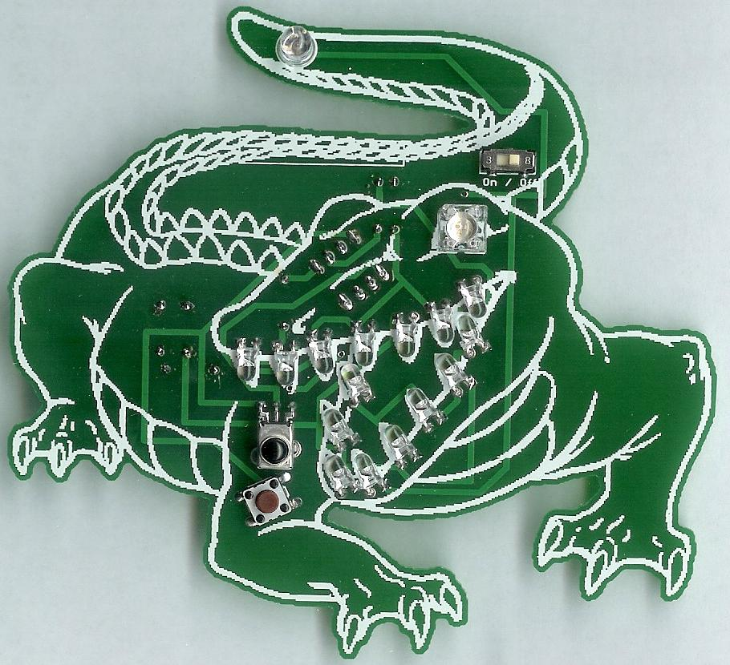 | - Sight – an IR receiver  - Touch – a push button  and ways to communicate:  - To us – 16 light emitting diodes (LEDs)  - To other blinkies – an infrared (IR) LED | 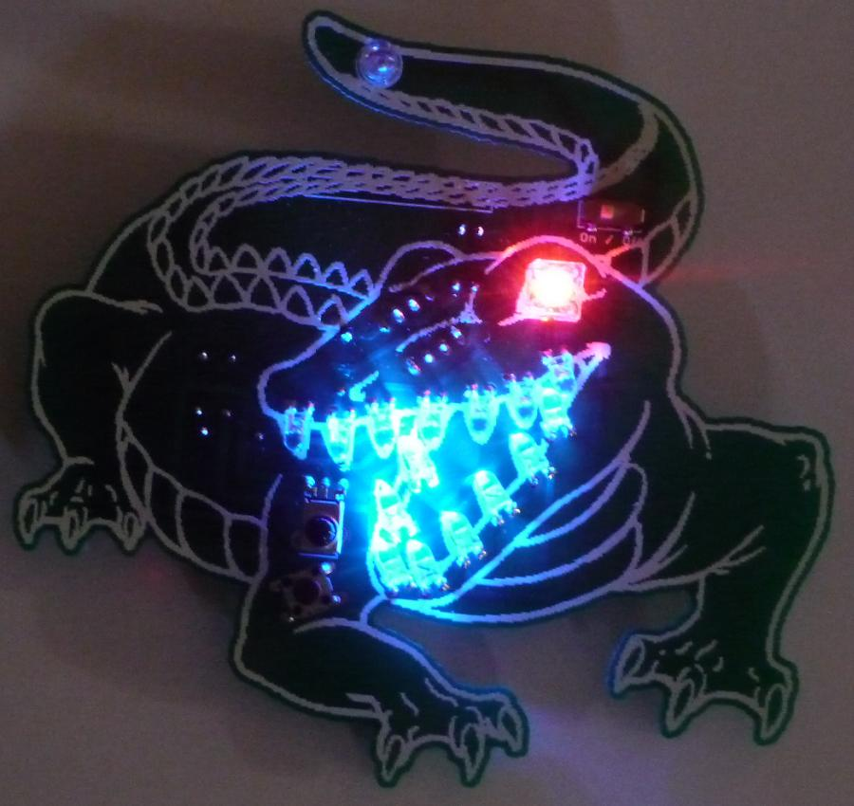

By building this blinkie, we hope you have a lot of fun, as well as learn how easy it is to assemble and solder a circuit, as well as gain a desire to learn more!

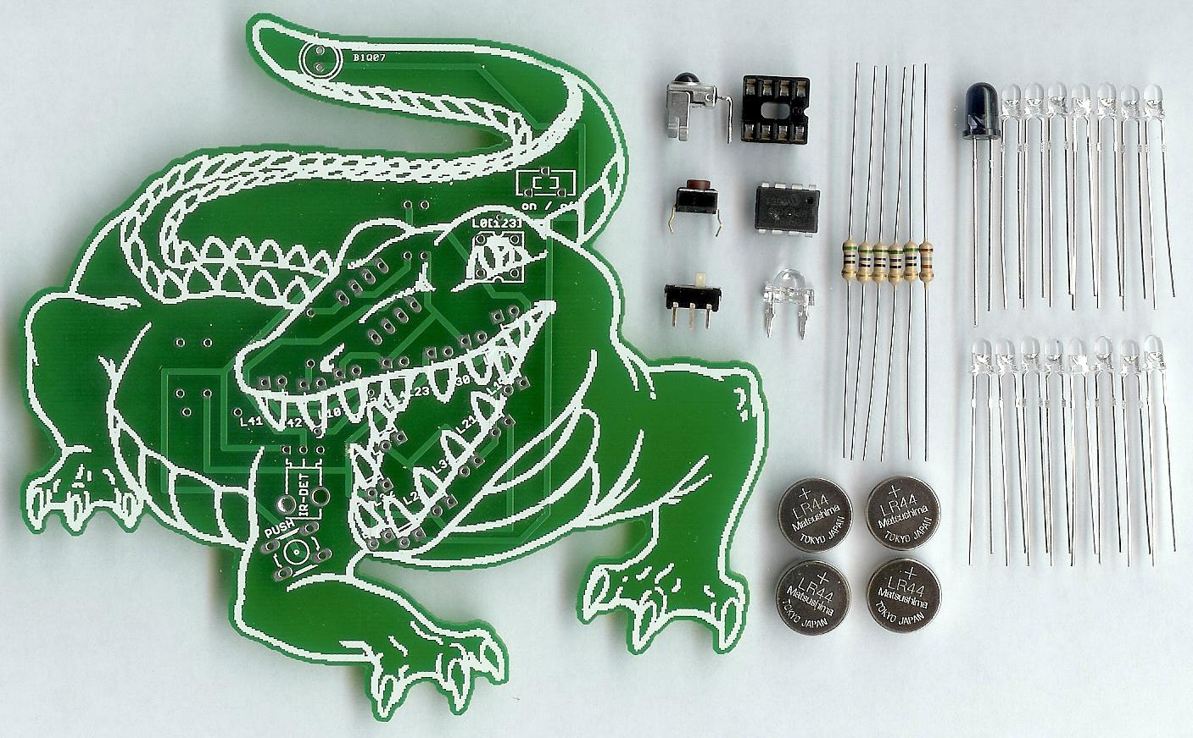
First, open up the kit and review the contents. Looking from left to right, and top to bottom there should be the following parts:

Contents:
- Circuit board (with battery clips and pin-back already soldered)  - IR detector  - Push button  - Power switch  - Eight pin socket  - 12F1822 PIC (later, if this is part of a class) | - One RGB LED  - Five 56 ohm (green, blue, black) resistors  - One 180 ohm (brown, grey, brown) resistor  - Four LR44 batteries (later, if this is part of a class)  - IR LED  - 15 LEDs

Got everything to start? If not, give us a shout. Also, since we pre-solder the battery clips, sometimes the switch gets hidden under the battery clips. Next, a few words on soldering…

Soldering Hints

Soldering is not like gluing; the solder forms an alloy with the metals to be connected that creates a stable electrical path and a certain amount of mechanical attachment. For the small connections on this project, a 25 or 30 watt soldering iron works well. Rosin core solder is used – the acid core solder sold for plumbing would eat your components in a short time.

Here’s how to make a good joint:
- Prepare the joint. Bend the component lead slightly after it passes through the printed circuit board (this helps hold it in place while soldering).
- Prepare the tool. The soldering iron should be up to temperature. Clean the tip by quickly brushing it against a dry wire pad, or damp sponge, or damp cloth. Melt a little solder (a 2mm length) onto the tip so it’s shiny. This is called “tinning”. The solder coating helps conduct heat from the tip to the joint.
- Place the tip in contact with the component lead and the printed circuit board pad.
- Place the solder against the joint directly opposite the tool. It should melt within 2 seconds, and flow around the joint. If it takes longer than that, you’re not getting enough heat into the joint.
- Keep the soldering iron in place until the solder flows freely and completely covers the joint. If the heat is removed too soon, the solder will tend to “ball up” and not stick well to the conductors. The solder joint should look "wetted”, with concave shapes.
- Let the joint cool without movement at room temperature. This usually takes only a few seconds.
- If a joint is moved before it cools, it will take on a dull, satin look that is characteristic of a cold solder joint. A cold solder joint is fragile and conducts poorly – reheat the joint until the solder flows freely, and hold it still until it cools.
- Keep the tip of the soldering iron clean. Wipe off flux and excess solder regularly in the damp sponge or cloth, and re-tin if needed.

Assembly

First, orient the board horizontally and so the battery clips and pin-back shows. As each group of parts is inserted, you will flip the board over and solder them in from the non-printed side.

- Insert the five 56 ohm (green, blue, black) resistors into the board. On the board the locations are labeled R0, R1, R2, R3, and R4. Flip the board over and solder each lead. To make inserting easier, pre-bend the lead like this: 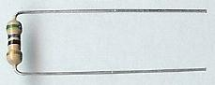  - Insert the 180 ohm (brown, grey, brown) resistor into the board. On the board, the location is labeled R6. Flip the board over and solder each lead.  - Insert the eight pin socket into the board. Note the small notch in the socket. It must face the left ( ) side of the board upward toward the tail. Flip the board over and solder each lead. | 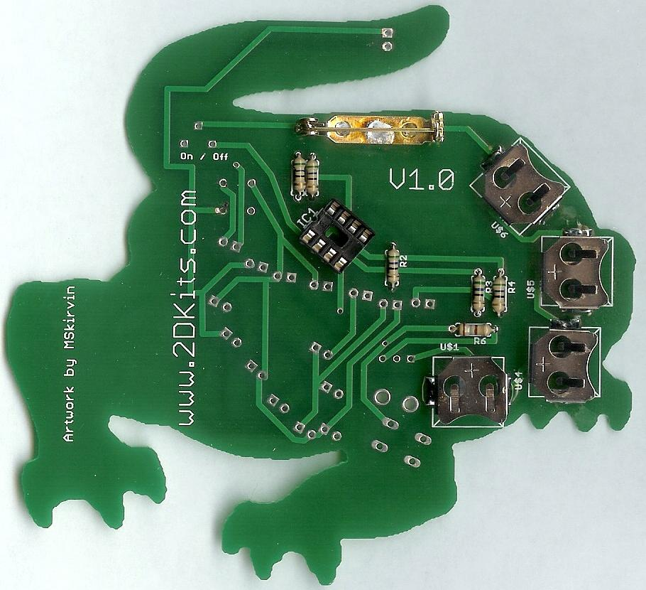

- Flip the board over so the white alligator outline is visible and the tail is up on top.  - Insert the power switch into the board. It is labeled on/off. Flip the board over and solder each lead.  - Insert the push button into the board. It is labeled PUSH. Flip the board over and solder each lead.  - Insert the IR detector into the board. It is labeled IR-DET. Flip the board over and solder each lead. | 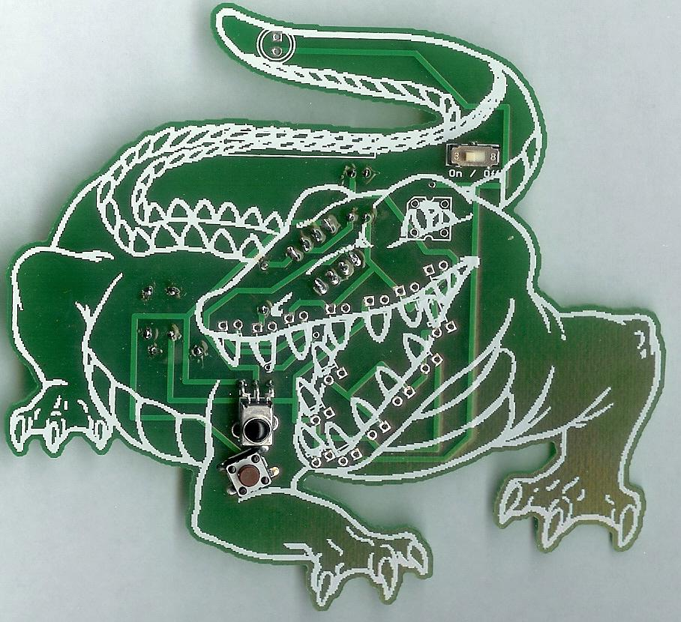

- Insert the square RGB LED. Orientation is important for LEDs. On the board, the IR LED is inserted at the eye. There is a small beveled corner on the LED. This goes into the upper left corner ( ) – it will also match the white outline on the board.  - Insert the IR LED into the board. Orientation is important for LEDs. Remember: Short lead, square pad. Long lead, round pad. On the board, the IR LED is inserted at the tip of the tail. Flip the board over and solder each lead. | 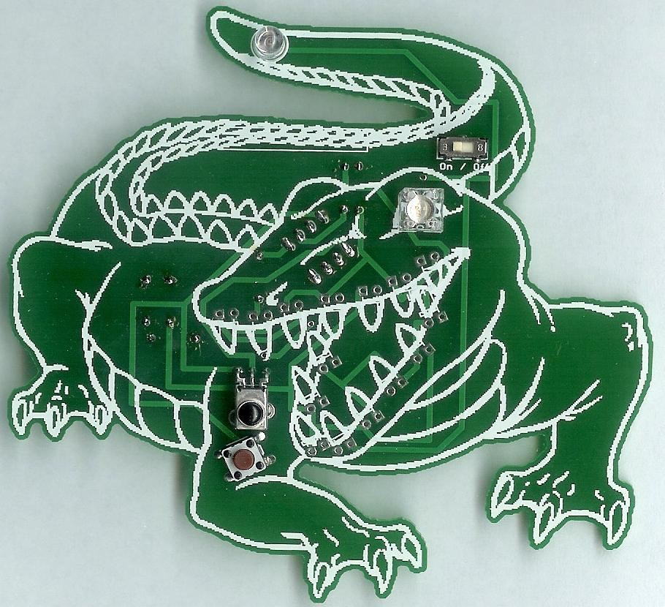

- Each LED must be bent so it matches the tooth outline. Be careful which way you bend it. However, once you’ve bent one correctly, all the other will be bent in the same way:
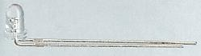

- Insert each of the 15 LEDs into the board. Orientation is important for LEDs. Remember: Short lead, square pad. Long lead, round pad. On the board, there is one LED for each tooth. Flip the board over and solder each lead. It may be easier to do the top of the jaw first, then the lower jaw.

- Flip the board over and insert the PIC into the eight pin socket. It must face the left ( ) side of the board upward toward the tail. Do not insert until after the socket has been soldered in!

- The four batteries are inserted so the “+” on the battery is facing up. It will match with the “+” on each battery clip. Turn on the board! Enjoy.

Troubleshooting

If the LEDs don’t flash, then you’ll need to do a little troubleshooting to finish your project. The following steps should isolate most problems.

- Recheck your solder connections. 80% of all problems are traced to this. Cold solder joints and broken joints will cause erratic performance or failure. Reheat any questionable solder connections until they flow and look shiny and secure.
- Check for bits of solder, wire ends, or other foreign matter which may be lodged in the wiring.
- LEDs reversed. You will need to remove the LED by desoldering, and then solder it in the correct way.
- Batteries incorrectly inserted. The “+” side of the battery should always be inserted facing up.
- Bad part – it does happen. In the hundreds of boards assembled, we’ve seen two or three parts fail. Send us email, and we will send a replacement part.
- A part got lost/melted/damaged/destroyed while building the kit. It happens – you’re not the first (or second, or fiftieth). Send us email, and we’ll see what we can do. We have no problem selling just the parts you need to get it working.
Use

Once built, the use of this blinkie is fairly straightforward. Don’t get it wet. Don’t stick it in a pocket with a bunch of change where it might short out.

This blinkie has additional patterns stored in the PIC. To change patterns, press either push button and hold. The topmost LED will light, and then the LEDs will count up (or down) in a binary sequence. Each binary number represents a stored pattern. If the push button is released, the pattern associated with that particular binary number will then be displayed on your blinkie.

This blinkie will also broadcast its current pattern via the IR LED. If another blinkie with an IR detector sees this, it will change its pattern to match. Of course, this can also happen to this blinkie – another blinkie may “infect” its pattern on this one before it can do the same.

