Atomic Blinkie

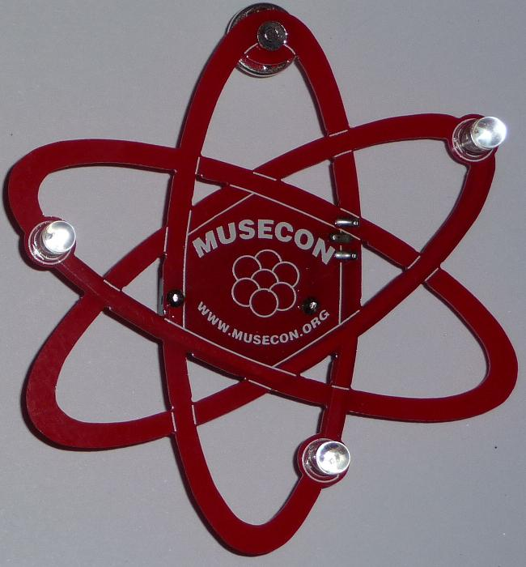 | The heart of this blinkie is a tiny chip embedded in each of the three LEDs. When power is applied, the chip tells the LED to turn on and off.  By building this blinkie, we hope you have a lot of fun, as well as learn how easy it is to assemble and solder a circuit, as well as gain a desire to learn more! |  | 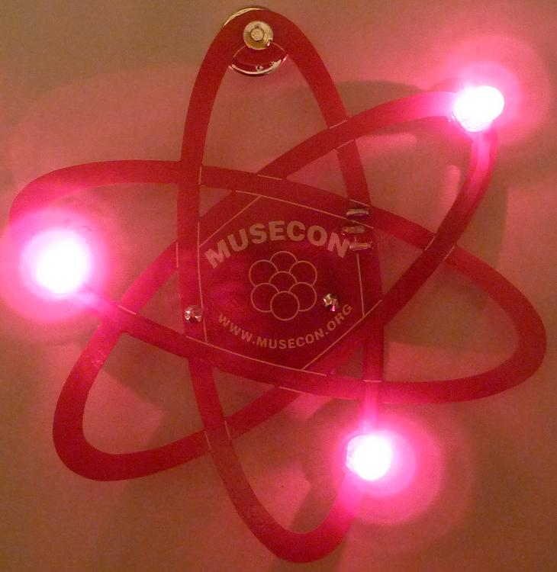
First, open up the kit and review the contents. Looking from left to right, and top to bottom there should be the following parts:  Contents:  - CR2032 battery  - Battery holder  - Red atomic circuit board  - Tie tack (pin and clasp)  - Power switch  - Three LEDs |  | 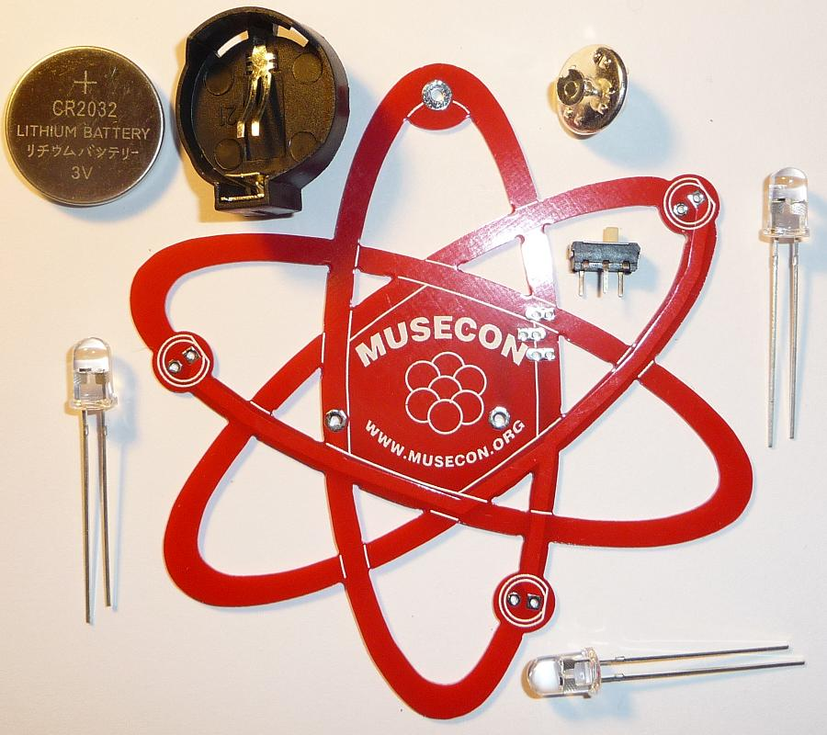

Got everything to start? If not, give us a shout. Next, a few words on soldering…

Soldering Hints

Soldering is not like gluing; the solder forms an alloy with the metals to be connected that creates a stable electrical path and a certain amount of mechanical attachment. For the small connections on this project, a 25 or 30 watt soldering iron works well. Rosin core solder is used – the acid core solder sold for plumbing would eat your components in a short time.

Here’s how to make a good joint:
- Prepare the joint. Bend the component lead slightly after it passes through the printed circuit board (this helps hold it in place while soldering).
- Prepare the tool. The soldering iron should be up to temperature. Clean the tip by quickly brushing it against a dry wire pad, or damp sponge, or damp cloth. Melt a little solder (a 2mm length) onto the tip so it’s shiny. This is called “tinning”. The solder coating helps conduct heat from the tip to the joint.
- Place the tip in contact with the component lead and the printed circuit board pad.
- Place the solder against the joint directly opposite the tool. It should melt within 2 seconds, and flow around the joint. If it takes longer than that, you’re not getting enough heat into the joint.
- Keep the soldering iron in place until the solder flows freely and completely covers the joint. If the heat is removed too soon, the solder will tend to “ball up” and not stick well to the conductors. The solder joint should look "wetted”, with concave shapes.
- Let the joint cool without movement at room temperature. This usually takes only a few seconds.
- If a joint is moved before it cools, it will take on a dull, satin look that is characteristic of a cold solder joint. A cold solder joint is fragile and conducts poorly – reheat the joint until the solder flows freely, and hold it still until it cools.
- Keep the tip of the soldering iron clean. Wipe off flux and excess solder regularly in the damp sponge or cloth, and re-tin if needed.
Assembly

First, orient the board horizontally and so the silk screening shows. If you see the word MUSECON and a cluster of seven circles, you are ready to begin.

- Separate the pin from the clasp of the tie tack. There is a small secondary post. Use the cutters to remove the smaller post as close as possible to the head of the pin. | 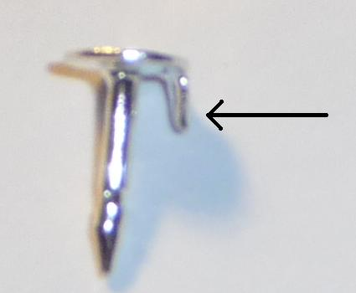

- Insert the pin through the hole. It should go through the front of the board on the MUSECON side.  - Flip the board over and solder the pin. | 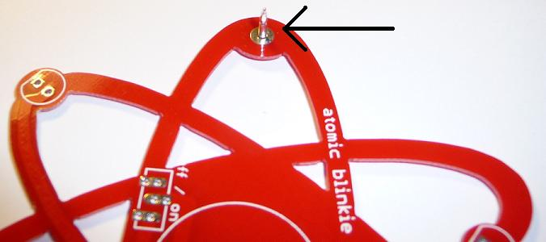

- Insert the power switch, and flip the board over to the MUSECON side. Solder the power switch.  - Flip the board over and insert the battery holder. Remember, orientation is important for the battery holder. Make sure the battery holder matches the printed outline. Flip the board over to the MUSECON side. Solder the battery holder. | 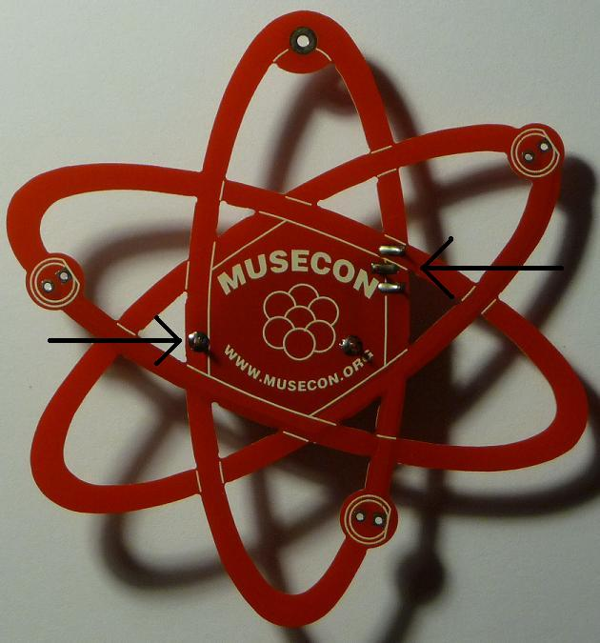

- Insert each LED into the board from the MUSECON side. Orientation is important for LEDs. Remember: Short lead, square pad. Long lead, round pad. Flip the board over and solder each lead.  - Trim the excess leads (wire) with the cutters. Hold your finger over the ends of each lead to keep it from flying off when cut. | 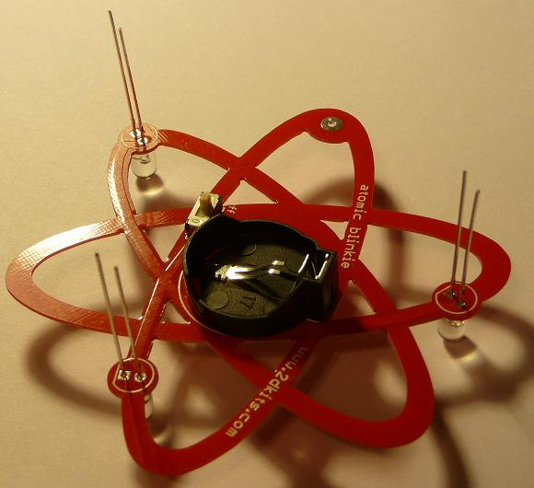

- Trim the excess leads (wire) with the cutters. Hold your finger over the ends of each lead to keep it from flying off when cut.  - Insert the CR2032 battery so the “+” on the battery is facing up. Turn on the board! Enjoy. | 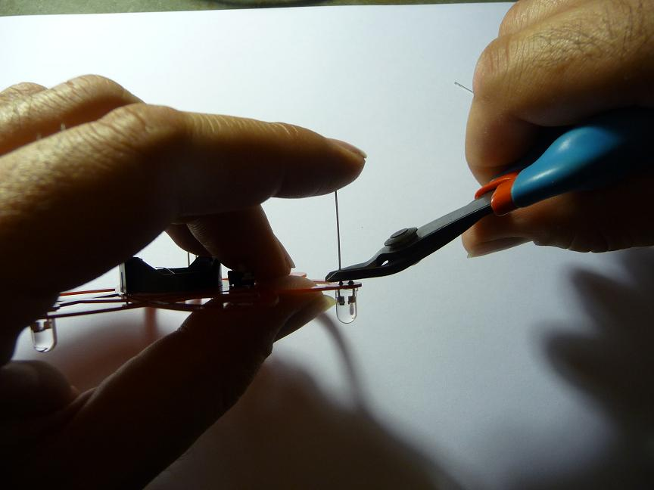

Troubleshooting

If the LEDs don’t flash, then you’ll need to do a little troubleshooting to finish your project. The following steps should isolate most problems.

- Recheck your solder connections. 80% of all problems are traced to this. Cold solder joints and broken joints will cause erratic performance or failure. Reheat any questionable solder connections until they flow and look shiny and secure.
- Check for bits of solder, wire ends, or other foreign matter which may be lodged in the wiring.
- LEDs reversed. You will need to remove the LED by desoldering, and then solder it in the correct way.
- The battery is incorrectly inserted. The “+” side of the battery should always be inserted facing up.
- Bad part – it does happen. In the hundreds of boards assembled, we’ve seen two or three parts fail. Send us email, and we will send a replacement part.
- A part got lost/melted/damaged/destroyed while building the kit. It happens – you’re not the first (or second, or fiftieth). Send us email, and we’ll see what we can do. We have no problem selling just the parts you need to get it working.
Use

Once built, the use of this blinkie is fairly straightforward. Don’t get it wet. Don’t stick it in a pocket with a bunch of coins or metal where it might short out.

