Blue Atomic Blinkie

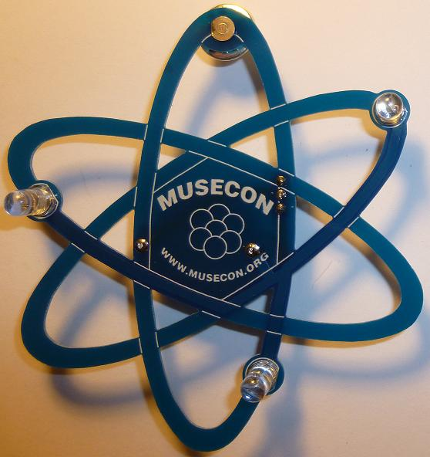 | The heart of this blinkie is a tiny chip embedded in each of the three LEDs. When power is applied, the chip tells the LED to turn on and off.  By building this blinkie, we hope you have a lot of fun, as well as learn how easy it is to assemble and solder a circuit, as well as gain a desire to learn more! |  | 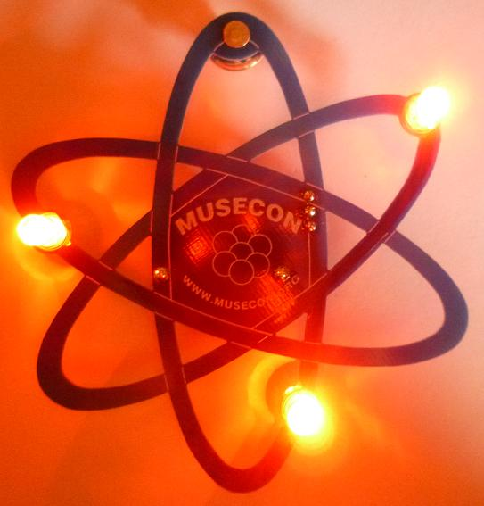
First, open up the kit and review the contents. Looking from left to right, and top to bottom there should be the following parts:  Contents:  - CR2032 battery  - Battery holder  - Blue atomic circuit board  - Tie tack (pin and clasp)  - Power switch  - Three LEDs |  | 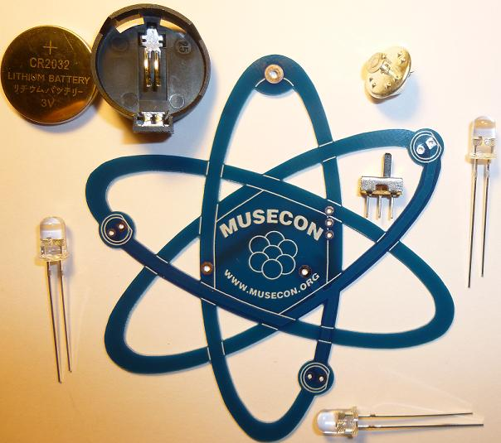

Got everything to start? If not, give us a shout. Next, a few words on soldering…

Soldering Hints

Soldering is not like gluing; the solder forms an alloy with the metals to be connected that creates a stable electrical path and a certain amount of mechanical attachment. For the small connections on this project, a 25 or 30 watt soldering iron works well. Rosin core solder is used – the acid core solder sold for plumbing would eat your components in a short time.

Here’s how to make a good joint:
- Prepare the joint. Bend the component lead slightly after it passes through the printed circuit board (this helps hold it in place while soldering).
- Prepare the tool. The soldering iron should be up to temperature. Clean the tip by quickly brushing it against a dry wire pad, or damp sponge, or damp cloth. Melt a little solder (a 2mm length) onto the tip so it’s shiny. This is called “tinning”. The solder coating helps conduct heat from the tip to the joint.
- Place the tip in contact with the component lead and the printed circuit board pad.
- Place the solder against the joint directly opposite the tool. It should melt within 2 seconds, and flow around the joint. If it takes longer than that, you’re not getting enough heat into the joint.
- Keep the soldering iron in place until the solder flows freely and completely covers the joint. If the heat is removed too soon, the solder will tend to “ball up” and not stick well to the conductors. The solder joint should look "wetted”, with concave shapes.
- Let the joint cool without movement at room temperature. This usually takes only a few seconds.
- If a joint is moved before it cools, it will take on a dull, satin look that is characteristic of a cold solder joint. A cold solder joint is fragile and conducts poorly – reheat the joint until the solder flows freely, and hold it still until it cools.
- Keep the tip of the soldering iron clean. Wipe off flux and excess solder regularly in the damp sponge or cloth, and re-tin if needed.
For the purposes of learning how to solder, you do not need to be perfect.  With a little bit of practice, your soldering skills will rapidly improve. That being said, the only thing that needs to be avoided is solder bridges, which are excess solder making an unexpected connection on the board.  If you make a bridge, it is easy to fix. You can often just reheat and pull the tip of the soldering iron through the bridge, breaking it. Or, reheat all the solder and *gently* tap to the board on edge to shake off the excess. Beyond that, we are more than happy to demonstrate various techniques.  The goal is to have fun while learning, and your skill will develop as you have fun. Happy soldering! | 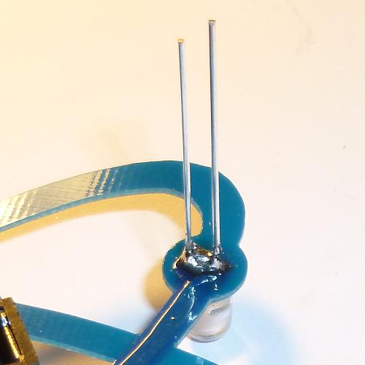
 | A bridge between the two leads of the LED. Current will flow through the bridge, and not the LED, thus the LED will not light up. Fortunately, this is easy to fix.

Assembly

Take a look at the completed picture on the first page. The only components that will be visible on the front are the LEDs. All other components (power switch, battery holder, and tie-tack will be placed facing the back of the board and soldering will occur on the front of the board – the side with MUSECON.

First, orient the board so the silk screen printing of MUSECON is seen. You are ready to begin.

- Separate the pin from the clasp of the tie tack (pin and clasp). There is a small secondary post. Use the cutters to remove the smaller post as close as possible to the head of the pin. | 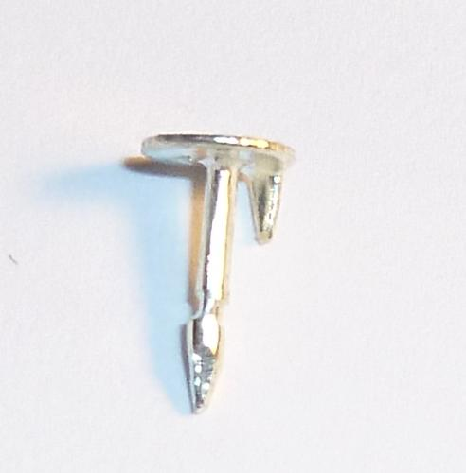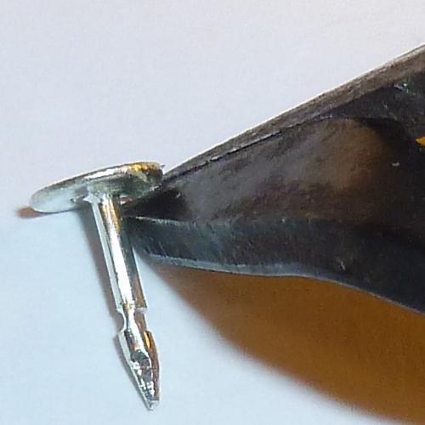

- Insert the pin through the hole. It should go through the front of the board on the MUSECON side.  - Flip the board over and solder the pin. | 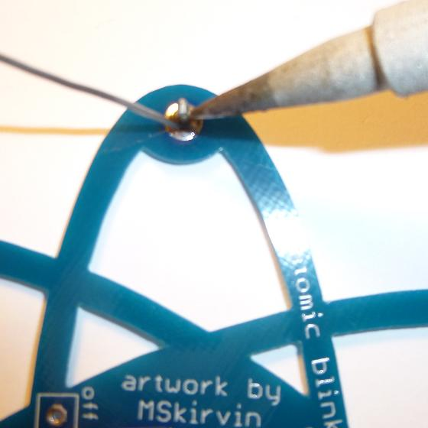

- Insert the power switch, and flip the board over to the MUSECON side. Solder the power switch. | 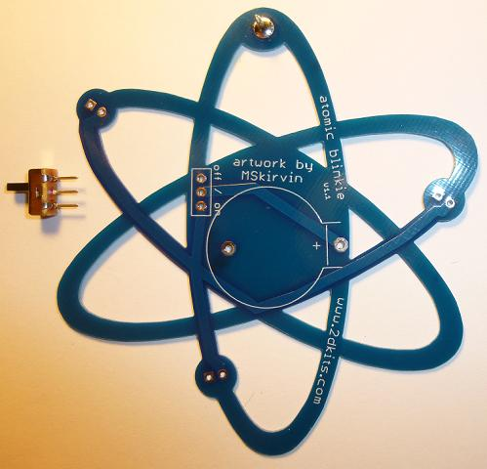

- Flip the board over and insert the battery holder. Remember, orientation is important for the battery holder. Make sure the battery holder matches the printed outline. Flip the board over to the MUSECON side. Solder the battery holder. | 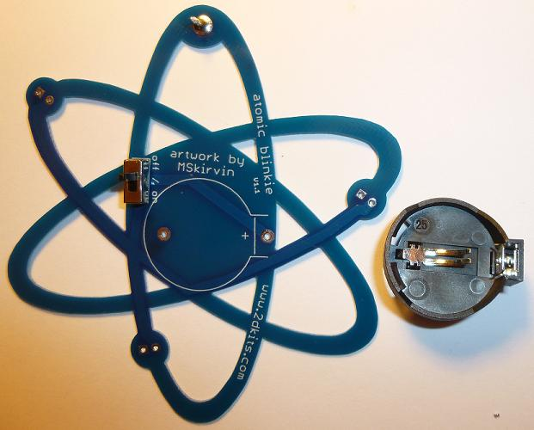

- Insert the battery. The plus sign “+” will face up. Angle it into the battery holder on the left side first, and then press down. It will snap in place. Verify the power switch is on. In the next few steps, the LEDs will be inserted and tested before they are soldered into the board. | 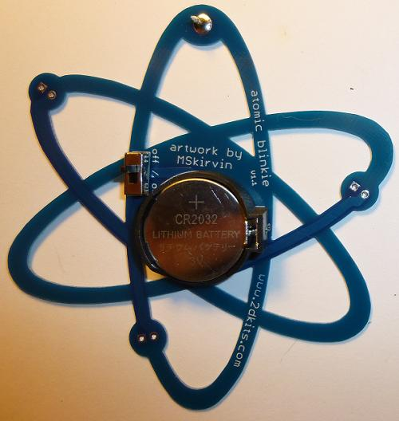

- Insert each LED into the board from the MUSECON side. Orientation is important for LEDs. Remember: Short lead, square pad. Long lead, round pad. | 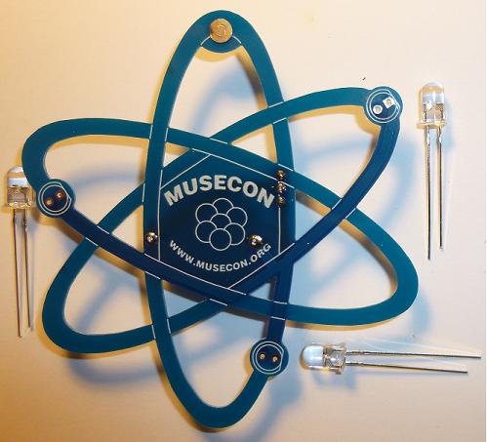

- Check the first LED. Does it blink? You may need to gently wiggle so it makes contact. If it blinks, great - move to the next step. If not, try reversing the LED. If that still doesn’t work, let us know. | 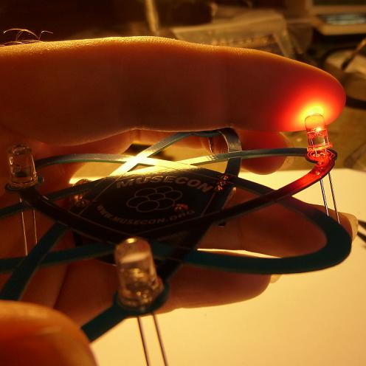

- Check the second LED. Does it blink? You may need to gently wiggle so it makes contact. If it blinks, great - move to the next step. If not, try reversing the LED. If that still doesn’t work, let us know. | 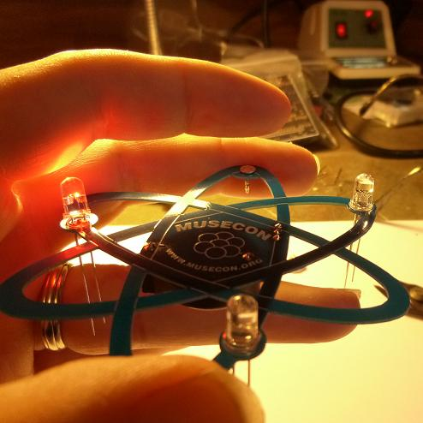

- Check the third LED. Does it blink? You may need to gently wiggle so it makes contact. If it blinks, great - move to the next step. If not, try reversing the LED. If that still doesn’t work, let us know.  - Take this time to confirm the LEDs were inserted from the correct side.  - Turn the power switch off. Flip the board over and solder the LEDs. | 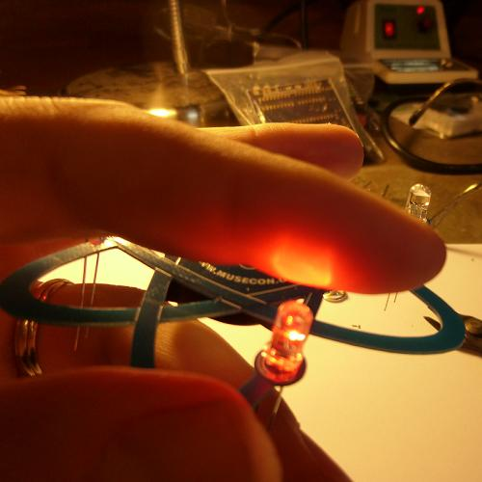

- Trim the excess leads (wire) with the cutters. Hold your finger over the ends of each lead to keep it from flying off when cut.  - You may also want to trim the leads on the front of the board from power switch and battery holder.  - Turn on the board! Enjoy. | 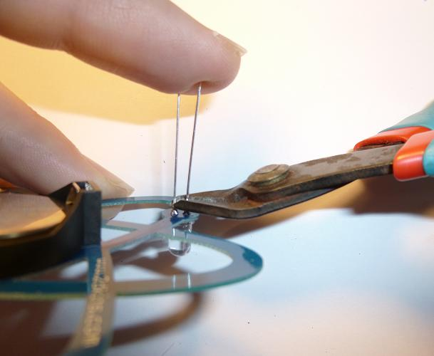

Troubleshooting

If the LEDs don’t flash, then you’ll need to do a little troubleshooting to finish your project. The following steps should isolate most problems.

- Recheck your solder connections. 80% of all problems are traced to this. Cold solder joints and broken joints will cause erratic performance or failure. Reheat any questionable solder connections until they flow and look shiny and secure.
- Check for bits of solder, wire ends, or other foreign matter which may be lodged in the wiring.
- LEDs reversed. You will need to remove the LED by desoldering, and then solder it in the correct way.
- The battery is incorrectly inserted. The “+” side of the battery should always be inserted facing up.
- Bad part – it does happen. In the hundreds of boards assembled, we’ve seen two or three parts fail. Send us email, and we will send a replacement part.
- A part got lost/melted/damaged/destroyed while building the kit. It happens – you’re not the first (or second, or fiftieth). If you are doing this at a convention, seminar, or class, just let us know. Otherwise, send us email, and we’ll see what we can do. We have no problem selling just the parts you need to get it working.
Use

Once built, the use of this blinkie is fairly straightforward. Don’t get it wet. Don’t stick it in a pocket with a bunch of coins or metal where it might short out.

