Rocket Ship Blinkie

The heart of this blinkie is a 12F1822 PIC produced by a company called Microchip. A PIC is a tiny, yet surprisingly powerful little computer. By itself, it can’t do much – it needs someway to interact with the world – we are going to do this by giving it senses:

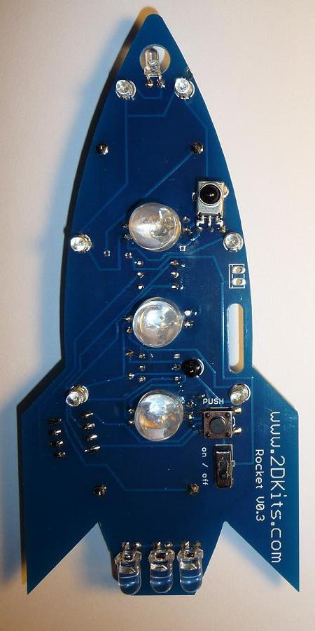 | - Sight – an IR receiver  - Touch – a push button  and ways to communicate:  - To us – ten light emitting diodes (LEDs) and three RGB LEDs.  - To other blinkies – an infrared (IR) LED | 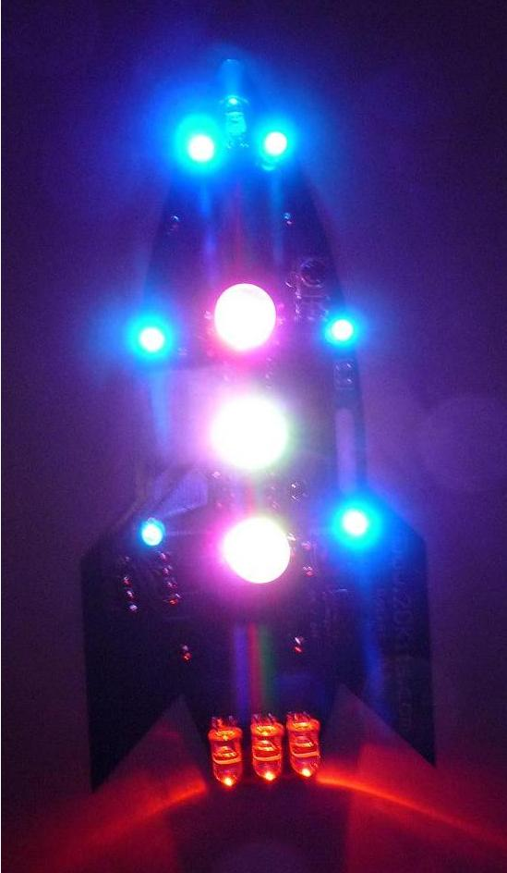

By building this blinkie, we hope you have a lot of fun, as well as learn how easy it is to assemble and solder a circuit, as well as gain a desire to learn more!

First, open up the kit and review the contents. Looking from left to right, and top to bottom there should be the following parts:

- Rocket circuit board  - Three 10mm RGB LEDs  - Three 5mm LEDs  - Five 56 ohm (green, blue, black) resistors  - One 180 ohm (brown, grey, brown) resistor  - Diode  - Seven 3mm LEDs  - IR LED  - IR detector  - Power switch  - 8 pin 12F1822 PIC (if assembled as part of a class, the PIC and batteries will be provided after the board is double checked)  - 8 pin socket  - Push button  - Two battery holders  - Two CR2032 batteries | 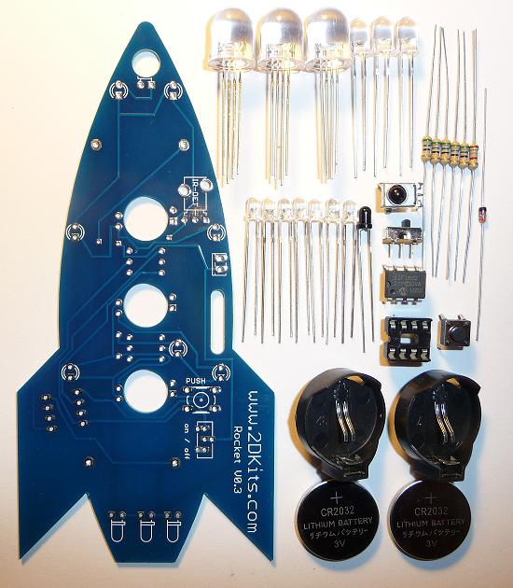

Got everything to start? If not, give us a shout. Next, a few words on soldering…

Soldering Hints

Soldering is not like gluing; the solder forms an alloy with the metals to be connected that creates a stable electrical path and a certain amount of mechanical attachment. For the small connections on this project, a 25 or 30 watt soldering iron works well. Rosin core solder is used – the acid core solder sold for plumbing would eat your components in a short time.

Here’s how to make a good joint:
- Prepare the joint. Bend the component lead slightly after it passes through the printed circuit board (this helps hold it in place while soldering).
- Prepare the tool. The soldering iron should be up to temperature. Clean the tip by quickly brushing it against a dry wire pad, or damp sponge, or damp cloth. Melt a little solder (a 2mm length) onto the tip so it’s shiny. This is called “tinning”. The solder coating helps conduct heat from the tip to the joint.
- Place the tip in contact with the component lead and the printed circuit board pad.
- Place the solder against the joint directly opposite the tool. It should melt within 2 seconds, and flow around the joint. If it takes longer than that, you’re not getting enough heat into the joint.
- Keep the soldering iron in place until the solder flows freely and completely covers the joint. If the heat is removed too soon, the solder will tend to “ball up” and not stick well to the conductors. The solder joint should look "wetted”, with concave shapes.
- Let the joint cool without movement at room temperature. This usually takes only a few seconds.
- If a joint is moved before it cools, it will take on a dull, satin look that is characteristic of a cold solder joint. A cold solder joint is fragile and conducts poorly – reheat the joint until the solder flows freely, and hold it still until it cools.
- Keep the tip of the soldering iron clean. Wipe off flux and excess solder regularly in the damp sponge or cloth, and re-tin if needed.

Assembly

First, orient the board horizontally and so the IR-DET silk screen printing shows.

- Insert the IR detector, the push button, and the power switch. Flip the board over and solder. | 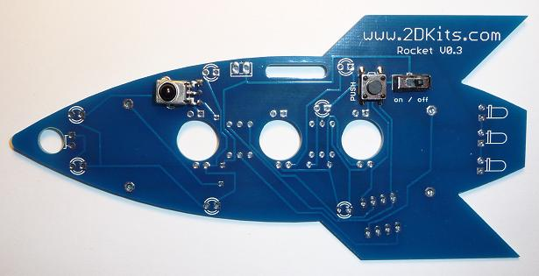

- Insert the five 56 ohm (green, blue, black) resistors into the board. On the board the locations are labeled R1, R0, R3, R4, and R2. To make inserting easier, pre-bend the lead like this: 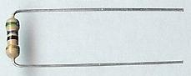  - Insert the 180 ohm (brown, grey, brown) resistor into the board. On the board, the location is labeled R5. Flip the board over and solder each lead. Trim the leads with the cutter. | 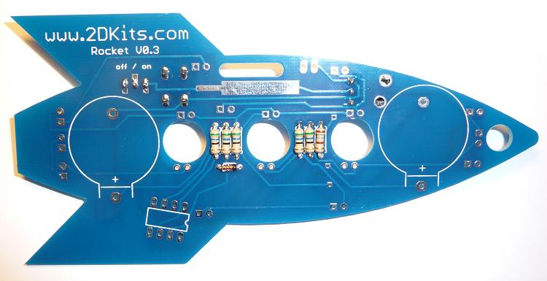

- Insert the diode into the board. On the board the location is labeled D1. To make inserting easier, pre-bend the lead. Orientation is important for diodes. Insert the diode to match the silk screen printing - the bar on the diode will be to the right. Flip the board over and solder. Trim the leads with the cutter.

- Flip the board over do the silk screen printing for the battery holders are visible. Insert the battery holders.  - Insert the 8 pin socket into the board. Make sure the little notch at the end matches the silk screen printing and faces to the right. Flip the board over and solder. | 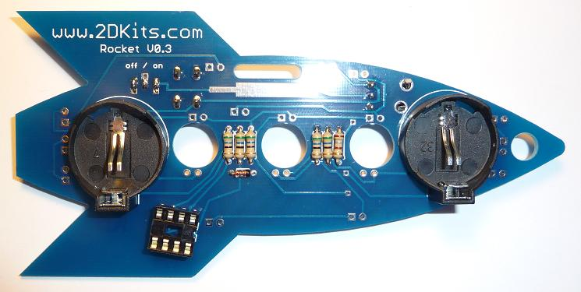

- Insert the 5mm LEDs into the tail of the rocket. The leads need to be bent at a 90 degree angle. Orientation is important for LEDs. Remember: Short lead, square pad. Long lead, round pad.  - Insert one 3mm LEDs into the nose of the rocket. The leads need to be bent at a 90 degree angle. Orientation is important for LEDs. Remember: Short lead, square pad. Long lead, round pad. | 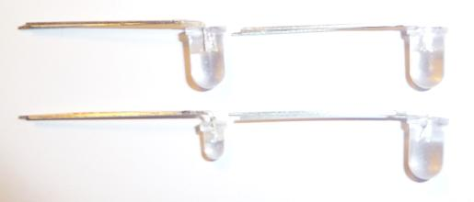

- Insert the other six 3mm LEDs. Orientation is important for LEDs. Remember: Short lead, square pad. Long lead, round pad.  - Insert the IR LED. Orientation is important for LEDs. Remember: Short lead, square pad. Long lead, round pad. Flip the board over and solder. Trim the leads with the cutters. | 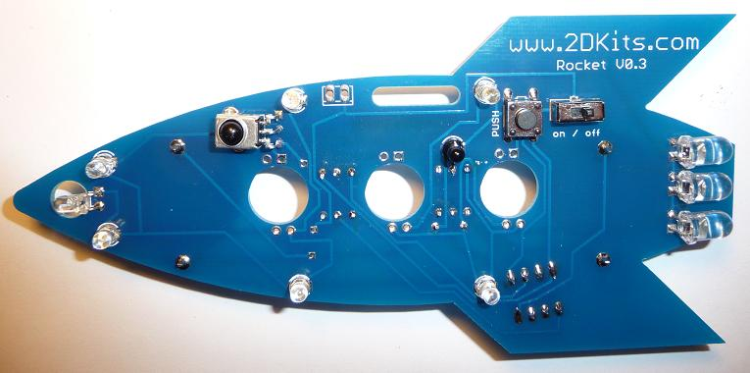

- Insert the three 10mm RGB LEDs. This requires the leads to be bent before inserting. Holding the LED, with the leads facing up, and the shortest one to your left, bend it down toward you, the next bend it down away from you, the next toward you, and the last away from you. For each lead, bend it around the LED. Repeat for each LED. It will look like the rightmost LED in the picture. | 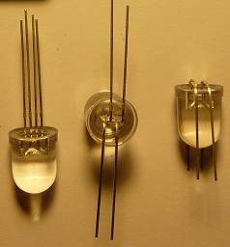

- Insert in each 10mm LED and snug up the LED leads. You will want to double check and make sure they are properly oriented. If you have any questions, please feel free to ask! Flip the board over and solder. Trim the leads with the cutter. | 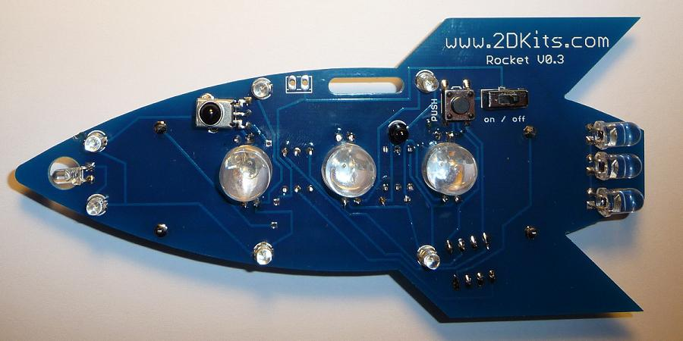

- Flip the board over and insert the PIC into the eight pin socket. The small notch or dot on the PIC must face toward the nose.

- The two batteries are inserted so the “+” on the battery is facing up. Turn on the board! Enjoy.

Troubleshooting

If the LEDs don’t flash, then you’ll need to do a little troubleshooting to finish your project. The following steps should isolate most problems.

- Recheck your solder connections. 80% of all problems are traced to this. Cold solder joints and broken joints will cause erratic performance or failure. Reheat any questionable solder connections until they flow and look shiny and secure.
- Check for bits of solder, wire ends, or other foreign matter which may be lodged in the wiring.
- LEDs reversed. You will need to remove the LED by desoldering, and then solder it in the correct way.
- Batteries incorrectly inserted. The “+” side of the battery should always be inserted facing up.
- Bad part – it does happen. In the hundreds of boards assembled, we’ve seen two or three parts fail. Send us email, and we will send a replacement part.
- A part got lost/melted/damaged/destroyed while building the kit. It happens – you’re not the first (or second, or fiftieth). Send us email, and we’ll see what we can do. We have no problem selling just the parts you need to get it working.
Use

Once built, the use of this blinkie is fairly straightforward. Don’t get it wet. Don’t stick it in a pocket with a bunch of car or house keys where it might short out.

This blinkie has additional patterns stored in the PIC. To change patterns, press the push button and hold. The topmost LED will light, and then the LEDs will count up (or down) in a sequence. Each sequence represents a stored pattern. If the push button is released, the pattern associated with that particular binary number will then be displayed on your blinkie.

This blinkie will also broadcast its current pattern via the IR LED. If another blinkie with an IR detector sees this, it will change its pattern to match. Of course, this can also happen to this blinkie – another blinkie may “infect” its pattern on this one before it can do the same.

