Star Blinkie

The heart of this blinkie is a 12F1822 PIC produced by a company called Microchip. A PIC is a tiny, yet surprisingly powerful little computer. By itself, it can’t do much – it needs someway to interact with the world – we are going to do this by giving it senses:

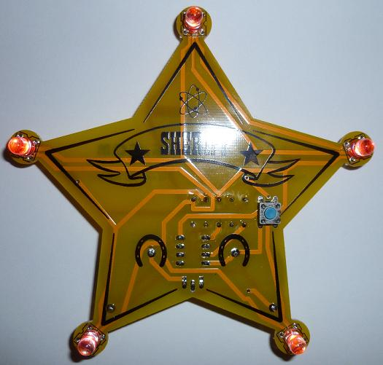 | - Touch – a push button  and ways to communicate:  - To us – five light emitting diodes (LEDs). | 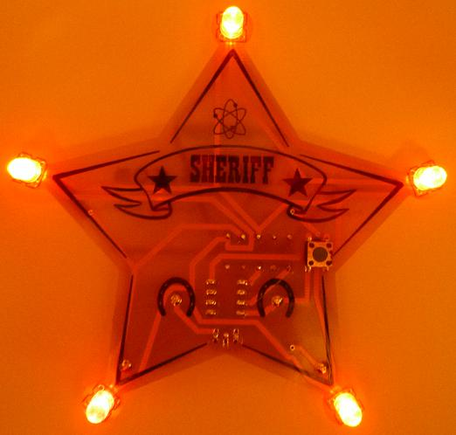

By building this blinkie, we hope you have a lot of fun, as well as learn how easy it is to assemble and solder a circuit, as well as gain a desire to learn more!

First, open up the kit and review the contents. Looking from left to right, and top to bottom there should be the following parts:

- 8 pin socket  - 8 pin 12F1822  - Push button  - Power switch  - Star circuit board  - Two battery holders  - Two CR2032 batteries  - Solder (at the soldering station)  - Pin back  - Five LEDs (two-lead LEDs shown, optional four-lead square LEDs)  - Five 56 ohm (green, blue, black) resistors | 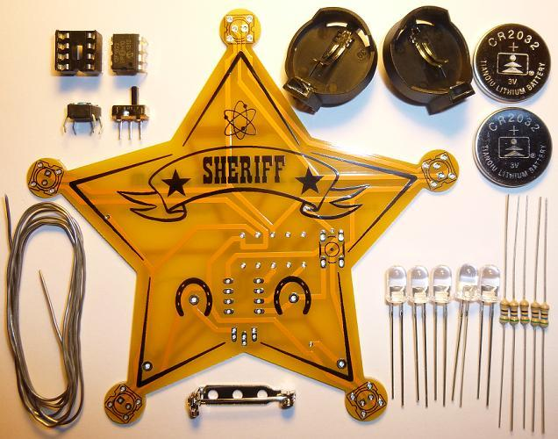

Got everything to start? If not, give us a shout. Next, a few words on soldering…

Soldering Hints

Soldering is not like gluing; the solder forms an alloy with the metals to be connected that creates a stable electrical path and a certain amount of mechanical attachment. For the small connections on this project, a 25 or 30 watt soldering iron works well. Rosin core solder is used – the acid core solder sold for plumbing would eat your components in a short time.

Here’s how to make a good joint:
- Prepare the joint. Bend the component lead slightly after it passes through the printed circuit board (this helps hold it in place while soldering).
- Prepare the tool. The soldering iron should be up to temperature. Clean the tip by quickly brushing it against a dry wire pad, or damp sponge, or damp cloth. Melt a little solder (a 2mm length) onto the tip so it’s shiny. This is called “tinning”. The solder coating helps conduct heat from the tip to the joint.
- Place the tip in contact with the component lead and the printed circuit board pad.
- Place the solder against the joint directly opposite the tool. It should melt within 2 seconds, and flow around the joint. If it takes longer than that, you’re not getting enough heat into the joint.
- Keep the soldering iron in place until the solder flows freely and completely covers the joint. If the heat is removed too soon, the solder will tend to “ball up” and not stick well to the conductors. The solder joint should look "wetted”, with concave shapes.
- Let the joint cool without movement at room temperature. This usually takes only a few seconds.
- If a joint is moved before it cools, it will take on a dull, satin look that is characteristic of a cold solder joint. A cold solder joint is fragile and conducts poorly – reheat the joint until the solder flows freely, and hold it still until it cools.
- Keep the tip of the soldering iron clean. Wipe off flux and excess solder regularly in the damp sponge or cloth, and re-tin if needed.

Assembly

Take a look at the completed picture on the first page. The only components that will be visible on the front are the LEDs and the push button. All other components (resistors, 8-pin socket, power switch, battery holder, and pin-back will be placed on the back of the board and soldered on the front of the board.

Although you need to choose all of one type of LED (no mixing and matching), the board supports two lead LEDs, both single- and bi-color, and four lead square (UFO package) RGB LEDs. It’s a fairly nifty bit of circuit design to allow for the various types of LEDs, and care will need to be taken when the LEDs are placed. Those are covered in the steps below.

Ready to start? First, orient the board so the SHERIFF silk screen printing shows.

- If you have a two-lead LEDs:  Insert the LEDs. Orientation is important for LEDs. Remember: Short lead, square pad. Long lead, round pad.  - Insert the push button. The silk screened outline shows where it goes. Flip the board over and solder. | 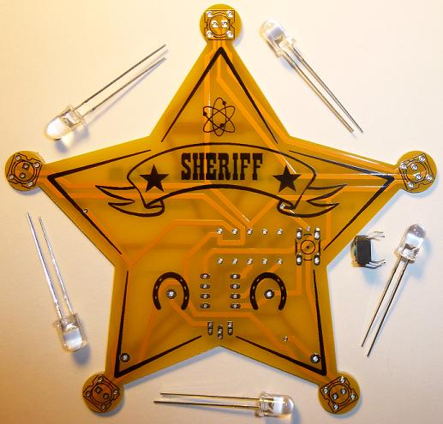

- If you have four-lead square LEDs:    Insert the LEDs. Orientation is important for LEDs:  - Topmost LED, notch lower left  - Leftmost LED, notch lower right  - Rightmost LED, notch upper left  - Bottom left LED, notch to the right  - Bottom right LED, notch to the top  - Insert the push button. The silk screened outline shows where it goes. Flip the board over and solder. | 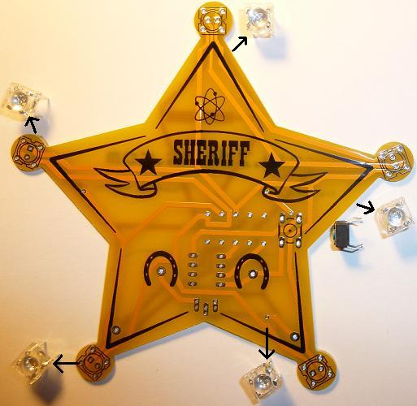

- Insert the five 56 ohm (green, blue, black) resistors into the board from the side that says www.2dkits.com. To make inserting easier, pre-bend the lead like this: 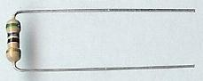 Flip the board over and solder. Trim the leads with the cutter. | 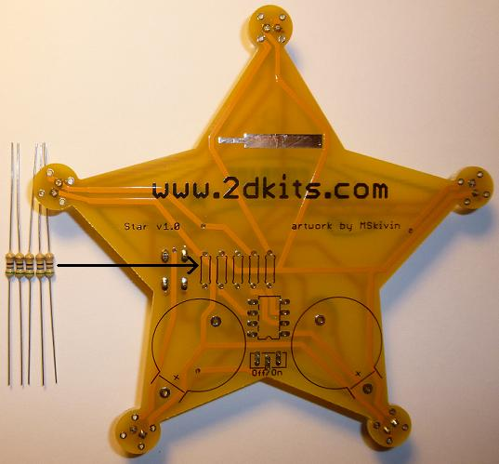

- Insert the 8-pin socket into the board so that the notch is facing down (and matches the silk screen outline. Flip the board over and solder. Trim the leads with the cutter.  - Flip the board over so the silk screening for the power switch is visible, Off/On. Insert the power switch. Note there are more than one set of holes – we do this to allow for two different types of power switches to be used. Your switch will fit in the correct set of holes. Flip the board over and solder. Trim the leads with the cutter. | 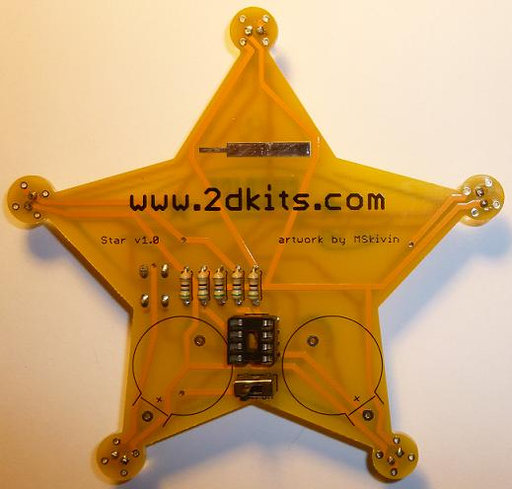

- Flip the board over do the silk screen printing for the battery holders are visible. Insert the battery holders.  - Solder the pin-back on the board. It will take a little longer for the pin-back to heat up and for the solder to melt and flow, so be patient. | 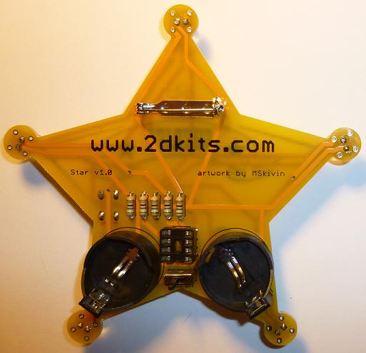

- Flip the board over and insert the PIC into the eight pin socket. The small notch or dot on the PIC must down toward the bottom of the circuit board.

- The two batteries are inserted so the “+” on the battery is facing up. Turn on the board! Enjoy.

Troubleshooting

If the LEDs don’t flash, then you’ll need to do a little troubleshooting to finish your project. The following steps should isolate most problems.

- Recheck your solder connections. 80% of all problems are traced to this. Cold solder joints and broken joints will cause erratic performance or failure. Reheat any questionable solder connections until they flow and look shiny and secure.
- Check for bits of solder, wire ends, or other foreign matter which may be lodged in the wiring.
- LEDs reversed. You will need to remove the LED by desoldering, and then solder it in the correct way.
- Batteries incorrectly inserted. The “+” side of the battery should always be inserted facing up.
- Bad part – it does happen. In the hundreds of boards assembled, we’ve seen two or three parts fail. Send us email, and we will send a replacement part.
- A part got lost/melted/damaged/destroyed while building the kit. It happens – you’re not the first (or second, or fiftieth). Send us email, and we’ll see what we can do. We have no problem selling just the parts you need to get it working.
Use

Once built, the use of this blinkie is fairly straightforward. Don’t get it wet. Don’t stick it in a pocket with a bunch of car or house keys where it might short out.

This blinkie has additional patterns stored in the PIC. To change patterns, press the push button and hold. The topmost LED will light, and then the LEDs will count up (or down) in a sequence. Each sequence represents a stored pattern. If the push button is released, the pattern associated with that particular binary number will then be displayed on your blinkie.

