Orion Blinkie

The heart of this blinkie is a 12F1822 PIC produced by a company called Microchip. A PIC is a tiny, yet surprisingly powerful little computer. By itself, it can’t do much – it needs someway to interact with the world – we are going to do this by giving it senses:

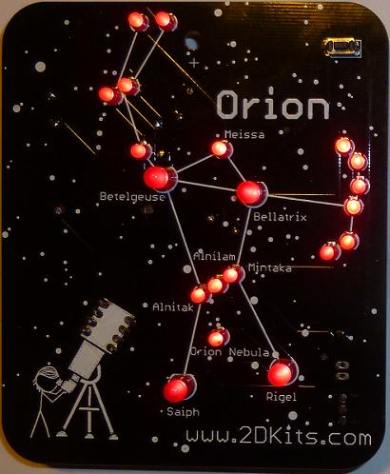 | - From us – a push button  - To us – 20 light emitting diodes (LEDs).  By building this blinkie, we hope you have a lot of fun, as well as learn how easy it is to assemble and solder a circuit, as well as gain a desire to learn more! | 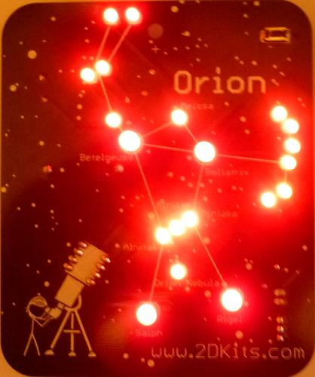

Use

Once built, the use of this blinkie is fairly straightforward. Don’t get it wet. Don’t stick it in a pocket with a bunch of car or house keys where it might short out.

This blinkie has additional patterns stored in the PIC. To change patterns or messages, press the push button and hold. The bottom LED on the shield will light, and then the LEDs will count up in a binary sequence. Each sequence represents a stored pattern. If the push button is released, the pattern associated with that particular binary number will then be displayed on your blinkie.

The blinkie has two display modes. Demo mode, where it will switch to a different stored pattern every minute, as it cycles through all the stored patterns. If it is in demo mode, when the push button is held down, the very top most LED will be lit. Normal mode, where will continue to display the current pattern until a new pattern is selected via the push buttons. To toggle between the modes, hold down the push button while turning on the power.

Now, on to the assembly…
First, open up the kit and review the contents. Looking from top to bottom, and left to right there should be the following parts:

- Circuit board  - Five 56 ohm resistors (green, blue, black)  - Pin back  - Power switch  - 8 pin socket  - Dual CR2032 battery holder  - Push button  - 8 pin 12F1822 PIC  - Sixteen 3mm LEDs  - Four 5mm LEDS  - Two CR2032 3V batteries | 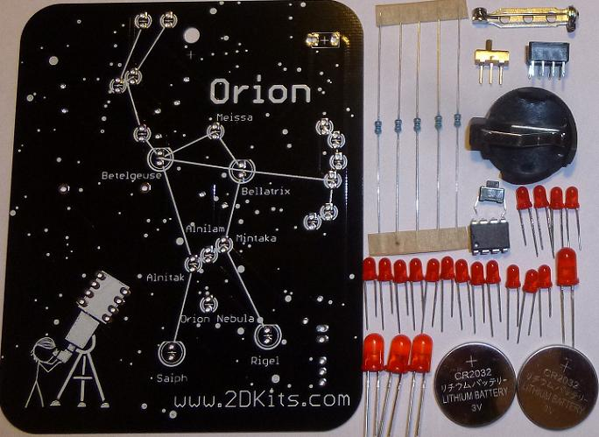

Got everything to start? If not, give us a shout. Next, a few words on soldering…

Soldering Hints

Soldering is not like gluing; the solder forms an alloy with the metals to be connected that creates a stable electrical path and a certain amount of mechanical attachment. For the small connections on this project, a 25 or 30 watt soldering iron works well. Rosin core solder is used – the acid core solder sold for plumbing would eat your components in a short time.

Here’s how to make a good joint:
- Prepare the joint. Bend the component lead slightly after it passes through the printed circuit board (this helps hold it in place while soldering).
- Prepare the tool. The soldering iron should be up to temperature. Clean the tip by quickly brushing it against a dry wire pad, or damp sponge, or damp cloth. Melt a little solder (a 2mm length) onto the tip so it’s shiny. This is called “tinning”. The solder coating helps conduct heat from the tip to the joint.
- Place the tip in contact with the component lead and the printed circuit board pad.
- Place the solder against the joint directly opposite the tool. It should melt within 2 seconds, and flow around the joint. If it takes longer than that, you’re not getting enough heat into the joint.
- Keep the soldering iron in place until the solder flows freely and completely covers the joint. If the heat is removed too soon, the solder will tend to “ball up” and not stick well to the conductors. The solder joint should look "wetted”, with concave shapes.
- Let the joint cool without movement at room temperature. This usually takes only a few seconds.
- If a joint is moved before it cools, it will take on a dull, satin look that is characteristic of a cold solder joint. A cold solder joint is fragile and conducts poorly – reheat the joint until the solder flows freely, and hold it still until it cools.
- Keep the tip of the soldering iron clean. Wipe off flux and excess solder regularly in the damp sponge or cloth, and re-tin if needed.

A suggestion on trimming leads (the excess wire visible after soldering). Hold your finger over the ends of each lead to keep it from flying off when cut. | 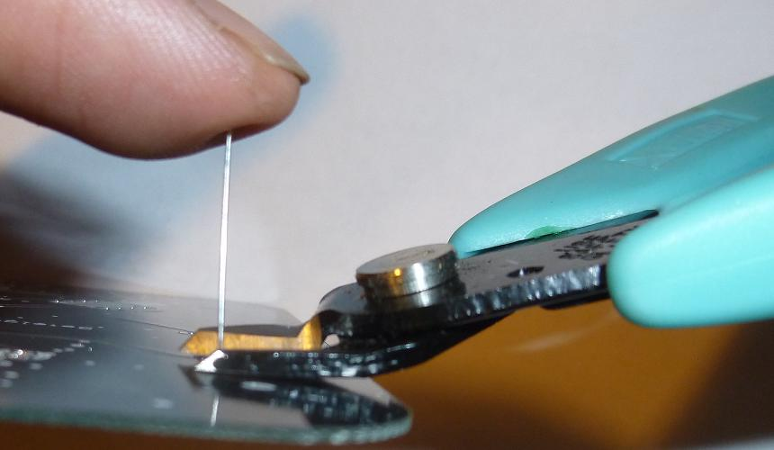

Assembly

Take care when soldering the headers and sockets to the circuit board and make sure you are soldering them from the correct side!

Ready to start? First, flip the circuit board over. Orient the board so the hole is at the top. You will see the silk screening for the resistors (R0, R1, R2, R3, and R4).

- Insert the resistors. To make inserting easier, pre-bend the leads as shown. They should be inserted into the locations marked (R0, R1, R2, R3, and R4). Flip the board over and solder. Trim the leads. Remember to trim the leads only after soldering them.  - Flip the board over. | 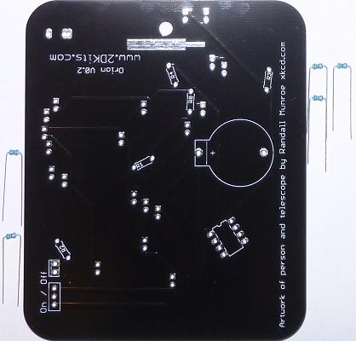

- Place the pin back and solder it in place. This is a larger component, so more time will be required to heat it up enough to solder. Once soldered, wait for it to cool for one minute.  - Insert the 8 pin socket. The socket will be inserted from the side that has the silk screen. Make sure the notch on the socket matches the silk screen outline; the notch will be to the top. Flip the board over and solder the leads. Flip the board back over.  - Insert the power switch. Flip the board over and solder the leads. Flip the board back over.  - Insert the dual battery holder. Orientation (the direction the battery holder is turned) is important. It will match the silk screen outline. The little bump on the side will match the bump by the “+” on the silk screening. Flip the board over and solder the leads. | 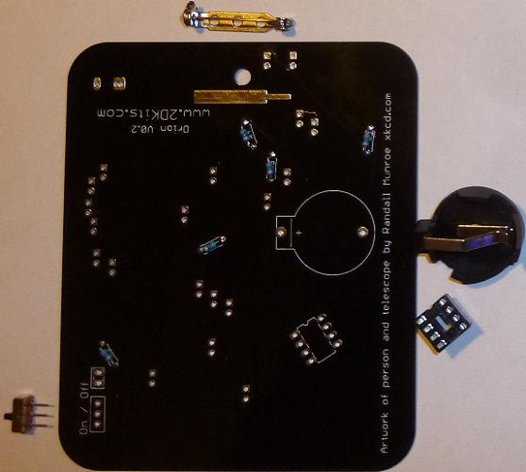

- Insert each LED into the board from the front side. Orientation (how the LED is inserted into the two holes) is important for LEDs. Remember: Short lead, square pad. Long lead, round pad. There are a total of sixteen 3mm LEDs to insert and solder. Remember to trim the leads only after soldering them. Flip the board over and solder the leads. Flip the board back over. | 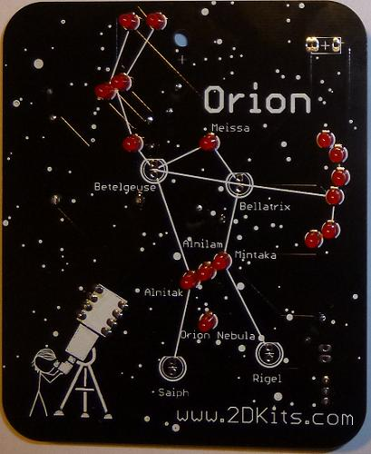

- Insert each LED into the board from the front side. Orientation (how the LED is inserted into the two holes) is important for LEDs. Remember: Short lead, square pad. Long lead, round pad. There are a total of four 5mm LEDs to insert and solder. Remember to trim the leads only after soldering them. Flip the board over and solder the leads. Flip the board back over.  - Insert the push button. It will snap into the two outmost pins. It is a tight fit, so some wiggling to get it to snap in properly may be necessary. Flip the board over and solder the leads. | 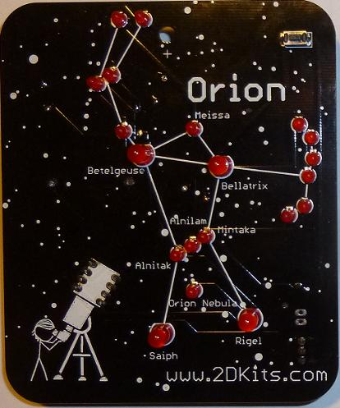

- Trim the excess leads (wire) with the cutters. Hold your finger over the ends of each lead to keep it from flying off when cut.

- Although the leads are short on the socket, push button, power switch, and dual battery holder, you may want to trim them flush with the board.

- Verify the power switch is in the off position. Insert the batteries. The plus “+” faces up. The batteries need to be angled in. The battery will slide under the right side twin terminals, and snap into place on the left. Repeat with the other battery holder.  - The PIC chip is inserted so the dot or notch is facing toward the top of the circuit board.  - Turn the power on and enjoy. | 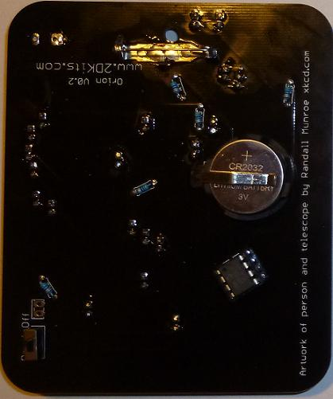

Troubleshooting

If one or more of the LEDs don’t flash, then you’ll need to do a little troubleshooting to finish your project. The following steps should isolate most problems.

- Recheck your solder connections. 80% of all problems are traced to this. Cold solder joints and broken joints will cause erratic performance or failure. Reheat any questionable solder connections until they flow and look shiny and secure.
- Check for bits of solder, wire ends, or other foreign matter which may be lodged in the wiring.
- LEDs were reversed.
- Batteries incorrectly inserted. The “+” side of the battery should always be inserted facing up.
- Bad part – it does happen. In the hundreds of boards assembled, we’ve seen two or three parts fail. Send us email, and we will send a replacement part.
- A part got lost/melted/damaged/destroyed while building the kit. It happens – you’re not the first (or second, or fiftieth). Let us know, and we’ll see what we can do.

