NIU STEMfest Blinkie

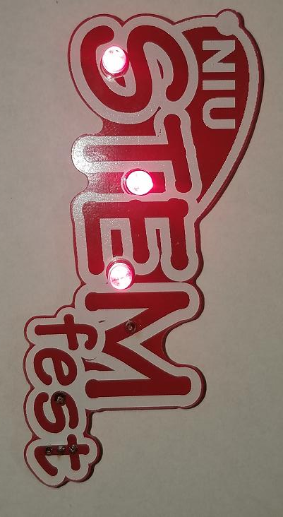

The heart of this blinkie is a tiny chip embedded in each of the three LEDs. When power is applied, the chip tells the LED to turn on and off.

By building this blinkie, we hope you have a lot of fun, as well as learn how easy it is to assemble and solder a circuit, and gain a desire to learn more!

First, open up the kit and review the contents. Looking from left to right, and top to bottom there should be the following parts:  Contents:  - Red NIU STEMfest circuit board  - Three LEDs  - CR2032 battery  - Battery holder  - Pin Back  - Power switch | 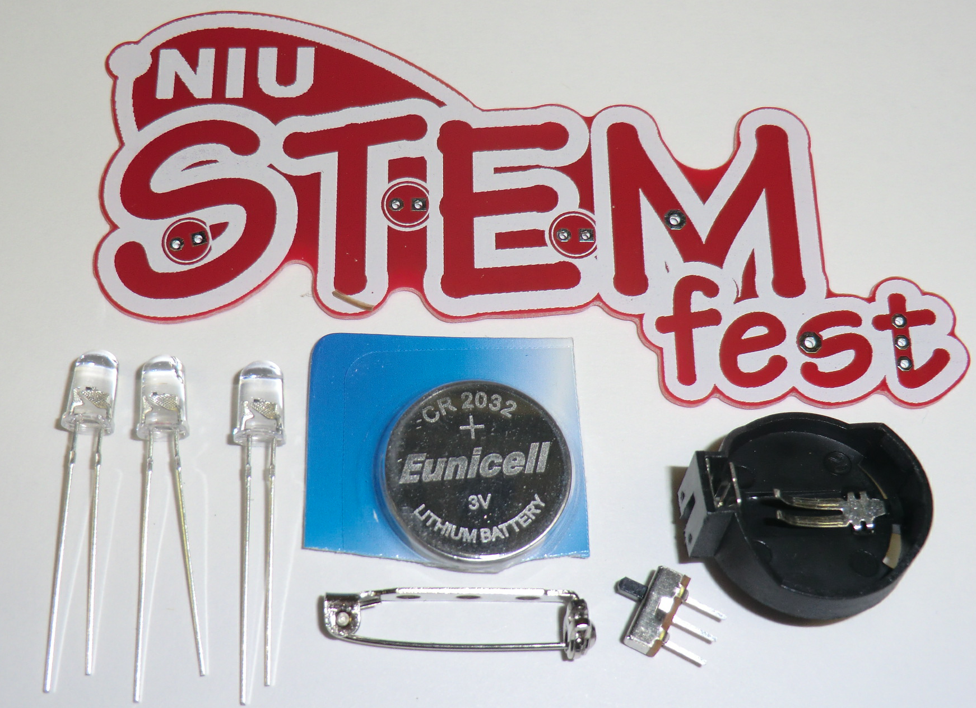
Got everything to start? If not, give us a shout.

Soldering Hints

Soldering is not like gluing: Both the “pad” (shiny circle or square on the circuit board) and the component (wire coming up through the hole) must be hot enough so the solder flows around them, making an electrical connection.

For the purposes of learning how to solder, you do not need to be perfect. With a little bit of practice, your soldering skills will rapidly improve. The goal is to have fun while learning, and your skill will develop as you have fun. Happy soldering!

Here’s how to make a good joint:
- Prepare the joint. Bend the component lead slightly after it passes through the printed circuit board (this helps hold it in place while soldering). Ex: Bend LED leads into a “V”.
- Prepare the tool. The soldering iron should be up to temperature. Clean the tip by plunging it into the stainless steel in the jar. Melt a little solder (a 2mm length) onto the tip so it’s shiny. This is called “tinning”. The solder coating helps conduct heat from the tip to the joint. If the iron doesn't get shiny, contact a Tech who has special tip cleaner.
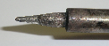
- Place the tip in contact with the component lead AND the printed circuit board pad.
- Place the solder against the joint directly opposite the tip. It should melt within 2 seconds, and flow around the joint. If it takes longer than that, you’re not getting enough heat into the joint. Use only a TINY bit of solder.
- Keep the soldering iron in place until the solder flows freely and completely covers the joint. If the heat is removed too soon, the solder will tend to “ball up” and not stick well to the conductors. The solder joint should look "wetted”, with concave shapes.
- Let the joint cool without movement at room temperature. This usually takes only a few seconds.
- If a joint is moved before it cools, it will take on a dull, satin look that is characteristic of a cold solder joint. A cold solder joint is fragile and conducts poorly – reheat the joint until the solder flows freely, and hold it still until it cools.
- Keep the tip of the soldering iron clean. Push it into and pull it out of the tip cleaner jar several times until it is shiny.

Assembly

Take a look at the completed picture on the first page. The only components that will be visible on the front are the LEDs. The pin-back is soldered to the back. The power switch and battery holder are placed on the back, and soldered on the front.

- Solder the pin-back.  - Find the stripe on the back of the circuit board where the pin-back will be soldered.  - Use a clothespin to hold the pin-back over the stripe. The clothespin comes from the OPPOSITE EDGE of the circuit board from the pin back, NOT the closest edge.  - Center the clothespin so the two outer holes show up in the pin-back.  - Hold the soldering iron tip in one of the holes, so it heats both the pin and the stripe.  - After about 5-10 seconds, feed a little solder into the hole near the tip. Take the iron away, and heat and solder the hole on the other side of the clothespin. | 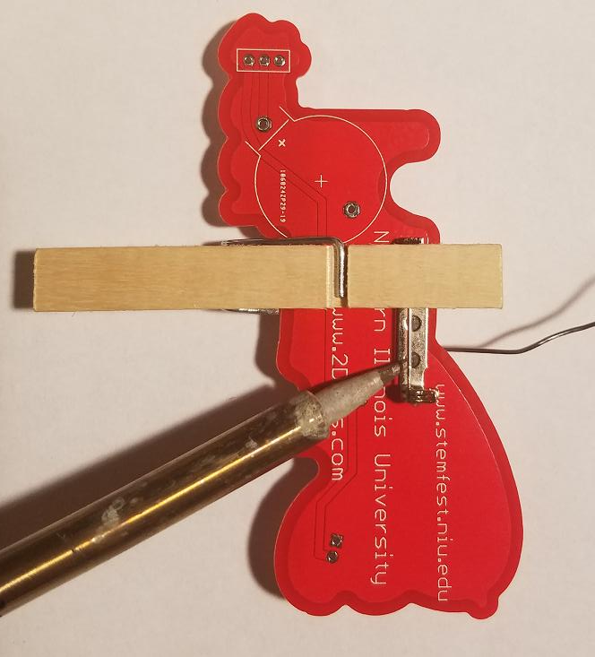

- Insert the power switch from the back. A printed black rectangle shows where it goes. The DIRECTION of the switch doesn't matter.  - Flip the board over to the STEMfest side.  - Solder ONE WIRE of the power switch using just a LITTLE BIT of solder.  - Look to see if the switch is straight – if not, you can use the soldering iron tip to heat the connection you just made, and straighten up the switch, then pull the iron back.  - Now solder the other two switch wires. | 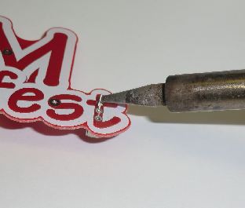

- Flip the board over to the back, and insert the battery holder.  - Orientation is important for the battery holder. Make sure the battery holder matches the black printed outline. Notice one end is round, the other square.  - Use the clothespin to hold the battery holder to the circuit board.  - Flip the board over to the STEMfest side. Solder each of the battery holder wires to the circuit board. | 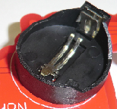

- Solder the battery holder.  - Flip the board over to the STEMfest side. Solder each of the battery holder wires to the circuit board. | 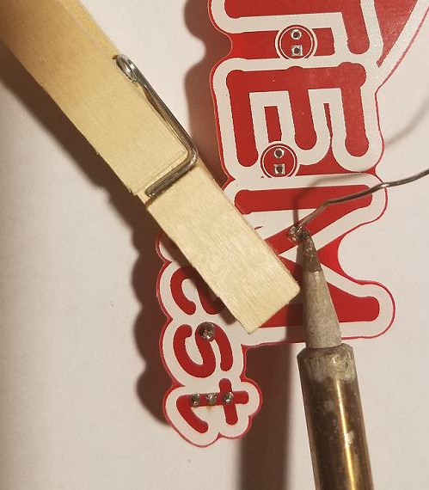

- Insert the battery. The plus sign “+” will face up.  - Angle it into the battery holder on the left side first, and then press down. It will snap in place.  - Verify the power switch is ON.  - In the next few steps, the LEDs will be inserted and tested before they are soldered into the board. | 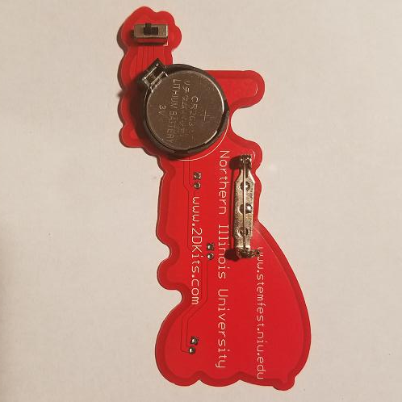

- Insert each LED into the board from the STEMfest side. You will see a printed black circle outline on the board. Orientation is important for LEDs.  - Insert the Long wire through the round pad.  - Then insert the Short wire through the square pad.  - Spread the wires out into a “V” to hold them in. | 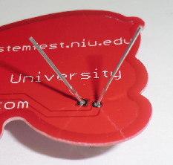

- Check the first LED. Does it blink?  - You may need to gently wiggle so it makes contact. If it blinks, great – move to the next step.  - If not, try reversing the LED wires. If that still doesn’t work, call a Tech over to help.  - Check the second LED. Does it blink? Check the third LED. Does it blink?  - Take this time to confirm the LEDs were inserted from the correct side.  - Turn the power switch off. If the LEDS blink in the “off” position, have a Blinkie Tech fix that problem – YOU did NOT do anything wrong.  - Flip the board over and solder the LEDs. | 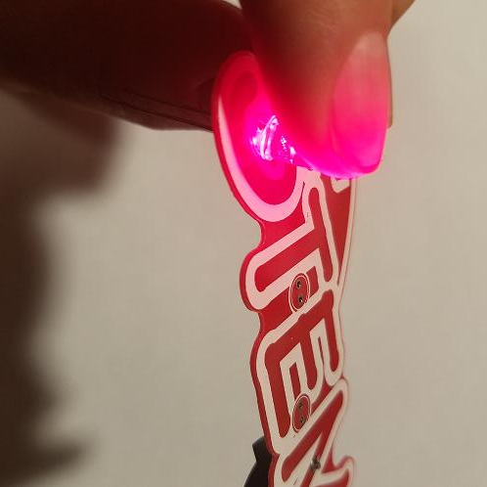

- Trim the excess leads (wire) with the cutters. Hold your finger over the ends of each lead to keep it from flying off when cut.  - You may also want to trim the leads on the front of the board from power switch and battery holder.  - Turn on the board! Enjoy.  - If you plan to use it a lot, NOW is the time to buy EXTRA BATTERIES, they are very cheap AT THE SHOW, compared to local retail stores. | 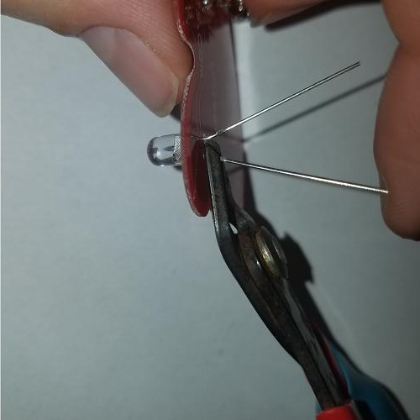

Troubleshooting

If the LEDs don’t flash, then you’ll need to do a little troubleshooting to finish your project. The following steps should isolate most problems.

Check for, and if found, remove solder bridges. What’s a solder bridge? Excess solder making an unexpected connection on the board, such that the power flows through the bridge, instead of the component.  If you make a bridge, it is easy to fix. You can often just reheat and pull the tip of the soldering iron through the bridge, breaking it. Or, reheat all the solder and *gently* tap to the board on edge to shake off the excess. Beyond that, we are more than happy to demonstrate various techniques. | 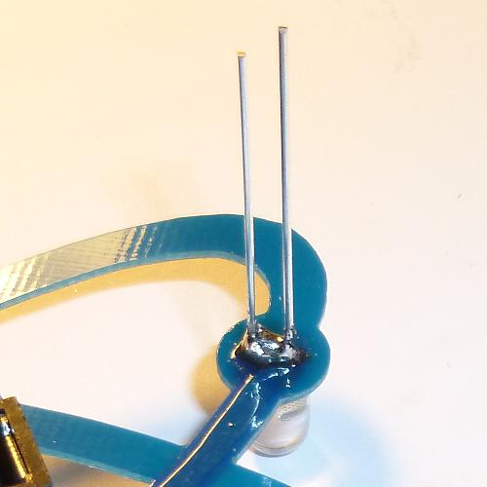
 | A bridge between the two leads of the LED. Current will flow through the bridge, and not the LED, thus the LED will not light up. Fortunately, this is easy to fix.

- Recheck your solder connections. 80% of all problems are traced to this. Cold solder joints and broken joints will cause erratic performance or failure. Reheat any questionable solder connections until they flow and look shiny and secure.
- Check for bits of solder, wire ends, or other foreign matter which may be lodged in the wiring.
- LEDs reversed. You will need to remove the LED by desoldering, and then solder it in the correct way. Ask a Tech to do this for you.
- The battery is incorrectly inserted. The “+” side of the battery should always be inserted facing up.
- Bad part – it does happen. In over a thousand boards assembled, we’ve seen two or three parts fail. Send us email, and we will send a replacement part.
- A part got lost/melted/damaged/destroyed while building the kit. It happens – you’re not the first (or second, or fiftieth). If you are doing this at a convention, seminar, or class, just let us know. Otherwise, send us email, and we’ll see what we can do. We have no problem selling just the parts you need to get it working.
Use

Once built, the use of this blinkie is fairly straightforward. Don’t get it wet. Don’t stick it in a pocket with a bunch of coins or metal where it might short out. Don't set it on a metal table top or in a metal dish, etc. To prevent it shorting out, you may want to keep it in the bag it came in.

ENJOY!!!

