3x3 Matrix Blinkie

The heart of this blinkie is a 16F688 PIC produced by a company called Microchip. A PIC is a tiny, yet surprisingly powerful little computer. By itself, it can’t do much – it needs someway to interact with the world – we are going to do this by giving it senses:  - Sight – an IR receiver  - Touch – five push buttons  and ways to communicate:  - To us – 9 light emitting diodes (LEDs)  - To other blinkies – an infrared (IR) LED  By building this blinkie, we hope you have a lot of fun, as well as learn how easy it is to assemble and solder a circuit, as well as gain a desire to learn more! | 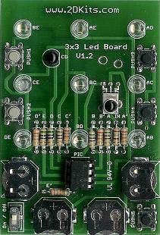

First, open up the kit and review the contents. Looking from left to right, and top to bottom there should be the following parts:

Contents:  - 4 batteries  - IR LED and nine LEDs  - Five 27K ohm resistors  - One 100 ohm resistor  - Five 56 ohm resistors  - IR receiver  - Power switch  - Five push buttons  - 8 pin socket  - 12F683 PIC  The board itself will have the battery clips and fastening pin already soldered. | 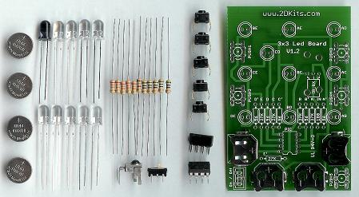

Got everything to start? If not, give us a shout. Also, since we pre-solder the battery clips, sometimes the switches or the IR detector gets hidden under the battery clips.
Soldering Hints

Soldering is not like gluing; the solder forms an alloy with the metals to be connected that creates a stable electrical path and a certain amount of mechanical attachment. For the small connections on this project, a 25 or 30 watt soldering iron works well. Rosin core solder is used – the acid core solder sold for plumbing would eat your components in a short time.

Here’s how to make a good joint:
- Prepare the joint. Bend the component lead slightly after it passes through the printed circuit board (this helps hold it in place while soldering).
- Prepare the tool. The soldering iron should be up to temperature. Clean the tip by quickly brushing it against a damp sponge or cloth. Melt a little solder (a 2mm length) onto the tip so it’s shiny. This is called “tinning”. The solder coating helps conduct heat from the tip to the joint.
- Place the tip in contact with the component lead and the printed circuit board pad.
- Place the solder against the joint directly opposite the tool. It should melt within 2 seconds, and flow around the joint. If it takes longer than that, you’re not getting enough heat into the joint.
- Keep the soldering iron in place until the solder flows freely and completely covers the joint. If the heat is removed too soon, the solder will tend to “ball up” and not stick well to the conductors. The solder joint should look "wetted”, with concave shapes.
- Let the joint cool without movement at room temperature. This usually takes only a few seconds.
- If a joint is moved before it cools, it will take on a dull, satin look that is characteristic of a cold solder joint. A cold solder joint is fragile and conducts poorly – reheat the joint until the solder flows freely, and hold it still until it cools.
- Keep the tip of the soldering iron clean. Wipe off flux and excess solder regularly in the damp sponge or cloth, and re-tin if needed.

Use

Once built, the use of this blinkie is fairly straightforward. Don’t get it wet. Don’t stick it in a pocket with a bunch of change where it might short out.

This blinkie has additional patterns stored in the PIC. To change patterns, press and hold the button labeled PUSH3 or PUSH4. The topmost LED will light, and then the LEDs will count up or down depending on which button is held, in a binary sequence. Each binary number represents a stored pattern. If the push button is released, the pattern associated with that particular binary number will then be displayed on your badge blinkie.

This blinkie will also broadcast its current pattern via the IR LED. If another blinkie with an IR detector sees this, it will change its pattern to match. Of course, this can also happen to this blinkie – another blinkie may “infect” its pattern on this one before it can do the same.

On to the assembly….
Assembly

First, orient the board horizontally and so the silk screening shows. If you see lots of little white letters, symbols, and the battery clips are on the bottom, you are ready to begin.

As each group of parts is inserted, you will flip the board over and solder them in from the non-printed side.

- Solder each push button into the board. On the board, they are labeled PUSH1, PUSH2, PUSH3, PUSH4, and PUSH5. They will only fit in one way.  - Solder the power switch into the board. It will only fit in one way.  - Solder the 14 pin socket into the board. The socket has a small notch in it. The notch should face the bottom of the board. | 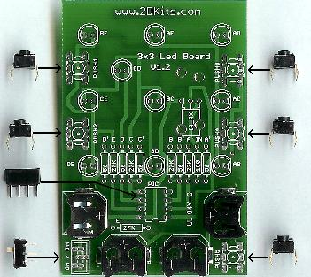

Now to solder in the resistors. There are three types:  - 27K ohm (red, purple, orange)  - 100 ohm (brown, black, brown)  - 56 ohm (green, blue, black).  The order in which they are arranged is important. Starting from left and moving right:  - Solder in a 27K ohm in the lower left position.  - Solder in a 27K ohm, three 56 ohm, and a 27K ohm in the left-hand set of positions.  - Solder in a 56 ohm, a 27K ohm, a 56 ohm, a 100 ohm, and a 27K ohm in the right-hand set of positions. | 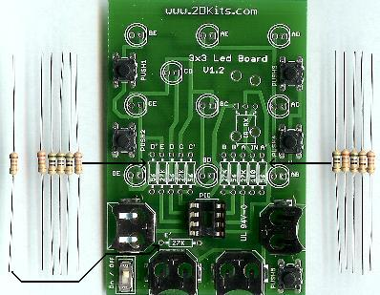

- Solder in the IR detector. On the board, it is labeled IR_RX.  - Solder in the IR LED. Orientation is important for LEDs. Remember: Short lead, square pad. Long lead, round pad. On the board, it is labeled CD.  - Now for the LEDs. Orientation is important for LEDs. Remember: Short lead, square pad. Long lead, round pad. On the board, they are labeled BE, AE, AD, CE, BC, AC, DE, BD, and AB. | 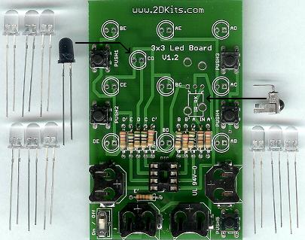

- Before installing the batteries and PIC chip, check all solder connections, and also make sure there are no solder bridges. If everything looks good, move onto the next step.

- The PIC chip is inserted so the dot or notch is facing the bottom of the board.

- The batteries are inserted so the “+” on the battery is facing up.

- Turn on the board! Enjoy.

Troubleshooting

If your blinkie doesn’t flash, then you’ll need to do a little troubleshooting to finish your project. The following steps should isolate most problems.

- Recheck your solder connections. 80% of all problems are traced to this. Cold solder joints and broken joints will cause erratic performance or failure. Reheat any questionable solder connections until they flow and look shiny and secure.
- Check for bits of solder, wire ends, or other foreign matter which may be lodged in the wiring.
- Batteries incorrectly inserted. The “+” side of the battery should always be inserted facing up.
- PIC chip inserted backwards. The notch which represents pin 1 should be to your left.
- Bad part – it does happen. In the hundreds of boards assembled, we’ve seen the rare part fail.

