6 LED Blinkie

The heart of this blinkie is a 16F683 PIC produced by a company called Microchip. A PIC is a tiny, yet surprisingly powerful little computer. By itself, it can’t do much – it needs someway to interact with the world – we are going to do this by giving it senses:  - Sight – an IR receiver  and ways to communicate:  - To us – 6 light emitting diodes (LEDs)  - To other blinkies – an infrared (IR) LED  By building this blinkie, we hope you have a lot of fun, as well as learn how easy it is to assemble and solder a circuit, as well as gain a desire to learn more! | 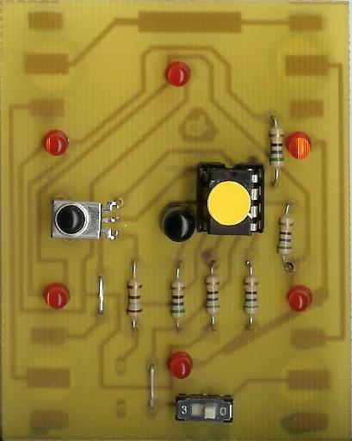

First, open up the kit and review the contents. Looking from left to right, and top to bottom there should be the following parts:

Contents:  - Five 56 ohm resistors  - 100 or 180 ohm resistor  - Six LEDs  - IR LED  - Fastening pin  - Power switch  - IR detector  - 8 pin socket  The board itself will have the battery clips and (possibly) the fastening pin already soldered. | 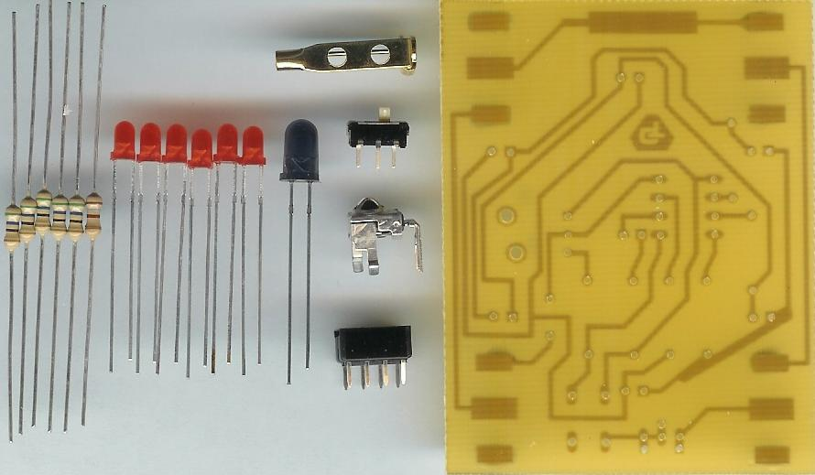

Got everything to start? If not, give us a shout. Also, since we pre-solder the battery clips, sometimes the switch or the IR detector gets hidden under the battery clips.
Assembly

First, orient the board with the foil (trace) side down and the holes for the switch along the bottom.

- Solder the IR detector into the board.  - Solder the 8 pin socket into the board. The socket has a small notch in it. The notch should face the top of the board.  - Solder the power switch into the board. | 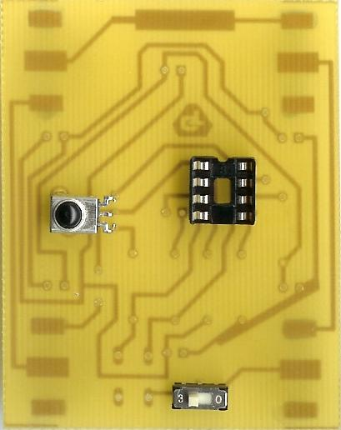

- Solder in the 100 (or 180) ohm resistor. There is only one. It is the leftmost resistor on the board.  - Solder in each of the five 56 ohm resistors into the board.  - Clip the excess wire from the resistors after they have been soldered. This will be used for jumper wire.  - Solder the first jumper wire immediately to the left of the left most (100 ohm) resistor.  - Solder the second jumper wire immediately to the left of the power switch. | 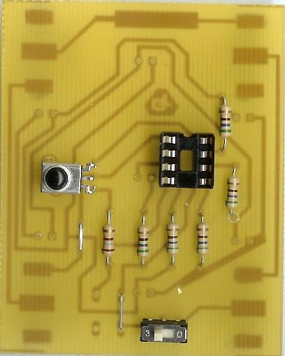

Now to solder in the LEDs.  - Solder the IR LED into the board – the long lead will go to the left hole, the short lead to the right hole.  - Solder the LEDs into the board. The long lead will go the left hole, the short lead to the right hole. | 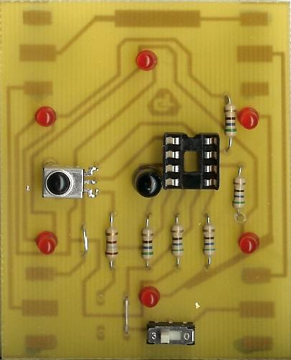

- Before installing the batteries and PIC chip, check all solder connections, and also make sure there are no solder bridges. If everything looks good, move onto the next step.

- The PIC chip is inserted so the dot or notch is facing the top of the board.

- The batteries are inserted so the “+” on the battery is facing up.

- Turn on the board! Enjoy.

Troubleshooting

If your blinkie doesn’t flash, then you’ll need to do a little troubleshooting to finish your project. The following steps should isolate most problems.

- Recheck your solder connections. 80% of all problems are traced to this. Cold solder joints and broken joints will cause erratic performance or failure. Reheat any questionable solder connections until they flow and look shiny and secure.
- Check for bits of solder, wire ends, or other foreign matter which may be lodged in the wiring.
- Batteries incorrectly inserted. The “+” side of the battery should always be inserted facing up.
- PIC chip inserted backwards. The notch which represents pin 1 should be toward the top of the board.
- Bad part – it does happen. In the hundreds of boards assembled, we’ve seen a few power switches fail and one bad PIC chip.

Soldering Hints

Soldering is not like gluing; the solder forms an alloy with the metals to be connected that creates a stable electrical path and a certain amount of mechanical attachment. For the small connections on this project, a 25 or 30 watt soldering iron works well. Rosin core solder is used – the acid core solder sold for plumbing would eat your components in a short time.

Here’s how to make a good joint:
- Prepare the joint. Bend the component lead slightly after it passes through the printed circuit board (this helps hold it in place while soldering).
- Prepare the tool. The soldering iron should be up to temperature. Clean the tip by quickly brushing it against a damp sponge or cloth. Melt a little solder (a 2mm length) onto the tip so it’s shiny. This is called “tinning”. The solder coating helps conduct heat from the tip to the joint.
- Place the tip in contact with the component lead and the printed circuit board pad.
- Place the solder against the joint directly opposite the tool. It should melt within 2 seconds, and flow around the joint. If it takes longer than that, you’re not getting enough heat into the joint.
- Keep the soldering iron in place until the solder flows freely and completely covers the joint. If the heat is removed too soon, the solder will tend to “ball up” and not stick well to the conductors. The solder joint should look "wetted”, with concave shapes.
- Let the joint cool without movement at room temperature. This usually takes only a few seconds.
- If a joint is moved before it cools, it will take on a dull, satin look that is characteristic of a cold solder joint. A cold solder joint is fragile and conducts poorly – reheat the joint until the solder flows freely, and hold it still until it cools.
- Keep the tip of the soldering iron clean. Wipe off flux and excess solder regularly in the damp sponge or cloth, and re-tin if needed.

