General Technics

Workshop Series

The Blinkie

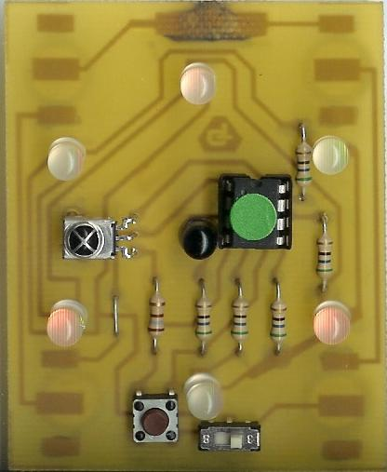

Circuit #6b
Table of Contents

Introduction
Parts List
Assembly Procedure
Troubleshooting
Soldering Hints
How It Works

Copyright 2005 General Technics
The Blinkie

The heart of this circuit is a 12F683 PIC produced by a company called Microchip. A PIC is a tiny, yet surprisingly powerful little computer. By itself, it can’t do much – it needs someway to interact with the world – we are going to do this by giving it senses:

- Sight – an IR receiver
- Touch – a push button

and ways to communicate:

- To us – six light emitting diodes (LEDs)
- To other PICs – an infrared (IR) LED

By building this blinkie, we hope you have a lot of fun, as well as learn how easy it is to assemble and solder a circuit, as well as gain a desire to learn more!

Parts List
1 – 12F683 PIC chip | 1 – 100Ω resistor
6 – Bi-color LEDs | 5 – 56Ω resistors
1 – Infrared (IR) detector | 1 – push button
1 – IR LED | 4 – 1.5V button batteries
1 – 8 pin socket | 1 – length of solder
1 – sliding power switch | 1 – board w/battery clips
 | 1 – this instruction book

Assembly Procedure

Refer to Figures 1 – 6 for the following steps.

- Orient the circuit board with the foil (trace) side down and the holes for the switch along the bottom.
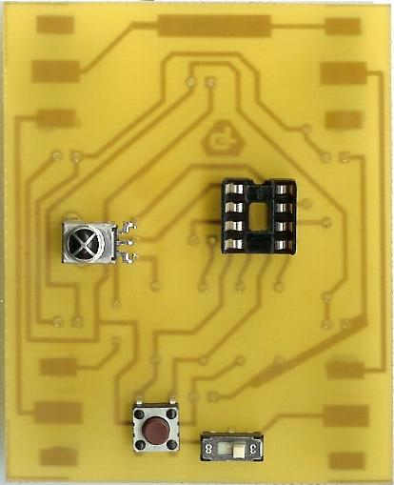

Figure 1

- Mount the IC socket in the 8 holes near the top of the board, as shown in Figure 1, with the notch pointing toward the top of the board.
- Mount the IR detector to the left of the IC socket, as shown in Figure 1.
- Mount the push button on the lower part of the board, just left of center, as shown in Figure 1. It will be a tight fit.
- Mount the switch on the lower part of the board, just right of center, as shown in Figure 1. You may need to bend the pins out slightly on the back of the board so the switch doesn’t fall out when you flip the board over for soldering.
- Flip the board over and solder all the leads to the circuit board pads. Clip off the excess leads after soldering.
- Flip the board back to the component side.
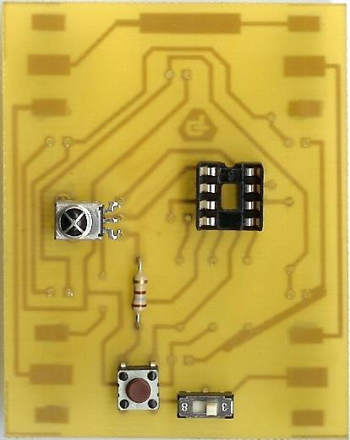

Figure 2

Figure 3

- Mount the 100Ω resistor in the 2 holes directly above the push button, as shown in Figure 2. Bend the leads slightly to hold the resistor in place, as shown in Figure 3.
- Flip the board over and solder all the leads to the circuit board pads. Clip off the excess leads after soldering.
- Save one of the leads clipped from the resistor. This will be used as a jumper.
- Flip the board back to the component side.
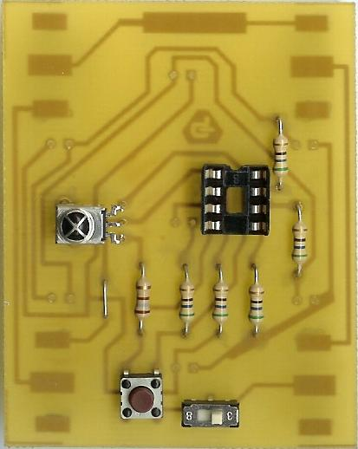
Figure 4

- Mount the five 56Ω resistors. Mount three of them in the set of holes to the right of the 100Ω resistor, and the remaining two in the set of holes to the upper right of the socket, as shown in Figure 4.
- Remember the clipped lead you saved as a jumper? Insert it to the in the 2 holes to the left of the 100Ω resistor. Bend the leads slightly to hold the resistors in place as well as the jumper, as shown in Figure 3.
- Flip the board over and solder all the leads to the circuit board pads. Clip off the excess leads after soldering.
- Flip the board back to the component side.
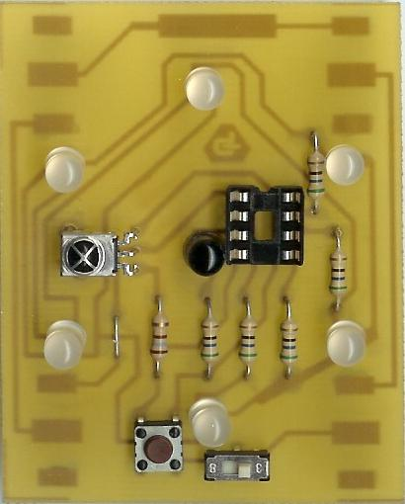
Figure 5

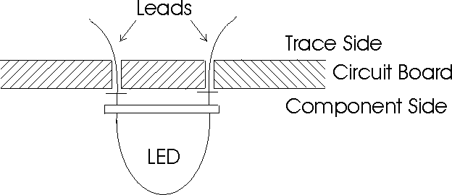
Figure 6
- Insert the bi-bolor LEDs and the IR LED, as shown in Figure 5. As you insert them, the longer lead will go to the left side of the board. Bend the leads slightly to hold the LED’s in place, as shown in Figure 6.
- Flip the board over and solder all the leads to the circuit board pads. Clip off the excess leads after soldering.
- Place the pin-back clip on the large circuit board pad at the top of the board and solder in place.
- Flip the board back to the component side and install the PIC chip. Pin one goes to the upper left corner of the socket.
- Install the four button cell batteries in the battery holders. The positive side (+) of the batteries face up.
- Turn on the switch and watch your blinkie go!

Troubleshooting

If your blinkie doesn’t flash, then you’ll need to do a little troubleshooting to finish your project. The following steps should isolate most problems.

- Recheck your solder connections. Cold solder joints and broken joints will cause erratic performance or failure. Reheat any questionable solder connections until they flow and look shiny and secure.
- Check the values and orientation of your parts. A reversed LED won’t light, and a reversed PIC will not work at all. (Resistors do not have polarity.)
- Check for bits of solder, wire ends, or other foreign matter which may be lodged in the wiring.

Soldering Hints

Soldering is not like gluing; the solder forms an alloy with the metals to be connected that creates a stable electrical path and a certain amount of mechanical attachment. For the small connections we will be doing on this project, we will be using a 25 or 30 watt soldering iron works well. We will be using rosin core solder – the acid core solder sold for plumbing would eat your components in a short time.

Here’s how to make a good joint:
- Prepare the joint. Bend the component lead slightly after it passes through the printed circuit board (this helps hold it in place while soldering).
- Prepare the tool. The soldering iron should be up to temperature. Clean the tip by quickly brushing it against a damp sponge or cloth. Melt a little solder (a 2mm length) onto the tip so it’s shiny. This is called “tinning”. The solder coating helps conduct heat from the tip to the joint.
- Place the tip in contact with the component lead and the printed circuit board pad.
- Place the solder against the joint directly opposite the tool. It should melt within 2 seconds, and flow around the joint. If it takes longer than that, you’re not getting enough heat into the joint.
- Keep the soldering iron in place until the solder flows freely and completely covers the joint. If the heat is removed too soon, the solder will tend to “ball up” and not stick well to the conductors. The solder joint should look "wetted”, with concave shapes.
- Let the joint cool without movement at room temperature. This usually takes only a few seconds.
- If a joint is moved before it cools, it will take on a dull, satin look that is characteristic of a cold solder joint. A cold solder joint is fragile and conducts poorly – reheat the joint until the solder flows freely, and hold it still until it cools.
- Keep the tip of the soldering iron clean. Wipe off flux and excess solder regularly in the damp sponge or cloth, and re-tin if needed.

How It Works

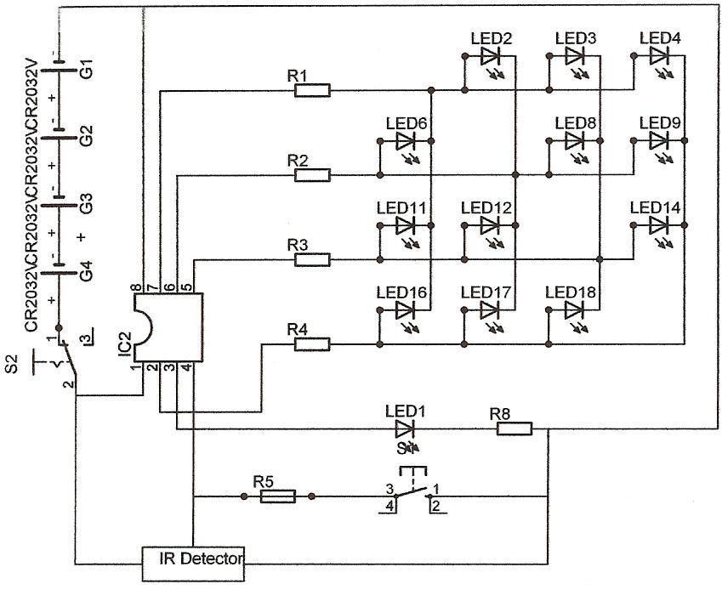
Blinkie Circuit Diagram

The PIC chip runs a program that outputs a bit pattern to the I/O pins. There is a short delay after each pattern is sent, before the next one is sent. These patterns give the illusion that the light is chasing itself around a circle. The PIC chip includes a built-in RC (resistor/capacitor) oscillator circuit that provides clock timing for the microprocessor.

The PIC chip is programmed using PIC assembler (an assembler type programming language). The program is burned into the FLASH memory on the chip. The IR receiver picks up IR (infra-red) signals from other blinkies, which causes the PIC to change the blink pattern/rate.
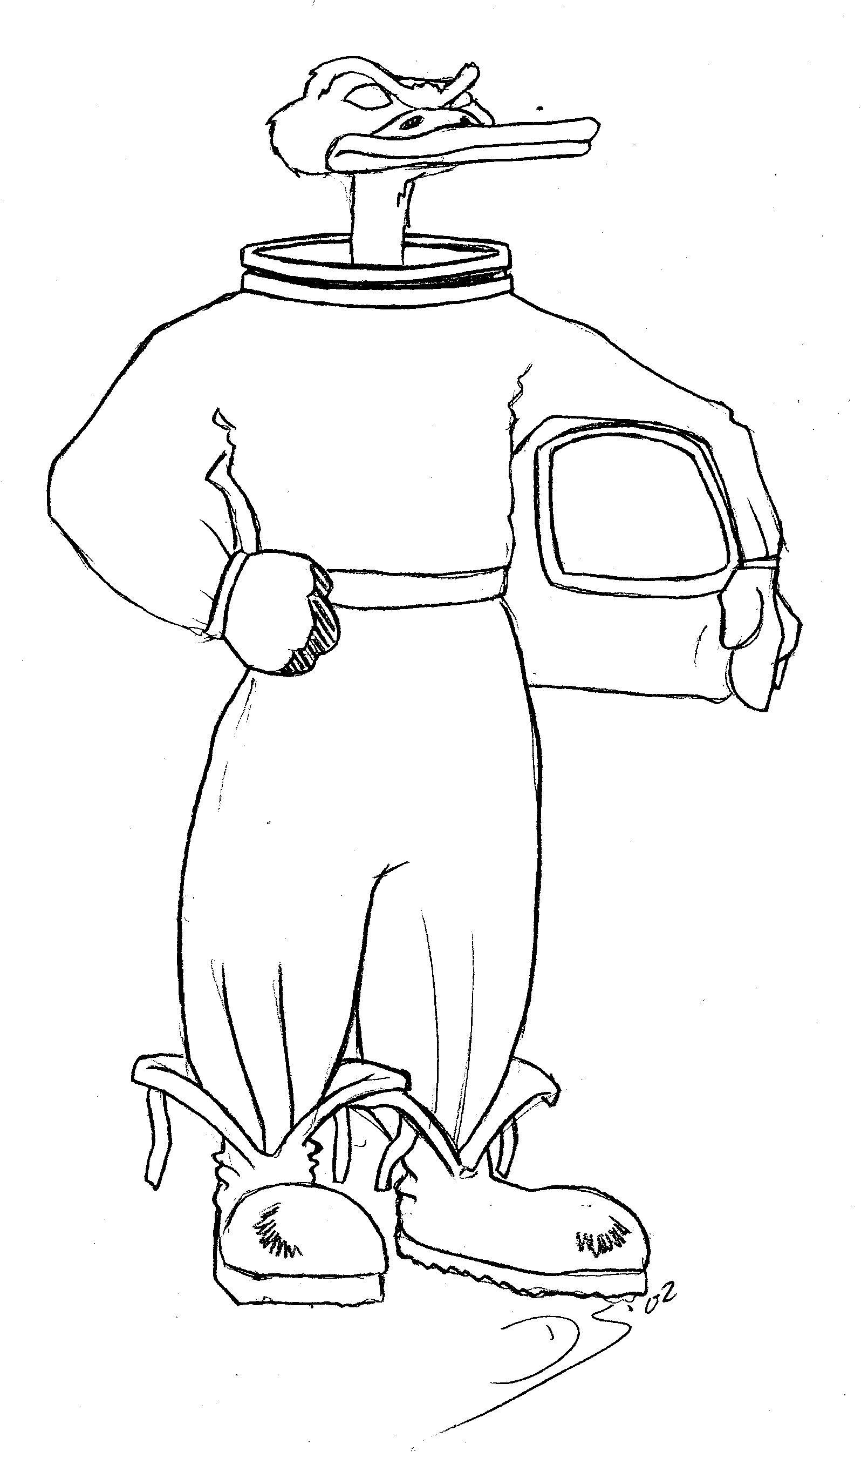


General Technics is an amateur Science and Technology club. Based in the Midwest, many members of GT are alumni of Michigan Technological University, and now hold positions in technical and academic institutions around the country. We meet at a number of science fiction conventions – ask any member for more details or come to one of our parties.

We hope you enjoyed this seminar – if you have comments, please email them to blinkie@duckon.org.

The circuit and software for this blinkie was designed by Dwayne Forsyth. The circuit boards were produced by the very talented James Brown. The assembly of the kits was done by Anita Eisenstein, Dwayne Forsyth, Maria Forsyth, Jeff Kalchik, Pete Richardson, Kris Southerland, and Dale Sulak. This pesky manual was updated by Dale Sulak. The Saturday Radiation Duck artwork by Dave Sutherland.

