8x7 Blinkie

The heart of this blinkie is a 16F1454 PIC produced by a company called Microchip. A PIC is a tiny, yet surprisingly powerful little computer. By itself, it can’t do much – it needs someway to interact with the world – we are going to do this by giving it senses:

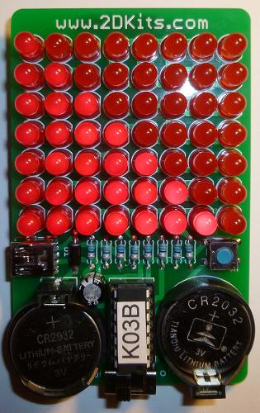 | - From us – a push button  - To us – 56 light emitting diodes (LEDs).  - A USB port, for power as well as communication.  By building this blinkie, we hope you have a lot of fun, as well as learn how easy it is to assemble and solder a circuit, as well as gain a desire to learn more! | 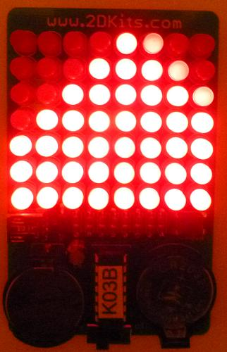

Use

Once built, the use of this blinkie is fairly straightforward. Don’t get it wet. Don’t stick it in a pocket with a bunch of car or house keys where it might short out.

This blinkie has additional patterns stored in the PIC. To change patterns or messages, press the push button and hold. The leftmost LEDs, about halfway up the tree will light, and then the LEDs will count up in a binary sequence. Each sequence represents a stored pattern or message. If the push button is released, the pattern associated with that particular binary number will then be displayed on your blinkie.

The blinkie has two display modes. Demo mode, where it will switch to a different stored pattern every minute, as it cycles through all the stored patterns. If it is in demo mode, when the push button is held down, the 2nd from the left top most LED will be lit. Normal mode, where will continue to display the current pattern until a new pattern is selected via the push buttons. To toggle between the modes, hold down the push button while turning on the power.

Now, on to the assembly…
First, open up the kit and review the contents. Looking from top to bottom, and left to right there should be the following parts:

- Circuit board  - Diode  - Eight 56 ohm resistors (green, blue, black)  - Pinback  - USB port  - Push button  - Power switch  - Capacitor  - Fifty-six LEDs  - Two CR2032 battery holders  - 14 pin socket  - Two CR2032 3V batteries  - 14 pin 16F1454 PIC | 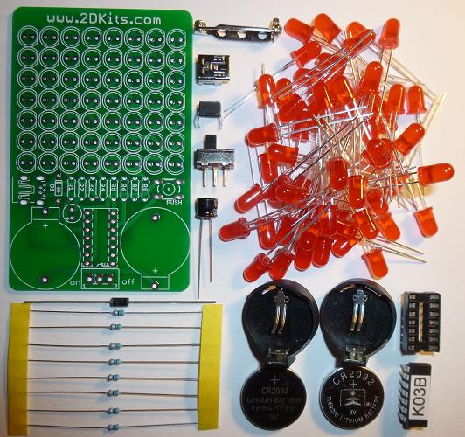

Got everything to start? If not, give us a shout. Next, a few words on soldering…

Soldering Hints

Soldering is not like gluing; the solder forms an alloy with the metals to be connected that creates a stable electrical path and a certain amount of mechanical attachment. For the small connections on this project, a 25 or 30 watt soldering iron works well. Rosin core solder is used – the acid core solder sold for plumbing would eat your components in a short time.

Here’s how to make a good joint:
- Prepare the joint. Bend the component lead slightly after it passes through the printed circuit board (this helps hold it in place while soldering).
- Prepare the tool. The soldering iron should be up to temperature. Clean the tip by quickly brushing it against a dry wire pad, or damp sponge, or damp cloth. Melt a little solder (a 2mm length) onto the tip so it’s shiny. This is called “tinning”. The solder coating helps conduct heat from the tip to the joint.
- Place the tip in contact with the component lead and the printed circuit board pad.
- Place the solder against the joint directly opposite the tool. It should melt within 2 seconds, and flow around the joint. If it takes longer than that, you’re not getting enough heat into the joint.
- Keep the soldering iron in place until the solder flows freely and completely covers the joint. If the heat is removed too soon, the solder will tend to “ball up” and not stick well to the conductors. The solder joint should look "wetted”, with concave shapes.
- Let the joint cool without movement at room temperature. This usually takes only a few seconds.
- If a joint is moved before it cools, it will take on a dull, satin look that is characteristic of a cold solder joint. A cold solder joint is fragile and conducts poorly – reheat the joint until the solder flows freely, and hold it still until it cools.
- Keep the tip of the soldering iron clean. Wipe off flux and excess solder regularly in the damp sponge or cloth, and re-tin if needed.

A suggestion on trimming leads (the excess wire visible after soldering). Hold your finger over the ends of each lead to keep it from flying off when cut. | 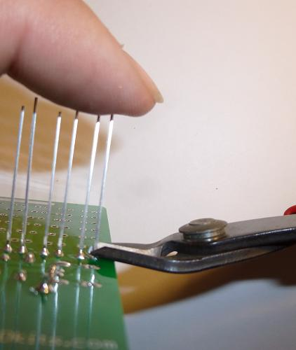

Assembly

Take care when soldering the headers and sockets to the circuit board and make sure you are soldering them from the correct side!

Ready to start? First, orient the board so the www.2DKits.com silk screen printing shows.

- Insert the resistors. To make inserting easier, pre-bend the leads as shown. They should inserted into the locations marked (R1, R2, R3, R4, R5, R6, R7, and R8). Flip the board over and solder. Trim the leads. Remember to trim the leads only after soldering them. Flip the board back.  - Insert the diode. To make inserting easier, pre-bend the leads as shown. Orientation (the direction the diode is inserted) is important. There is a silver band on the diode. It should face toward the top of the board. It will also match the silk screen of the diode on the board. Flip the board over and solder. Trim the leads. Remember to trim the leads only after soldering them. Flip the board back.  - Do not insert or solder the capacitor yet. | 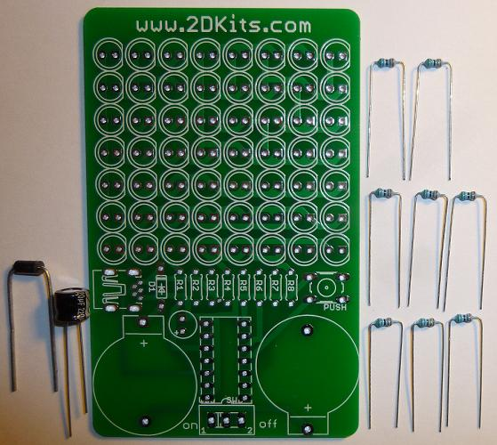

- Assembly tests have shown the USB socket is easier to solder if it is inserted at this step (before the capacitor) as opposed to the next step. Flip the board over and solder. Flip the board back.  - Insert the capacitor. Orientation (the direction the capacitor is inserted) is important. Remember: Short lead, square pad. Long lead, round pad. The negative lead will go toward the top of the board; the negative is marked on the capacitor. Flip the board over and solder. Trim the leads. Remember to trim the leads only after soldering them. Flip the board back.  - Insert the push button. It is a tight fit, so it may need to be wiggled during insertion. Flip the board over and solder. Flip the board back. | 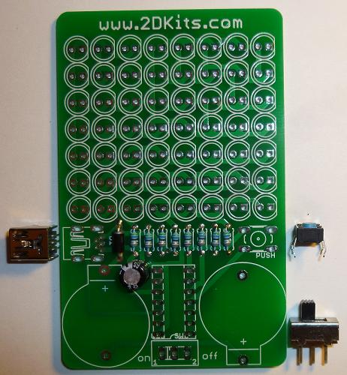

- Insert the power switch. Flip the board over and solder. Flip the board back.  - Insert the 14 pin socket. The socket will be inserted from the side that has the silk screen. Make sure the notch on the socket matches the silk screen outline; the notch will be to the bottom of the board. Flip the board over and solder the leads. | 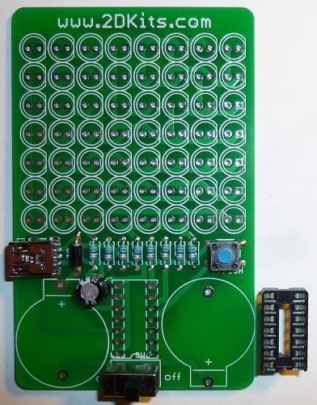

- Insert the battery holders. Orientation (the direction the battery holder is turned) is important. It will match the silk screen outline. The little bump on the side of the battery holder will match the bump by the “+” on the silk screening. | 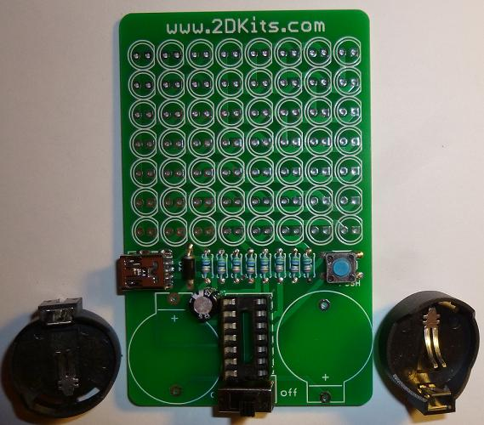

- Flip the board over. Insert each LED into the board. Orientation (how the LED is inserted into the two holes) is important for LEDs. Remember: Short lead, square pad. Long lead, round pad. There are a total of 56 LEDs to insert and solder. It may be easier to insert a row of eight at a time (starting at the bottom), flip the board over, solder them, trim the leads, flip the board over, then insert and solder the next set. Remember to trim the leads only after the LED is soldered in place. | 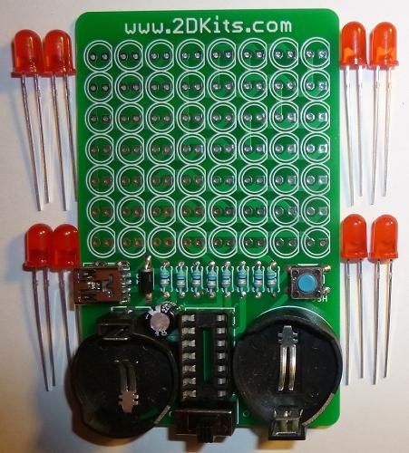

- Place the pinback on the pad at the top of the board. Solder it. It will take a bit longer to heat up this component enough so that the solder will flow.  - Wait two minutes for the part to cool down before proceeding. It does get very hot and needs to cool down to avoid a hot surprise. | 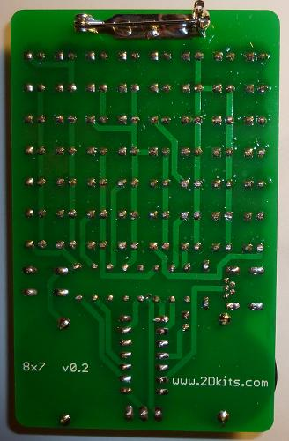

- Trim the excess leads (wire) with the cutters. Hold your finger over the ends of each lead to keep it from flying off when cut.

- You may also want to trim the leads from the power switch and battery holder.

- Verify the power switch is in the off position. Insert the batteries. The plus “+” faces up. The batteries need to be angled in. The battery will slide under the terminal arm, and snap into place. Repeat with the other battery holder.  - The PIC chip is inserted so the dot or notch is facing to the bottom of the board.  - Turn the power on and enjoy. | 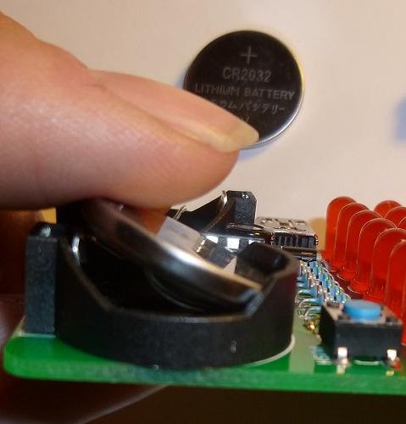

Troubleshooting

If one or more of the LEDs don’t flash, then you’ll need to do a little troubleshooting to finish your project. The following steps should isolate most problems.

- Recheck your solder connections. 80% of all problems are traced to this. Cold solder joints and broken joints will cause erratic performance or failure. Reheat any questionable solder connections until they flow and look shiny and secure.
- Check for bits of solder, wire ends, or other foreign matter which may be lodged in the wiring.
- LEDs were reversed.
- Batteries incorrectly inserted. The “+” side of the battery should always be inserted facing up.
- Bad part – it does happen. In the hundreds of boards assembled, we’ve seen two or three parts fail. Send us email, and we will send a replacement part.
- A part got lost/melted/damaged/destroyed while building the kit. It happens – you’re not the first (or second, or fiftieth). Let us know, and we’ll see what we can do.

