4 LED RGB Blinkie

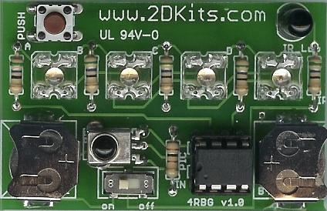  Square RGB LEDs | The heart of this blinkie is a 12F683 PIC produced by a company called Microchip. A PIC is a tiny, yet surprisingly powerful little computer. By itself, it can’t do much – it needs someway to interact with the world – we are going to do this by giving it senses:  - Sight – an IR receiver  and ways to communicate:  - To us – 4 RGB light emitting diodes (LEDs)  - To other blinkies – an infrared (IR) LED | 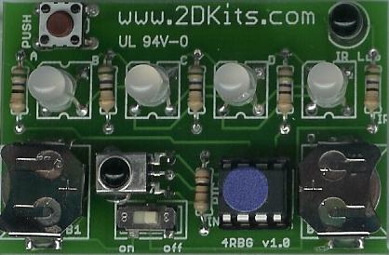  Round RGB LEDs

By building this blinkie, we hope you have a lot of fun, as well as learn how easy it is to assemble and solder a circuit. Plus, cause jealousy in all those who gaze upon your new blinkie!

First, open up the kit and review the contents. Looking from left to right, and top to bottom there should be the following parts:

Contents:  - IR detector  - Push button  - Power switch  - 8 pin socket  - 8 pin PIC chip (not shown)  - IR LED  - Four LEDs (may be square or round)  - Circuit board  - One 100 or 180 ohm resistor  - Five 56 ohm resistors  - 4 batteries (not shown) | 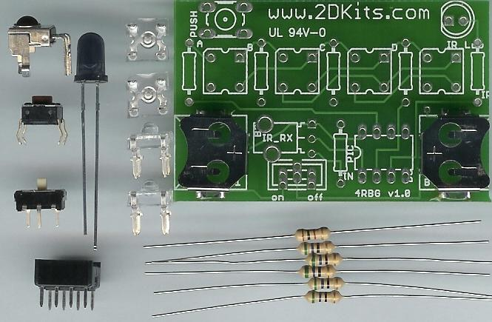

The board itself will have the battery clips and pin-back already soldered. Got everything to start? If not, give us a shout. Also, since we pre-solder the battery clips, sometimes the switch gets hidden under the battery clips.
Soldering Hints

Soldering is not like gluing; the solder forms an alloy with the metals to be connected that creates a stable electrical path and a certain amount of mechanical attachment. For the small connections on this project, a 25 or 30 watt soldering iron works well. Rosin core solder is used – the acid core solder sold for plumbing would eat your components in a short time.

Here’s how to make a good joint:
- Prepare the joint. Bend the component lead slightly after it passes through the printed circuit board (this helps hold it in place while soldering).
- Prepare the tool. The soldering iron should be up to temperature. Clean the tip by quickly brushing it against a damp sponge or cloth. Melt a little solder (a 2mm length) onto the tip so it’s shiny. This is called “tinning”. The solder coating helps conduct heat from the tip to the joint.
- Place the tip in contact with the component lead and the printed circuit board pad.
- Place the solder against the joint directly opposite the tool. It should melt within 2 seconds, and flow around the joint. If it takes longer than that, you’re not getting enough heat into the joint.
- Keep the soldering iron in place until the solder flows freely and completely covers the joint. If the heat is removed too soon, the solder will tend to “ball up” and not stick well to the conductors. The solder joint should look "wetted”, with concave shapes.
- Let the joint cool without movement at room temperature. This usually takes only a few seconds.
- If a joint is moved before it cools, it will take on a dull, satin look that is characteristic of a cold solder joint. A cold solder joint is fragile and conducts poorly – reheat the joint until the solder flows freely, and hold it still until it cools.
- Keep the tip of the soldering iron clean. Wipe off flux and excess solder regularly in the damp sponge or cloth, and re-tin if needed.

Use

Once built, the use of this blinkie is fairly straightforward. Don’t get it wet. Don’t stick it in a pocket with a bunch of change where it might short out.

This blinkie has additional patterns stored in the PIC. To change patterns, press the push button and hold. The first LED will light, and then the LEDs will count up in a binary sequence. Each binary number represents a stored pattern. If the push button is released, the pattern associated with that particular binary number will then be displayed on your badge blinkie.

This blinkie will also broadcast its current pattern via the IR LED. If another blinkie with an IR detector sees this, it will change its pattern to match. Of course, this can also happen to this blinkie – another blinkie may “infect” its pattern on this one before it can do the same.

On to the assembly….
Assembly

As each group of parts is inserted, you will flip the board over and solder them in from the non-printed side.

First, orient the board as. If you see lots of little white letters and symbols, you are ready to begin.  - Solder in the 100 ohm (brown, black, brown) or 180 ohm (brown, grey, brown) resistor. There is only one. It is the bottom-most resistor on the board.  - Solder in each of the five 56 ohm (green, blue, black) resistors into the board.  - Once the resistors have been soldered in, trim off the excess leads. | 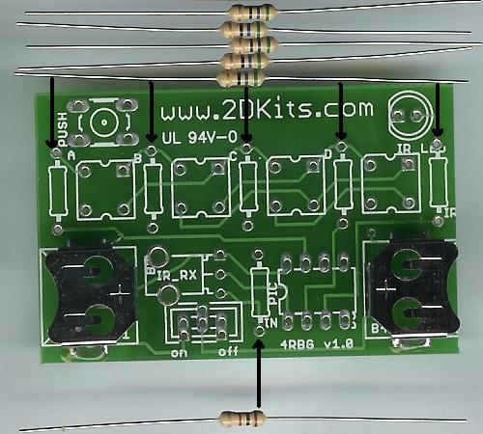

- Solder the push button into the board. It will only fit in one way.  - Solder the IR LED into the board. Orientation is important for LEDs. Remember: Short lead, square pad. Long lead, round pad.  - Solder the IR detector into the board.  - Solder the power switch into the board.  - Solder the 8 pin socket into the board. The socket has a small notch in it. The notch should be to the left. | 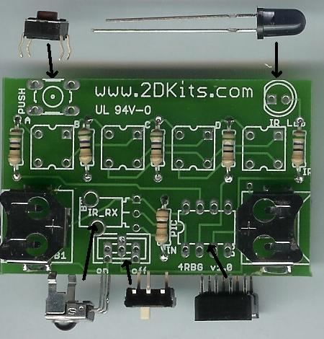

Now to solder in the LEDs. If you kit has square LEDs, continue with the next step. Otherwise, skip to step 11.

- Solder the four LEDs into the board. There are four small squares on the board. Orientation is important for LEDs. There is a small beveled corner on the LED. This goes into the upper left corner – it will also match the white outline on the board for each of the 4 LEDs.  - Skip to step 14. | 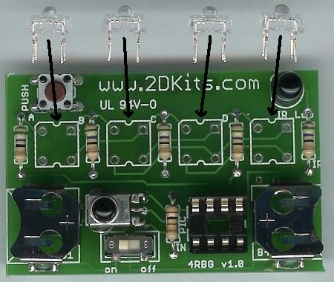
- FOR ROUND LEDS ONLY. Place the LEDs into the board. This board was not originally designed for this type of LED, but they can be used if a bit of care is taken. If you look at the LED, you will see a short lead, a slightly longer lead, a long lead, and then a short lead. The first lead goes in upper left-hand corner, the next lead goes in the lower left-hand corner. The third lead, the longest, goes in the square hole in the upper right hand corner. The fourth lead goes in the lower right-hand corner. | 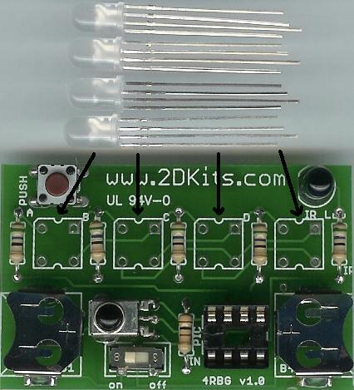

- FOR ROUND LEDS ONLY. Now, slowly rock the LED and press it toward the circuit board. This takes a bit of finesse and care, so take it slow and gently. Stop when the LED is about the height of the push button away from the surface of the board. Any closer and the leads may crush or break.

- FOR ROUND LEDS ONLY. Repeat this process with the remaining three LEDs, and solder them into the board.

- Before installing the batteries and PIC chip, check all solder connections, and also make sure there are no solder bridges. If everything looks good, move onto the next step.

- The PIC chip is inserted so the dot or notch is facing to the left.

- The batteries are inserted so the “+” on the battery is facing up.

- Turn on the board. Enjoy!

Troubleshooting

If your blinkie doesn’t flash, then you’ll need to do a little troubleshooting to finish your project. The following steps should isolate most problems.

- Recheck your solder connections. 80% of all problems are traced to this. Cold solder joints and broken joints will cause erratic performance or failure. Reheat any questionable solder connections until they flow and look shiny and secure.
- Check for bits of solder, wire ends, or other foreign matter which may be lodged in the wiring.
- Batteries incorrectly inserted. The “+” side of the battery should always be inserted facing up.
- PIC chip inserted backwards. The notch which represents pin 1 should be toward the left.
- Bad part – it does happen. In the hundreds of boards assembled, we’ve seen the rare part fail.

