5 RGB Blinkie

The heart of this blinkie is a 12F1822 PIC produced by a company called Microchip. A PIC is a tiny, yet surprisingly powerful little computer. By itself, it can’t do much – it needs someway to interact with the world – we are going to do this by giving it senses:

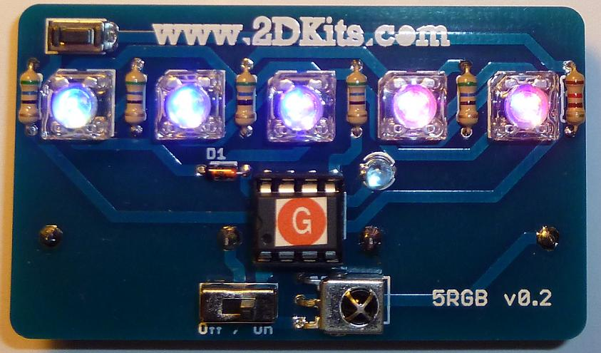  Beginner Skill Level  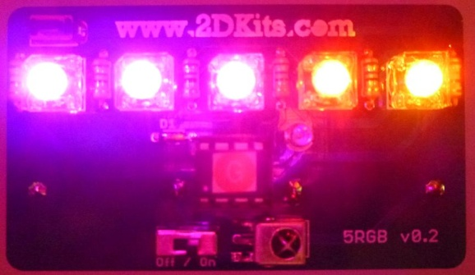 | - Sight – an IR receiver  - Touch – a push button  and ways to communicate:  - To us – 5 light emitting diodes (LEDs)  - To other blinkies – an infrared (IR) LED | 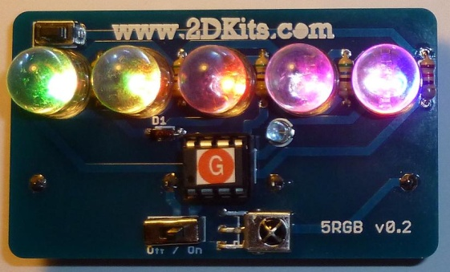  Intermediate Skill Level  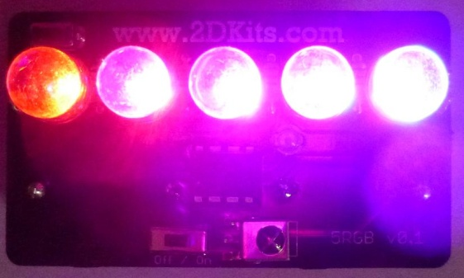

By building this blinkie, we hope you have a lot of fun, as well as learn how easy it is to assemble and solder a circuit, as well as gain a desire to learn more!

First, open up the kit and review the contents. Looking from left to right, and top to bottom there should be the following parts:

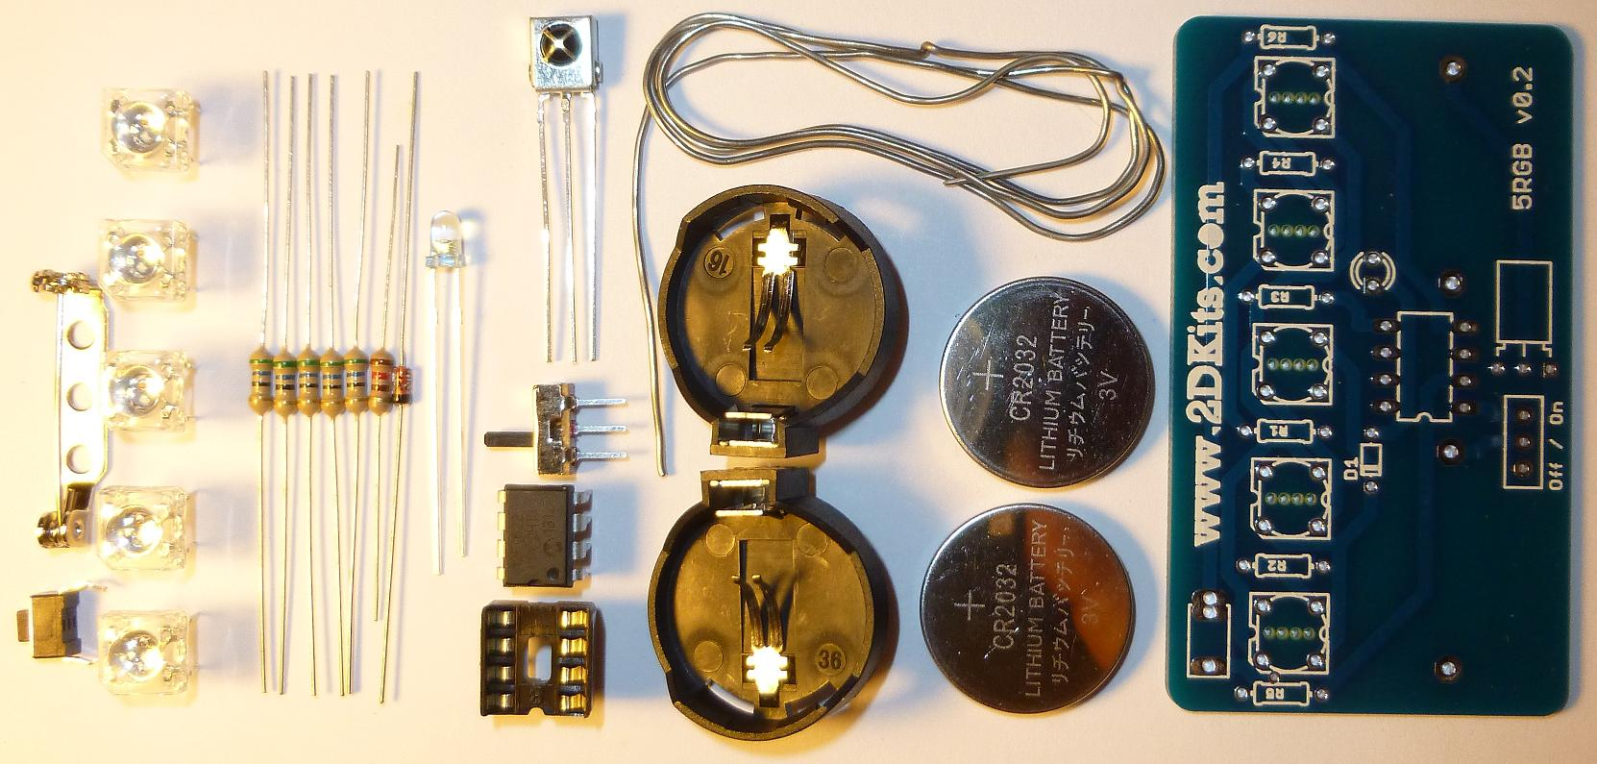
- Pin back  - Two-lead push button  - Five LEDs (four-lead square RGB LEDs shown, optional four-lead 10mm round RGB LEDs available)  - Five 56 ohm (green, blue, black) resistors  - One 120 ohm (brown, red, brown) resistor  - Diode  - IR LED | - IR detector  - Power switch  - 8 pin socket  - 8 pin 12F1822  - Solder (if in classroom)  - Two battery holders  - Two CR2032 batteries  - 5 RGB circuit board

Got everything to start? In the above list, a 180 ohm (brown, grey, brown) resistor may be substituted for the 120 ohm. If not, give us a shout. Next, a few words on soldering…

Soldering Hints

Soldering is not like gluing; the solder forms an alloy with the metals to be connected that creates a stable electrical path and a certain amount of mechanical attachment. For the small connections on this project, a 25 or 30 watt soldering iron works well. Rosin core solder is used – the acid core solder sold for plumbing would eat your components in a short time.

Here’s how to make a good joint:
- Prepare the joint. Bend the component lead slightly after it passes through the printed circuit board (this helps hold it in place while soldering).
- Prepare the tool. The soldering iron should be up to temperature. Clean the tip by quickly brushing it against a dry wire pad, or damp sponge, or damp cloth. Melt a little solder (a 2mm length) onto the tip so it’s shiny. This is called “tinning”. The solder coating helps conduct heat from the tip to the joint.
- Place the tip in contact with the component lead and the printed circuit board pad.
- Place the solder against the joint directly opposite the tool. It should melt within 2 seconds, and flow around the joint. If it takes longer than that, you’re not getting enough heat into the joint.
- Keep the soldering iron in place until the solder flows freely and completely covers the joint. If the heat is removed too soon, the solder will tend to “ball up” and not stick well to the conductors. The solder joint should look "wetted”, with concave shapes.
- Let the joint cool without movement at room temperature. This usually takes only a few seconds.
- If a joint is moved before it cools, it will take on a dull, satin look that is characteristic of a cold solder joint. A cold solder joint is fragile and conducts poorly – reheat the joint until the solder flows freely, and hold it still until it cools.
- Keep the tip of the soldering iron clean. Wipe off flux and excess solder regularly in the damp sponge or cloth, and re-tin if needed.

Assembly

Take a look at the completed picture on the first page. Take care the components are placed and soldered on the correct side of the circuit board.

The board supports four-lead squareRGB LEDs and four-lead 10mm round RGB LEDs. It’s a fairly nifty bit of circuit design to allow for the various types of LEDs, and care will need to be taken when the LEDs are placed. Those are covered in the steps below.

Ready to start? First, orient the board so the round battery holder silk screen outlines show.

- Solder the pin-back on the board. It needs to be centered properly and soldered so the top of the pin-back just touches the top of the board. It will take a little longer for the pin-back to heat up and the solder to melt and flow, so be patient. | 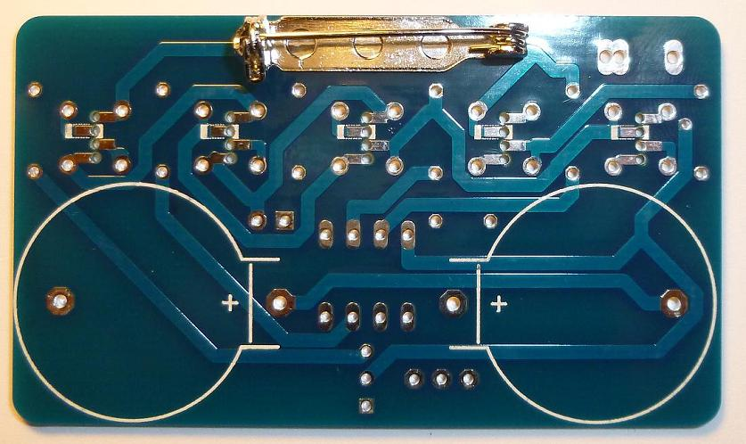

- Flip the board over and insert the 120 ohm (brown, red, brown) resistor into the board on the right-most side. The silk screen outline of the resistor with the label R6 will show where it goes. To make inserting easier, pre-bend the lead like this: Flip the board over and solder. Trim the leads with the cutter. | 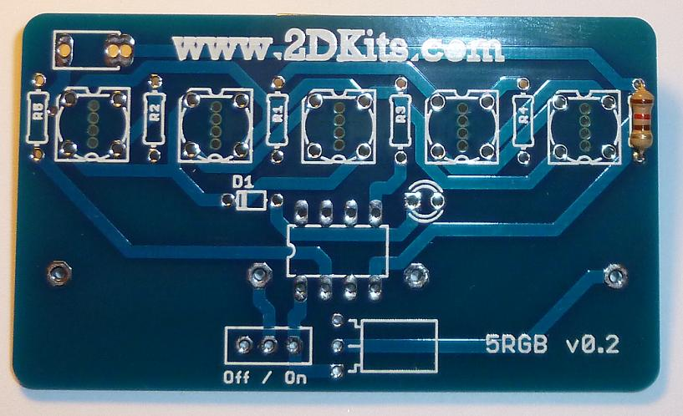

- Flip the board over and insert the five 56 ohm (green, blue, black) resistors into the board into the remaining five resistor locations. The silk screen outline of the resistor with the labels R5, R2, R1, R3, and R4 will show where they go. To make inserting easier, pre-bend the lead like this: Flip the board over and solder. Trim the leads with the cutter. | 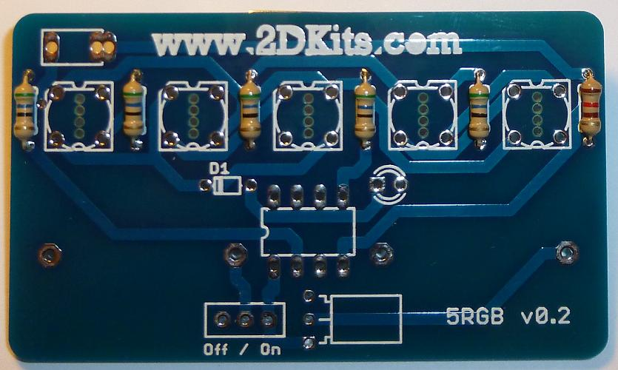

- Flip the board over and insert the diode into the board. The silk screen outline of the diode with the label D1 will show where it goes. The black band on the diode goes to the left. Orientation is important for diodes. To make inserting easier, pre-bend the lead like this: Flip the board over and solder. Trim the leads with the cutter. | 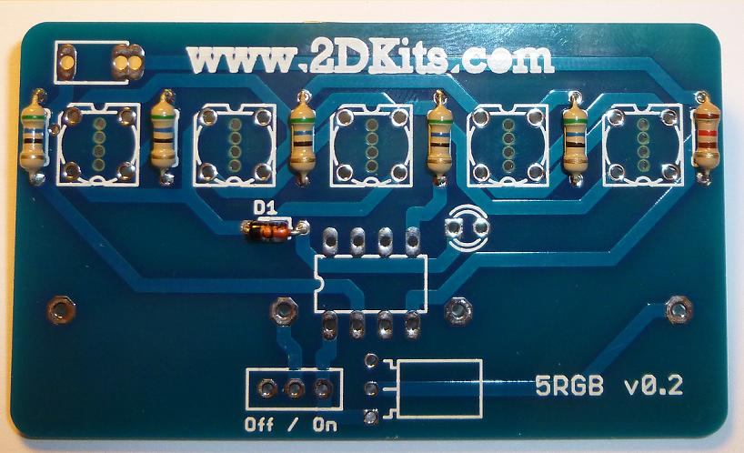

- Flip the board over and insert the IR detector into the board. The silk screen outline of the IR detector will show where it goes. To make inserting easier, pre-bend the leads like this: Flip the board over and solder. Trim the leads with the cutter. | 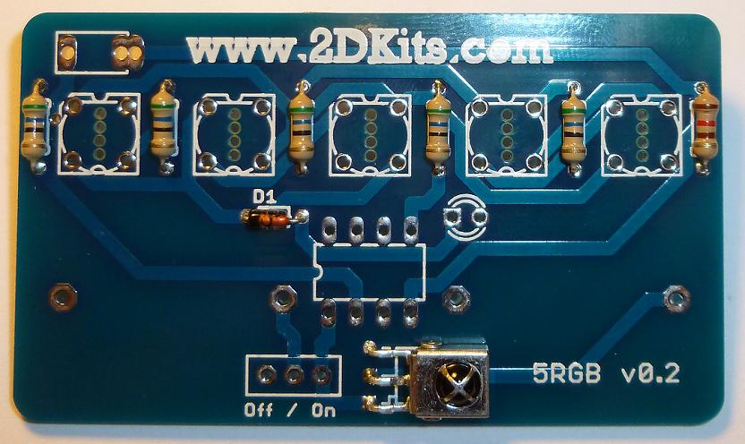

- Flip the board over and insert the 8-pin socket into the board so that the notch is facing to the left (and matches the silk screen outline. Flip the board over and solder. Trim the leads with the cutter (they will already be short, but this will make them smoother). | 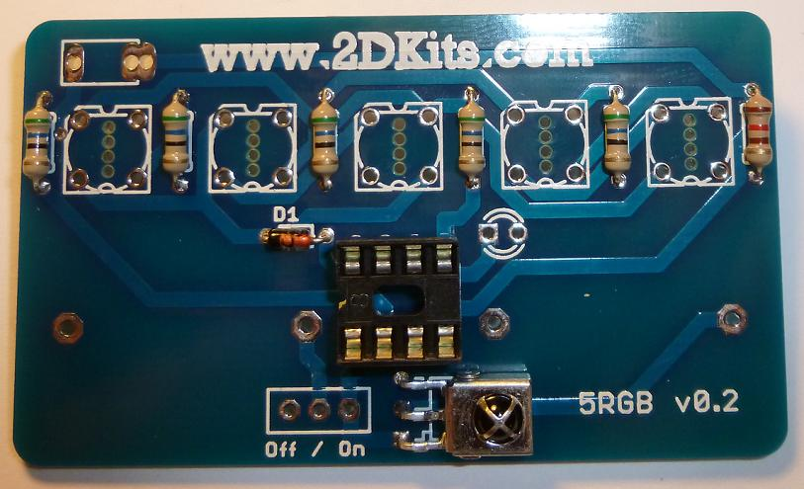

- Flip the board over so the silk screening for the power switch is visible, Off/On. Insert the power switch. Flip the board over and solder. Trim the leads with the cutter  - Flip the board over so the silk screening for push button is visible. It’s in the upper left-hand corner of the board. The leads are springy, so it will require a bit of wiggling to fit the push button in. Flip the board over and solder. | 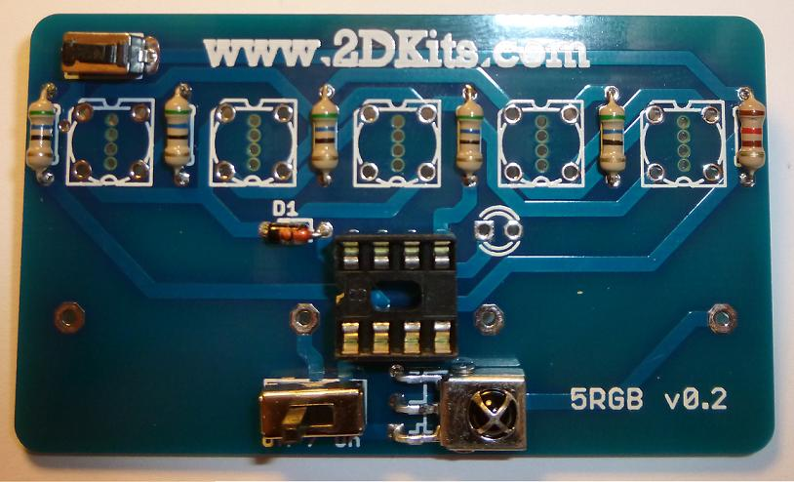

- Flip the board and insert the 3mm round IR LED. Orientation is important for LEDs. Remember: Short lead, square pad. Long lead, round pad. | 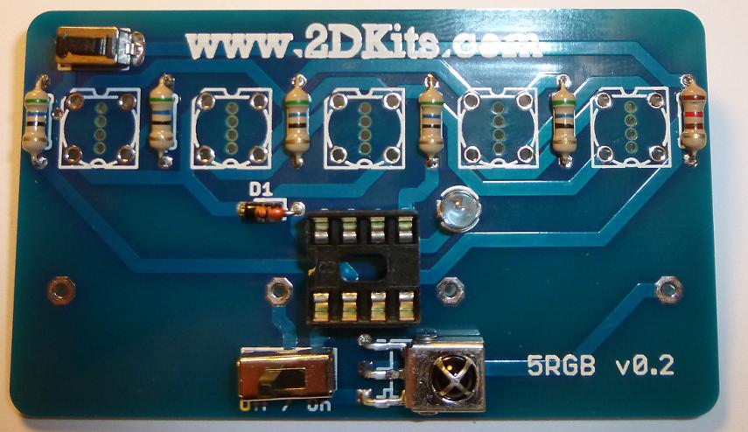

- If you have four-lead round 10mm RGB LEDs:  These LEDs will take a bit more effort, care, and time, but it will be well worth the extra effort. Each one will be inserted, trimmed, bent, and soldered in one at a time.  One of the leads will be longer than the others. Sometimes, the leads are trimmed imperfectly at the factory and it’s tough to tell. An alternate way to determine is the longest lead will go to the widest metal pillar within the LED.  Orient the LED so the longest lead will go into the second hole from the top. While holding the LED in place, trim the leads so they are 1/8” long or 3mm in length.  With a needle-nosed pliers, fold them down as in the picture: topmost folded to the right, the next to the left, the next to the right, and the last one to the left. Solder the four leads of the LED. As you can see in the picture, only a little bit of solder is needed. Repeat this procedure for the next four LEDs. | 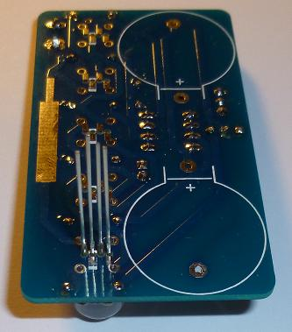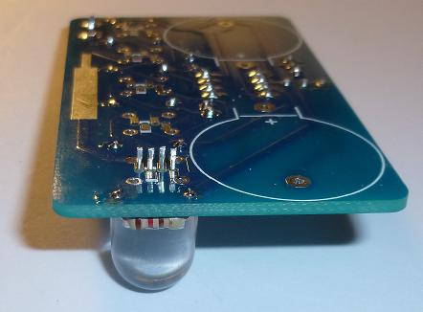  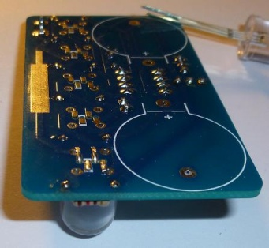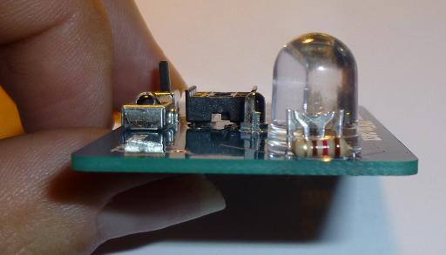  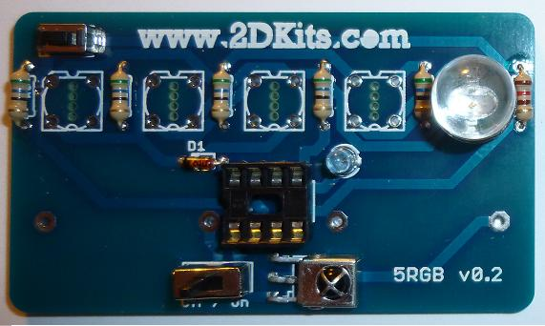

- If you have four-lead square LEDs:  Insert the LEDs. Orientation is important for LEDs. The notch goes in the upper left hand corner. It will match the silk screen outline on the circuit board | 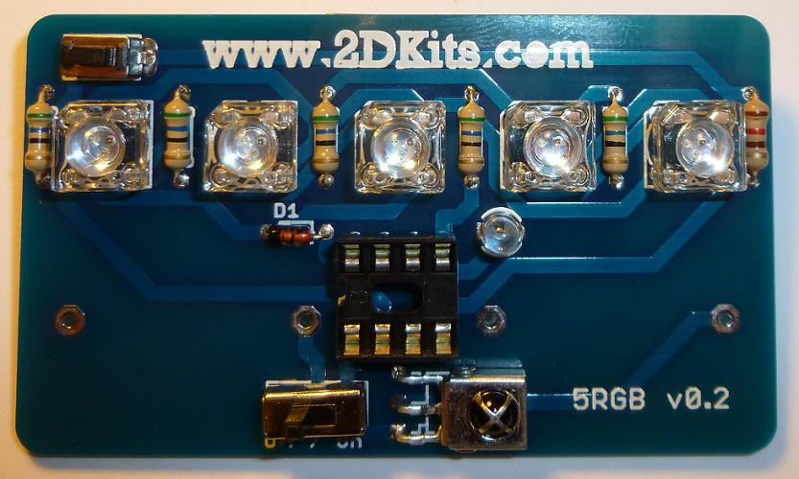

- Flip the board over do the silk screen printing for the battery holders are visible. Insert the battery holders.

- Flip the board over and insert the PIC into the eight pin socket. The small notch or dot on the PIC must face toward the left of the circuit board.

- The two batteries are inserted so the “+” on the battery is facing up. Turn on the board! Enjoy.

Troubleshooting

If the LEDs don’t flash, then you’ll need to do a little troubleshooting to finish your project. The following steps should isolate most problems.

- Recheck your solder connections. 80% of all problems are traced to this. Cold solder joints and broken joints will cause erratic performance or failure. Reheat any questionable solder connections until they flow and look shiny and secure.
- Check for bits of solder, wire ends, or other foreign matter which may be lodged in the wiring.
- LEDs reversed. You will need to remove the LED by desoldering, and then solder it in the correct way.
- Batteries incorrectly inserted. The “+” side of the battery should always be inserted facing up.
- Bad part – it does happen. In the hundreds of boards assembled, we’ve seen two or three parts fail. Send us email, and we will send a replacement part.
- A part got lost/melted/damaged/destroyed while building the kit. It happens – you’re not the first (or second, or fiftieth). Send us email, and we’ll see what we can do. We have no problem selling just the parts you need to get it working.

Use

Once built, the use of this blinkie is fairly straightforward. Don’t get it wet. Don’t stick it in a pocket with a bunch of car or house keys where it might short out.

This blinkie has additional patterns stored in the PIC. To change patterns, press the push button and hold. The topmost LED will light, and then the LEDs will count up (or down) in a sequence. Each sequence represents a stored pattern. If the push button is released, the pattern associated with that particular binary number will then be displayed on your blinkie.

