14 RGB Stick Blinkie

The heart of this circuit is a 16F688 PIC produced by a company called Microchip. A PIC is a tiny, yet surprisingly powerful little computer. By itself, it can’t do much – it needs someway to interact with the world – we are going to do this by giving it senses:
- Sight – an IR receiver
- Touch – a push button

and ways to communicate:
- To us – fourteen light emitting RGB diodes (LEDs)
- To other blinkies – an infrared (IR) LED

By building this blinkie, we hope you have a lot of fun, as well as learn how easy it is to assemble and solder a circuit, as well as gain a desire to learn more!

First, open up the kit and review the contents. Looking from left to right, there should be the following parts in addition to the board. The battery clips will have already been soldered:

Power switch Two push buttons 180 ohm resistor Seven 56 ohm resistors
Four batteries IR detector 16F688 PIC chip Fourteen RGB LEDs
Four battery clips IR LED 14 pin socket
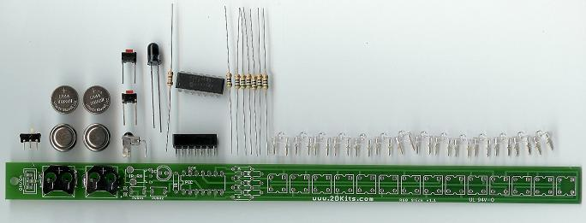
Got everything to start? If not, give us a shout. Also, since we pre-solder the battery clips, sometimes the switches or IR detector gets hidden under the battery clips.
Soldering Hints

Soldering is not like gluing; the solder forms an alloy with the metals to be connected that creates a stable electrical path and a certain amount of mechanical attachment. For the small connections on this project, a 25 or 30 watt soldering iron works well. Rosin core solder is used – the acid core solder sold for plumbing would eat your components in a short time.

Here’s how to make a good joint:
- Prepare the joint. Bend the component lead slightly after it passes through the printed circuit board (this helps hold it in place while soldering).
- Prepare the tool. The soldering iron should be up to temperature. Clean the tip by quickly brushing it against a damp sponge or cloth. Melt a little solder (a 2mm length) onto the tip so it’s shiny. This is called “tinning”. The solder coating helps conduct heat from the tip to the joint.
- Place the tip in contact with the component lead and the printed circuit board pad.
- Place the solder against the joint directly opposite the tool. It should melt within 2 seconds, and flow around the joint. If it takes longer than that, you’re not getting enough heat into the joint.
- Keep the soldering iron in place until the solder flows freely and completely covers the joint. If the heat is removed too soon, the solder will tend to “ball up” and not stick well to the conductors. The solder joint should look "wetted”, with concave shapes.
- Let the joint cool without movement at room temperature. This usually takes only a few seconds.
- If a joint is moved before it cools, it will take on a dull, satin look that is characteristic of a cold solder joint. A cold solder joint is fragile and conducts poorly – reheat the joint until the solder flows freely, and hold it still until it cools.
- Keep the tip of the soldering iron clean. Wipe off flux and excess solder regularly in the damp sponge or cloth, and re-tin if needed.

Assembly

First, orient the board horizontally and so the silk screening shows. If you see lots of little white letters, symbols, and “RGB Stick” along the bottom, you are ready to begin.

As each group of parts is inserted, you will flip the board over and solder them in from the non-printed side.

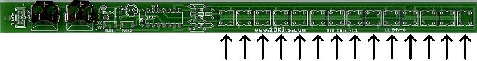
- Solder in the 14 RGB LEDs onto the board. There are fourteen small squares on the board. Orientation is important for LEDs. There is a small beveled corner on the LED. This goes into the upper left corner – it will also match the white outline on the board for each of the 14 LEDs.
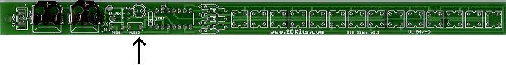
- Place the IR LED – it’s the one that looks tinted. It goes in the double circle. The long lead goes in the hole with the round pad, and the small lead goes in the hole with the square pad. Remember: Short lead, square pad. Long lead, round pad.

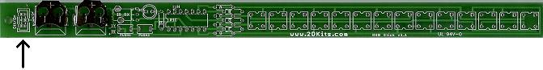
- Place the power switch into the board. It will only fit in one way.

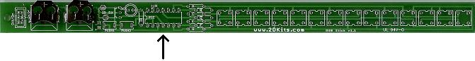
- Place the socket into the board. The little notch in the middle of the socket should face the battery clips.

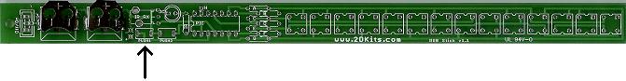
- Place the IR detector. Its position is marked “IR_RX”. The IR detector will only fit in one way.

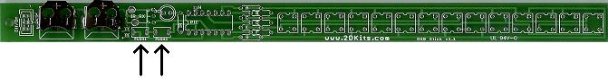
- Place the two push buttons. Their positions are marked “PUSH1” and “PUSH2”.

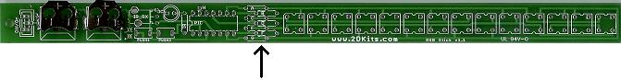
- Solder in the seven 56 ohm resistors (green, blue, black). The resistor positions are marked “A”, “B”, “C”, “D”, “E”, “F”, and “G”.

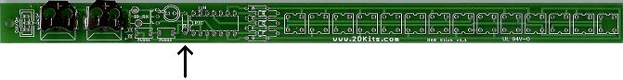
- Solder in the 180 ohm resistor (brown, grey, brown). The resistor position is marked “IR”.

- Before installing the batteries and PIC chip, check all solder connections, and also make sure there are no solder bridges. If everything looks good, move onto the next step.

- The PIC chip is inserted so the dot or notch is facing the battery clips.

- The batteries are inserted so the “+” on the battery is facing up.

- Turn on the board! Enjoy.

Use

Once built, the use of this blinkie is fairly straightforward. Don’t get it wet. Don’t stick it in a pocket with a bunch of change where it might short out.

This blinkie has additional patterns stored in the PIC. To change patterns, press the push button and hold. The topmost LED will light, and then the LEDs will count up in a binary sequence. Each binary number represents a stored pattern. If the push button is released, the pattern associated with that particular binary number will then be displayed on your badge blinkie.

This blinkie will also broadcast its current pattern via the IR LED. If another blinkie with an IR detector sees this, it will change its pattern to match. Of course, this can also happen to this blinkie – another blinkie may “infect” its pattern on this one before it can do the same.

Troubleshooting

If your blinkie doesn’t flash, then you’ll need to do a little troubleshooting to finish your project. The following steps should isolate most problems.

- Recheck your solder connections. 80% of all problems are related to this problem. Cold solder joints and broken joints will cause erratic performance or failure. Reheat any questionable solder connections until they flow and look shiny and secure.
- Check for bits of solder, wire ends, or other foreign matter which may be lodged in the wiring.
- Batteries incorrectly inserted. The “+” side of the battery should always be inserted facing up.
- PIC chip inserted backwards. The notch which represents pin 1 should be closest to the batteries.
- Bad part – it does happen. In the hundreds of boards assembled, we’ve seen the rare part fail.

