19 LED Stick Blinkie
aka LEDs-on-a-Stick

The heart of this circuit is a 12F683 PIC produced by a company called Microchip. A PIC is a tiny, yet surprisingly powerful little computer. By itself, it can’t do much – it needs someway to interact with the world – we are going to do this by giving it senses:

- Sight – an IR receiver
- Touch – a push button

and ways to communicate:

- To us – nineteen light emitting diodes (LEDs)
- To other blinkies – an infrared (IR) LED

By building this blinkie, we hope you have a lot of fun, as well as learn how easy it is to assemble and solder a circuit, as well as gain a desire to learn more!

First, open up the kit and review the contents. Looking from left to right, there should be the following parts in addition to the board (minus the chip and batteries, as the blinkie techs have them):

Power switch IR detector 8 pin socket Length of solder
Four battery clips Push button 12F683 PIC chip IR LED
Four batteries 100 or 180 ohm resistor Five 56 ohm resistors Nineteen LEDs
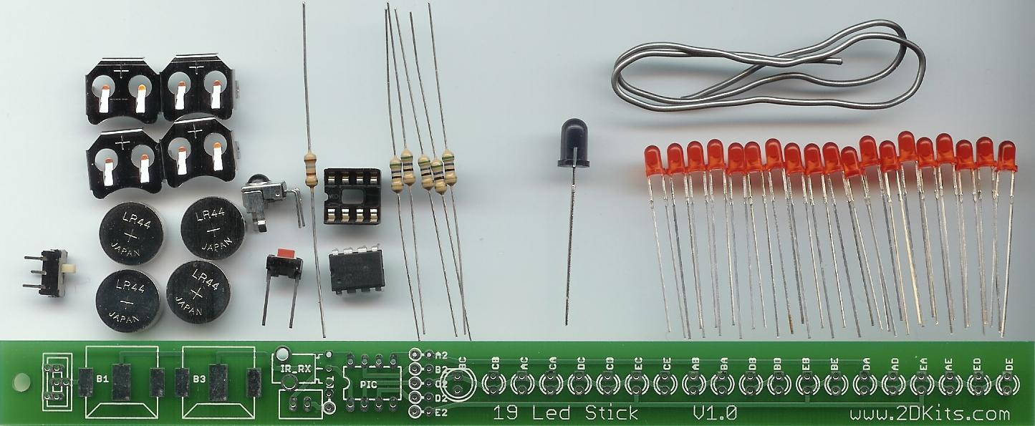

When completed, the board will look similar to this:

Got everything to start? If not, give us a shout. Also, since we pre-solder the battery clips, sometimes the switches or IR detector gets hidden under the battery clips.
Assembly

First, orient the board horizontally and so the silk screening shows. If you see lots of little white letters, symbols, and “19 Led Stick” along the bottom, you are ready to begin.

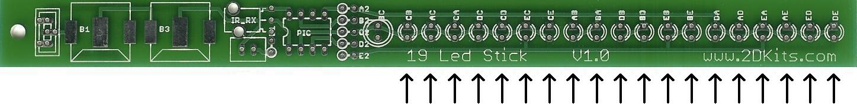
- Solder the 19 LEDs onto the board. There are nineteen small circles on the board. The long lead goes in the hole with the round pad, and the small lead goes in the hole with the square pad.

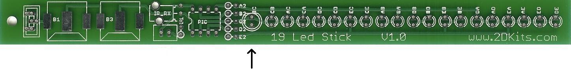
- Place the IR LED – it’s the one that looks tinted. It’s in the center of board – the leftmost set of circles. The long lead goes in the hole with the round pad, and the small lead goes in the hole with the square pad.

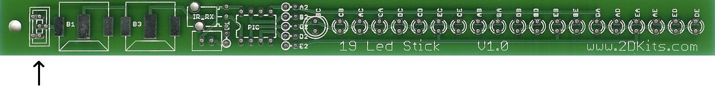
- Place the power switch into the board. It will only fit in one way.

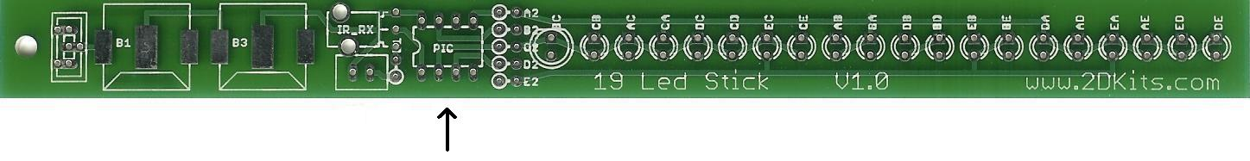
- Place the socket into the board. The little notch in the middle of the socket should be facing toward the battery clips.

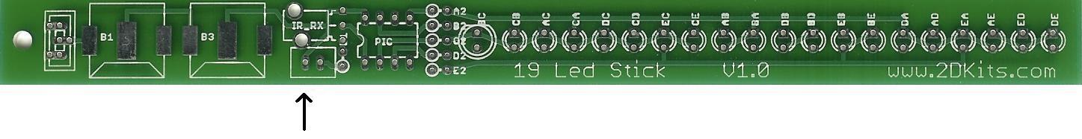
- Place the IR detector. It will only fit in one way.

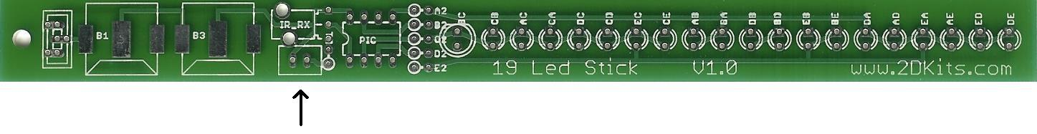
- Place the push button. This is a little more tricky as the leads are wider than the board holes. Push it into place so it is centered.

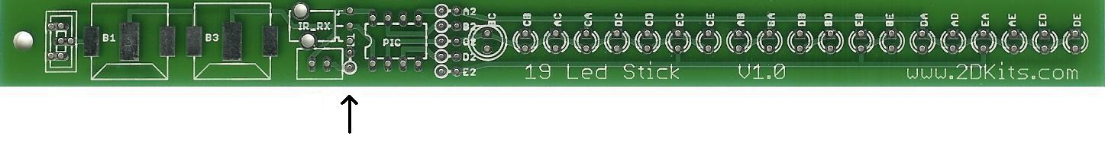
- Solder in the last resistor. It will either be a 100 ohm (brown, black, red) or a 180 ohm (brown, grey, red) . You will need to bend one lead over, like this, 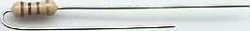, and place it into the board next to the push button, so it is sticking straight up (perpendicular) to the board.

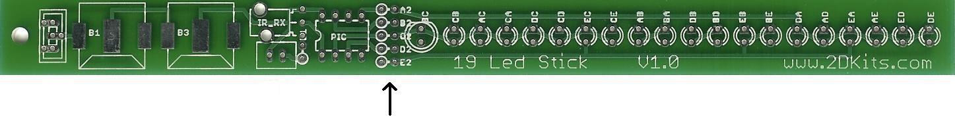
- Solder in the five 56 ohm resistors (green, blue, black). You will need to bend one lead over as you did in the previous step, and place it into the board between the socket and the IR LED.

- Before installing the batteries and PIC chip, check all solder connections, and also make sure there are no solder bridges. If everything looks good, move onto the next step.

- The PIC chip is inserted so the dot or notch is facing the battery clips.

- The batteries are inserted so the “+” on the battery is facing up.

- Turn on the board! Enjoy.

Troubleshooting

If your blinkie doesn’t flash, then you’ll need to do a little troubleshooting to finish your project. The following steps should isolate most problems.

- Recheck your solder connections. 80% of all problems are related to this problem. Cold solder joints and broken joints will cause erratic performance or failure. Reheat any questionable solder connections until they flow and look shiny and secure.
- Check for bits of solder, wire ends, or other foreign matter which may be lodged in the wiring.
- Batteries incorrectly inserted. The “+” side of the battery should always be inserted facing up.
- PIC chip inserted backwards. The notch which represents pin 1 should be closest to the batteries.
- Bad part – it does happen. In the hundreds of boards assembled, we’ve seen a few power switches fail and one bad PIC chip.

Soldering Hints

Soldering is not like gluing; the solder forms an alloy with the metals to be connected that creates a stable electrical path and a certain amount of mechanical attachment. For the small connections on this project, a 25 or 30 watt soldering iron works well. Rosin core solder is used – the acid core solder sold for plumbing would eat your components in a short time.

Here’s how to make a good joint:
- Prepare the joint. Bend the component lead slightly after it passes through the printed circuit board (this helps hold it in place while soldering).
- Prepare the tool. The soldering iron should be up to temperature. Clean the tip by quickly brushing it against a damp sponge or cloth. Melt a little solder (a 2mm length) onto the tip so it’s shiny. This is called “tinning”. The solder coating helps conduct heat from the tip to the joint.
- Place the tip in contact with the component lead and the printed circuit board pad.
- Place the solder against the joint directly opposite the tool. It should melt within 2 seconds, and flow around the joint. If it takes longer than that, you’re not getting enough heat into the joint.
- Keep the soldering iron in place until the solder flows freely and completely covers the joint. If the heat is removed too soon, the solder will tend to “ball up” and not stick well to the conductors. The solder joint should look "wetted”, with concave shapes.
- Let the joint cool without movement at room temperature. This usually takes only a few seconds.
- If a joint is moved before it cools, it will take on a dull, satin look that is characteristic of a cold solder joint. A cold solder joint is fragile and conducts poorly – reheat the joint until the solder flows freely, and hold it still until it cools.
- Keep the tip of the soldering iron clean. Wipe off flux and excess solder regularly in the damp sponge or cloth, and re-tin if needed.

