24 LED Sphere Blinkie

The heart of this blinkie is a 16F886 PIC produced by a company called Microchip. A PIC is a tiny, yet surprisingly powerful little computer. By itself, it can’t do much – it needs someway to interact with the world – we are going to do this by giving it senses:  - Sight – an IR receiver  - Touch – push buttons  and ways to communicate:  - To us – 24 light emitting diodes (LEDs)  - To other blinkies – an infrared (IR) LED  By building this blinkie, we hope you have a lot of fun, as well as learn how easy it is to assemble and solder a circuit, as well as gain a desire to learn more! | 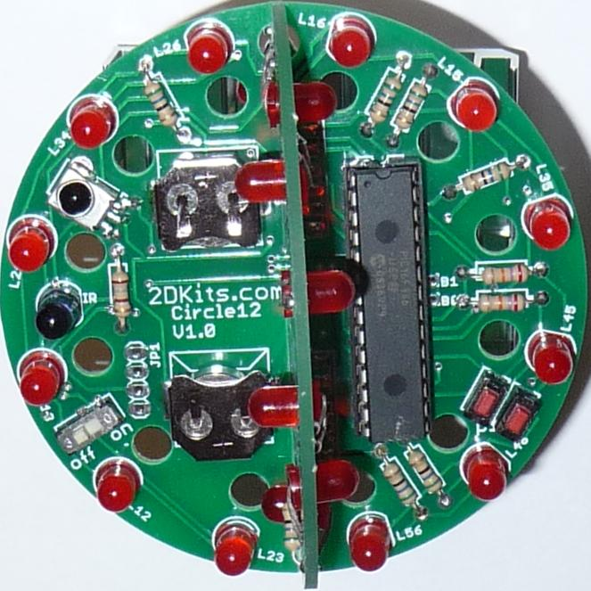

This kit contains two circuit boards – one with the battery clips, and one without. First, open up the kit and review the contents. Looking from left to right, and top to bottom there should be the following parts:
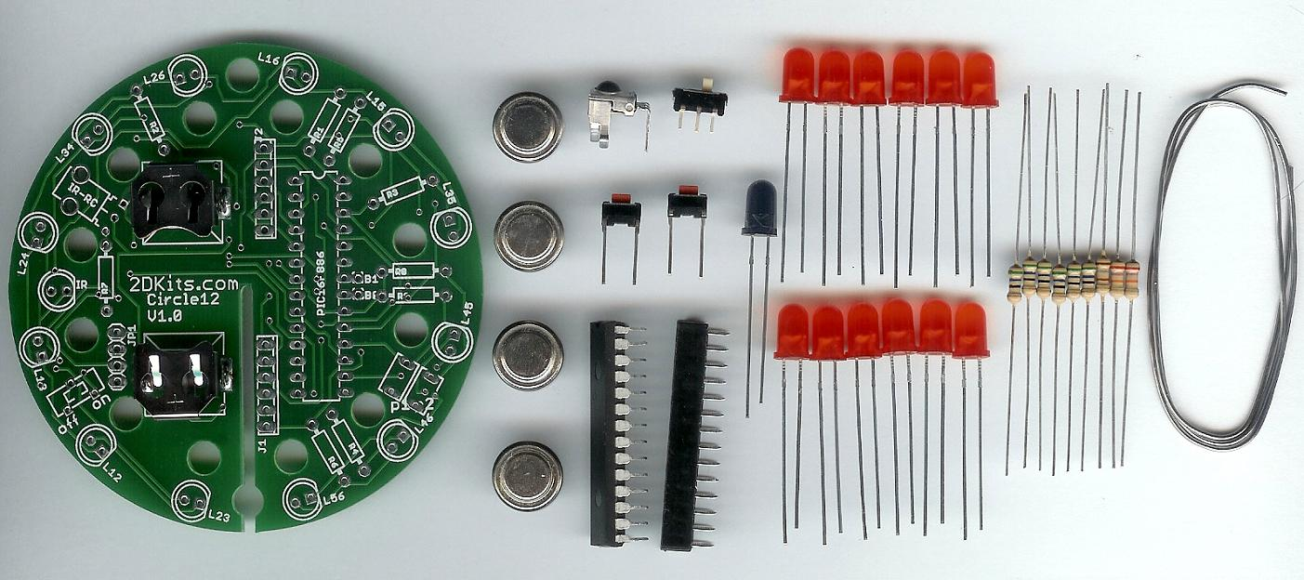
Circuit board 16F886 PIC Six 56 ohm resistors
Four LR44 batteries 28 pin socket One 180 ohm resistor
IR detector IR LED Two 27K ohm resistors
Power switch Twelve LEDs Length of solder
Two push buttons

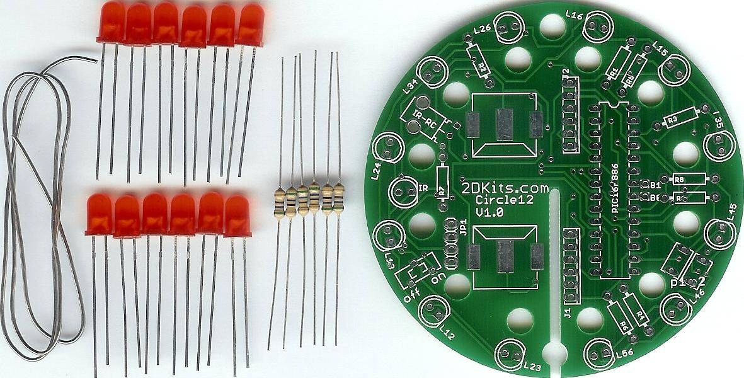
Length of solder Twelve LEDs Six 56 ohm resistors Circuit board

Got everything to start? If not, give us a shout. If you're building at a convention, the kit won't initially include solder, batteries, or PIC. Get the solder at the work table.

Soldering Hints

Soldering is not like gluing; the solder forms an alloy with the metals to be connected that creates a stable electrical path and a certain amount of mechanical attachment. For the small connections on this project, a 25 or 30 watt soldering iron works well. Rosin core solder is used – the acid core solder sold for plumbing would eat your components in a short time.

Here’s how to make a good joint:
- Prepare the joint. Bend the component lead slightly after it passes through the printed circuit board (this helps hold it in place while soldering).
- Prepare the tool. The soldering iron should be up to temperature. Clean the tip by quickly brushing it against a damp sponge or metal fiber pad. Melt a little solder (a 2mm length) onto the tip so it’s shiny. This is called “tinning”. The solder coating helps conduct heat from the tip to the joint.
- Place the tip in contact with the component lead and the printed circuit board pad.
- Place the solder against the joint directly opposite the tool. It should melt within 2 seconds, and flow around the joint. If it takes longer than that, you’re not getting enough heat into the joint.
- Keep the soldering iron in place until the solder flows freely and completely covers the joint. If the heat is removed too soon, the solder will tend to “ball up” and not stick well to the conductors. The solder joint should look "wetted”, with concave shapes.
- Let the joint cool without movement at room temperature. This usually takes only a few seconds.
- If a joint is moved before it cools, it will take on a dull, satin look that is characteristic of a cold solder joint. A cold solder joint is fragile and conducts poorly – reheat the joint until the solder flows freely, and hold it still until it cools.
- Keep the tip of the soldering iron clean. Wipe off flux and excess solder regularly in the damp sponge or metal fiber pad, and re-tin if needed.
Use

Once built, the use of this blinkie is fairly straightforward. Don’t get it wet. Don’t stick it in a pocket with a bunch of change where it might short out.

This blinkie has additional patterns stored in the PIC. To change patterns, press either push button and hold. The topmost LED will light, and then the LEDs will count up (or down) in a binary sequence. Each binary number represents a stored pattern. If the push button is released, the pattern associated with that particular binary number will then be displayed on your badge blinkie.

This blinkie will also broadcast its current pattern via the IR LED. If another blinkie with an IR detector sees this, it will change its pattern to match. Of course, this can also happen to this blinkie – another blinkie may “infect” its pattern on this one before it can do the same.

Assembly

First, orient the board with the battery clips so the slot points down and so the silk screening (white printing) shows. Since both sides are silk screened, it is the side that has the IR-RC and PIC16F886 labels.

Insert the parts from the side with the IR-RC and PIC 16F886 labels, then flip the board over and solder.  - Solder in the six 56 ohm (green, blue, black) resistors into the board. On the board it is labeled R1, R2, R3, R4, R5, and R6.  - Solder in the 180 ohm (brown, grey, brown) resistor. There’s only one. It is the leftmost resistor on the board. On the board it is labeled R7.  - Solder in the two 27K ohm (red, purple, orange) resistors. They go next to each other on the rightmost side of the board. On the board it is labeled R8 and R9. | 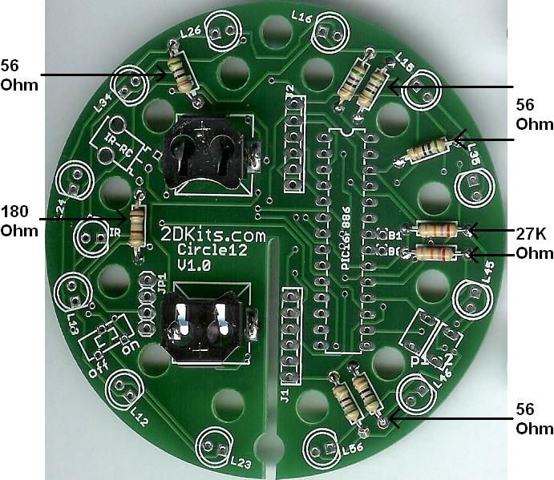

- Once all the resistors have been soldered in, trim off the excess wire (leads).

Insert the parts from the side with the IR-RC and PIC16F886 labels, then flip the board over and solder.  - Solder the IR detector into the board. On the board it is labeled IR_RC.  - Solder the 28 pin socket into the board. The socket has a small notch in it. The notch should face the top of the board. On the board it is labeled PIC16F886.  - Solder the power switch into the board. It will only fit in one way. On the board it is labeled off on. | 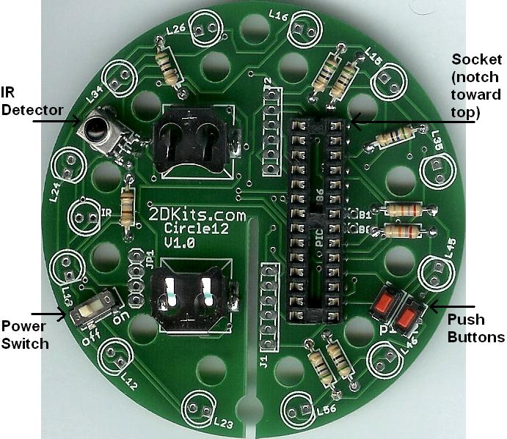

- Solder the push buttons into the board. On the board they are labeled P1 and P2.

- Once all the parts have been soldered, trim off the excess wire (leads) on the push buttons.

- Solder the IR LED into the board – on the left side of the board. Orientation is important for LEDs. Remember: Short lead, square pad. Long lead, round pad. It is labeled IR.  - Solder in the LEDs. There are several LED placement options:  Option A – LEDs on the front (shown here).  Option B – LEDs alternating.  Option C – LEDs on edge.  Option D – LEDs through the board. This option does not work with jumbo (10mm) LEDs.  Option A  (LEDs On The Front) | 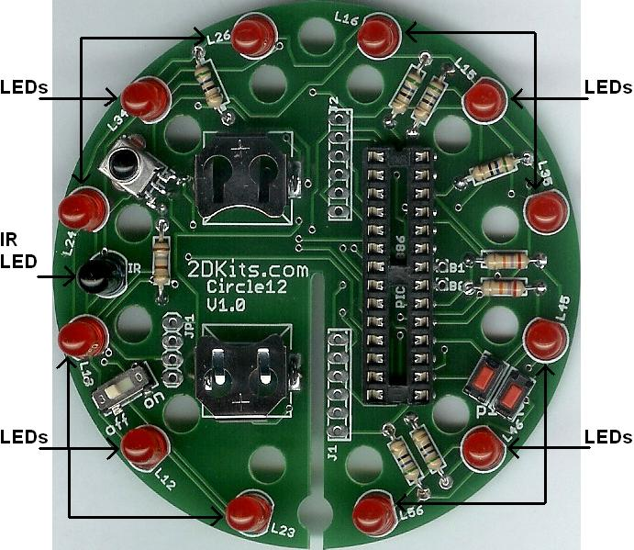

Insert the LEDs from the side as shown. Since both sides are silk screened (white printing), it is the side that has the L23, L12, L13, L24, L34, L26, L16, L15, L35, L45, L46, and L56 labels. Insert the LEDs at those locations. Then flip the board over and solder. Orientation is important for LEDs. Remember: Short lead, square pad. Long lead, round pad.

Option B  (LEDs Alternating)  Insert the LEDs from the side as shown. Since both sides are silk screened (white printing), it is the side that has the L15, L45, L56, L12, and L24 labels. Insert the LEDs at those locations. Then flip the board over and solder. Orientation is important for LEDs. Remember: Short lead, square pad. Long lead, round pad.  On the other side, insert the remaining LEDs. Then flip the board over and solder. | 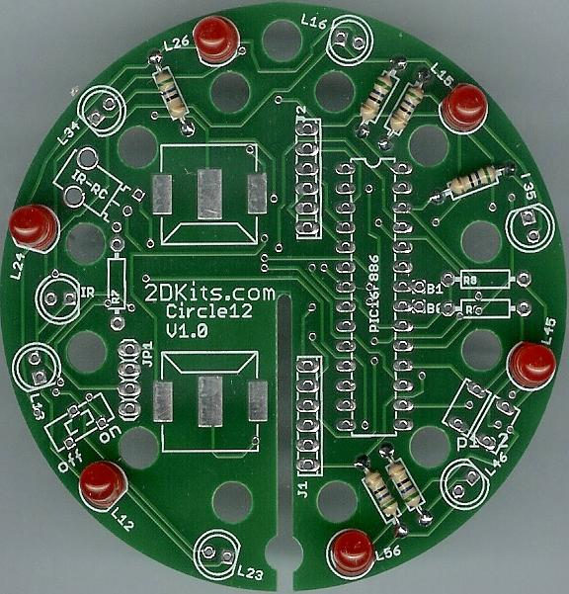  Other components removed for clarity.

Option C  (LEDs On Edge)  Since both sides are silk screened (white printing), it is the side that has the L15, L45, L56, L12, and L24 labels. Insert the LEDs at those locations. Then flip the board over and solder. Orientation is important for LEDs. Remember: Short lead, square pad. Long lead, round pad.  On the other side, insert the remaining LEDs along the edge. Then flip the board over and solder. | 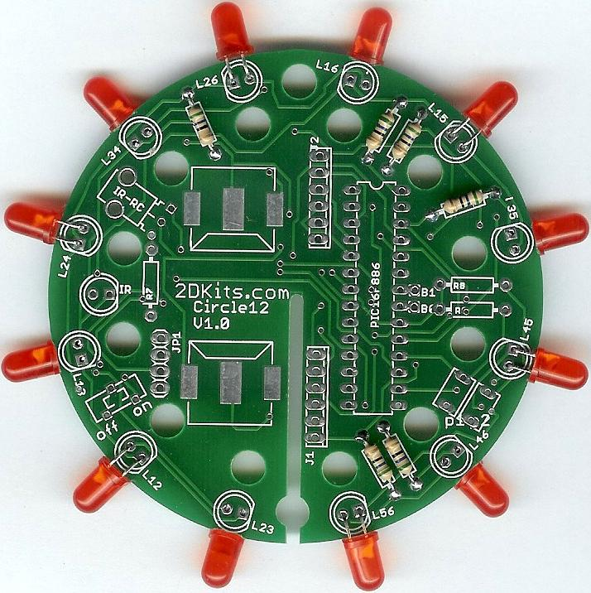  Other components removed for clarity.
  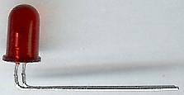 | Make a 90 degree bend in the legs (leads) of the LED, so when inserted the LED will just touch the edge of the board

Option D  (LEDs Through The Board)  Since both sides are silk screened (white printing), it is the side that has the L16, L35, L46, L23, L13, and L34 labels. Insert the LEDs at those locations. Then flip the board over and solder. Orientation is important for LEDs. Remember: Short lead, square pad. Long lead, round pad. On the other side, insert the remaining LEDs. Then flip the board over and solder. | 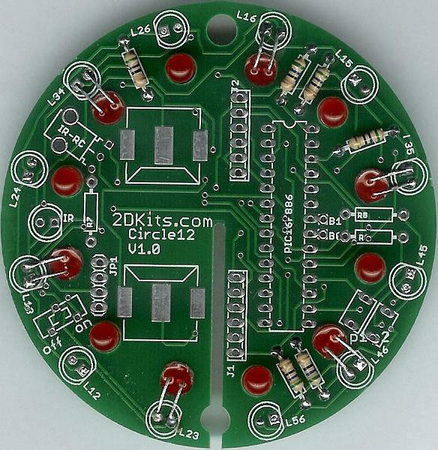  Other components removed for clarity.
  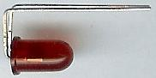 | Make a 90 degree bend in the legs (leads) of the LED right at the surface of the LED. Make another 90 bend, so when inserted, the leads will fit in the board and the LED will fit in the hole.

- Once all the LEDs have been soldered, trim off the excess wire (leads) on the LEDs.

- Before installing the batteries and PIC, check all solder connections, and also make sure there are no solder bridges. If everything looks good, move onto the next step.

- The PIC chip is inserted so the dot or notch is facing up.

- The batteries are inserted so the “+” on the battery is facing up.

- Turn on the board and verify the LEDs light up. If there are any problems, review the troubleshooting section.

- Remove the batteries from the main board before proceeding!

- First, orient the second board (the one without battery clips) so the slot points down and so the silk screening (white printing) shows. Since both sides are silk screened, it is the side that has the IR-RC and PIC16F886 labels.

Insert the parts from the side with the IR-RC and PIC 16F886 labels, then flip the board over and solder.  - Solder in the six 56 ohm (green, blue, black) resistors into the board. On the board it is labeled R1, R2, R3, R4, R5, and R6.  - Once all the resistors have been soldered in, trim off and save the excess wire (leads).  - Solder the LEDs.  There are several LED placement options:  Option A – LEDs on the front (easy).  Option B – LEDs alternating (easy).  Option C – LEDs on edge.  Option D – LEDs through the board. This option does not work with jumbo (10mm) LEDs.  There are other combinations of the various options, but only the above will be covered to keep it simple… | 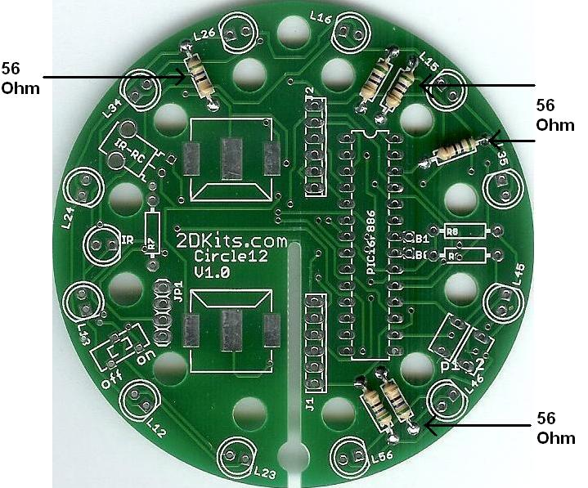

Option A  (LEDs On The Front)  Note: Two Option A boards or an Option A and an Option B board will not fit together – two pairs of LEDs will interfere with each other. Choose Option C or D instead.  Insert the LEDs from the side as shown. Since both sides are silk screened (white printing), it is the side that has the IR-RC and PIC16F886 labels. Then flip the board over and solder. Orientation is important for LEDs. Remember: Short lead, square pad. Long lead, round pad.  Once all the LEDs have been soldered, trim off the excess wire (leads) on the LEDs. | 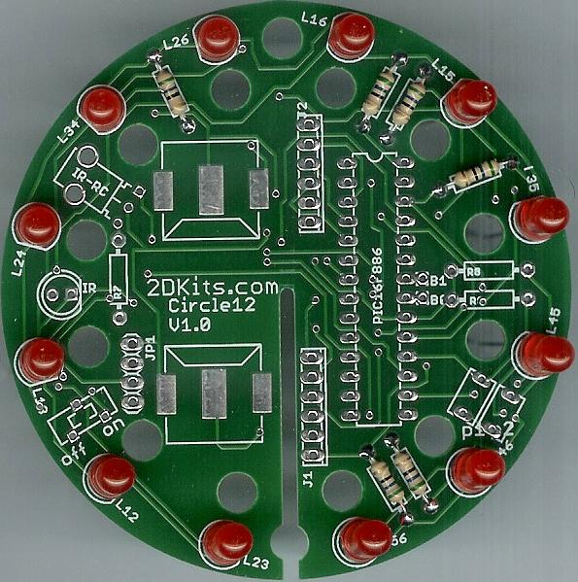

Option B  (LEDs Alternating)  Note: If your main board is an Option A, the Option B board will not fit together – two pairs of LEDs will interfere with each other. Choose Option C or D instead.  Insert the LEDs from the side as shown. Since both sides are silk screened (white printing), it is the side that has the IR-RC and PIC16F886 labels. Then flip the board over and solder. Orientation is important for LEDs. Remember: Short lead, square pad. Long lead, round pad.  On the other side, insert the remaining LEDs. Then flip the board over and solder.  Once all the LEDs have been soldered, trim off the excess wire (leads) on the LEDs. | Note: Do not solder the bottom two LEDs (in the above picture), on either side of the slot, labeled L23 and L56. You will solder them in after the two boards are slid together!

Option C
(LEDs On Edge)

Make a 90 degree bend in the legs (leads) of the LED, so when inserted the LED will just touch the edge of the board
Since both sides are silk screened (white printing), it is the side that has the IR-RC and PIC16F886 labels. Insert every other LED. Then flip the board over and solder. Orientation is important for LEDs. Remember: Short lead, square pad. Long lead, round pad.

On the other side, insert the remaining LEDs along the edge. Then flip the board over and solder.

Once all the LEDs have been soldered, trim off the excess wire (leads) on the LEDs

Option D
(LEDs Through The Board)

Make a 90 degree bend in the legs (leads) of the LED right at the surface of the LED. Make another 90 bend, so when inserted, the leads will fit in the board and the LED will fit in the hole.
Since both sides are silk screened (white printing), it is the side that has the IR-RC and PIC16F886 labels. Insert every other LED. Then flip the board over and solder. Orientation is important for LEDs. Remember: Short lead, square pad. Long lead, round pad.

On the other side, insert the remaining LEDs. Then flip the board over and solder.

Once all the LEDs have been soldered, trim off the excess wire (leads) on the LEDs

Now to connect up the boards. This takes a steady hand, needle nosed pliers, and patience.  - With six of the excess resistor leads (saved when the excess was trimmed after soldering), cut them in half. You should have twelve wire segments.  - Bend them with the needle nosed pliers to form a “C” shape. Each of the three sides of the “C” should be about the same size. It doesn’t have to be exact, but close enough.  - Remove the batteries from the main board before proceeding!  - Slide the two boards together. There are two ways the boards can slide together. One way will be easier to solder. See the picture below. | 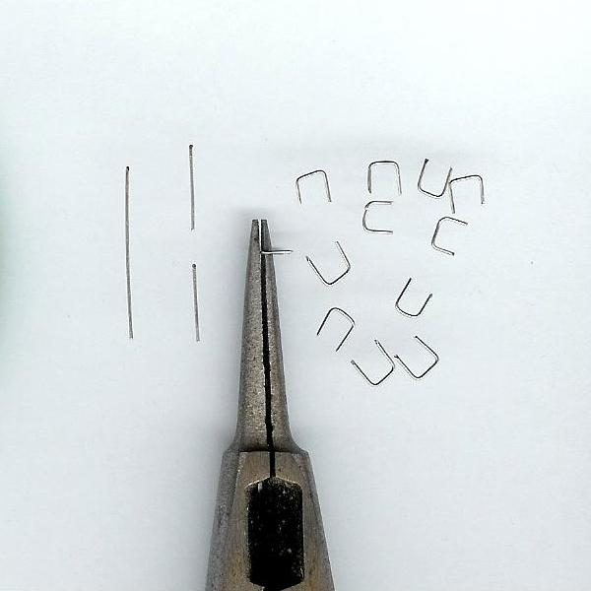

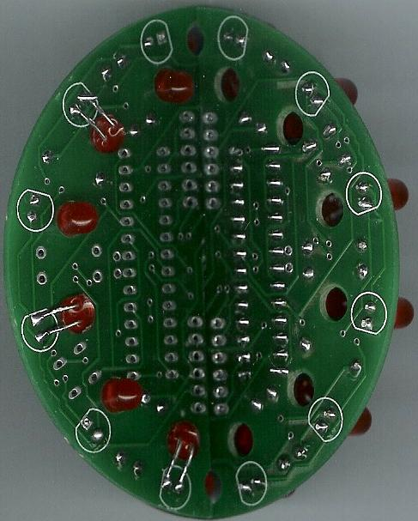 | - If you chose Option A or B, you need to solder the last two LEDs in place. Hey, it’s tough to solder those LEDs in place! Here’s a trick - slide the board back about ½” (or 12mm). Now insert the LEDs and solder them. Trim the excess wire. Slide the boards the rest of the way together again.  - Solder the twelve connections together. | 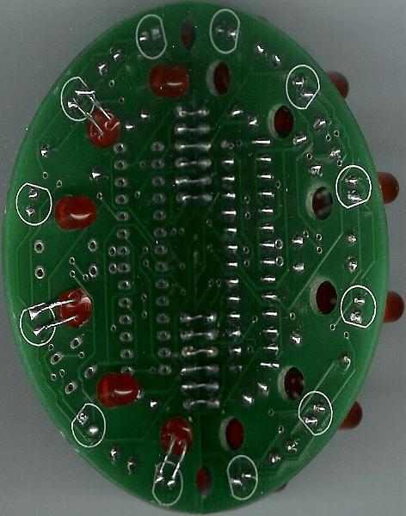

- Trim the excess wire from the other side of the board. Make sure the wire does not touch the battery clips.

- Reinsert the batteries. The batteries are inserted so the “+” on the battery is facing up.

- Turn on the board! Enjoy.

Troubleshooting

If your LEDs don’t flash, then you’ll need to do a little troubleshooting to finish your project. The following steps should isolate most problems.

- Recheck your solder connections. 80% of all problems are traced to this. Cold solder joints and broken joints will cause erratic performance or failure. Reheat any questionable solder connections until they flow and look shiny and secure.
- Check for bits of solder, wire ends, or other foreign matter which may be lodged in the wiring.
- LEDs reversed. You will need to remove the LED by desoldering, and then solder it in the correct way.
- Batteries incorrectly inserted. The “+” side of the battery should always be inserted facing up.
- Bad part – it does happen. In the hundreds of boards assembled, we’ve seen two or three parts fail. Let us know.
- A part was missing or wrong. Sorry about that, we sort and bag the parts by hand – no outsourcing here! Let us know.
- A part was lost/melted/damaged/destroyed while building the kit. It happens – you’re not the first (or second, or fiftieth). Let us know.

