8x16 Matrix Blinkie

The heart of this blinkie is a 18F25K50 PIC produced by a company called Microchip. A PIC is a tiny, yet surprisingly powerful little computer. By itself, it can’t do much – it needs someway to interact with the world – we are going to do this by giving it senses:

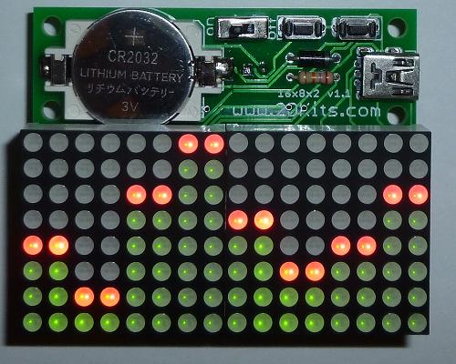 | - From us – two push buttons  - To us – 128 two color (red/green) light emitting diodes (LEDs).  - To a computer - via USB. | 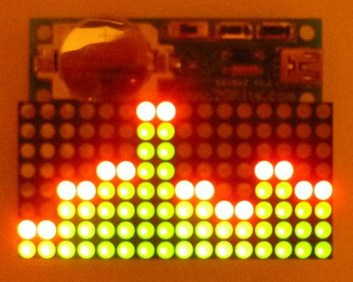

By building this blinkie, we hope you have a lot of fun, as well as learn how easy it is to assemble and solder a circuit, as well as gain a desire to learn more!

Use

Once built, the use of this blinkie is fairly straightforward. Don’t get it wet. Don’t stick it in a pocket with a bunch of car or house keys where it might short out.

This blinkie has additional patterns and scrolling text stored in the PIC. To change patterns or messages, press the push button and hold. The topmost LED will light, and then the LEDs will count up (or down) in a sequence. Each sequence represents a stored pattern or message. If the push button is released, the pattern associated with that particular binary number will then be displayed on your blinkie.

The blinkie has two display modes. Demo, where it will switch to a different stored pattern every minute, as it cycles through all the stored patterns. Normal, where will continue to display the current pattern until a new pattern is selected via the push buttons. To toggle between the modes, hold down both push buttons.

Now, on to the assembly…
First, open up the kit and review the contents. Looking from top to bottom, and left to right there should be the following parts:

- Two 2032 battery holders  - Two 2032 3V batteries  - 8x16 matrix circuit board  - Diode  - 27K ohm resistor (red, violet, orange)  - Two 220 uF electrolytic capacitors  - Two 8x8 dual color (red/green) LED matrixes  - 28 pin 18F25K50 PIC  - 28 pin socket  - Two 74AC138 LED driver chips  - Two 16 pin sockets  - Four 12 pin single header sockets  - Power switch  - USB socket  - Two push buttons | 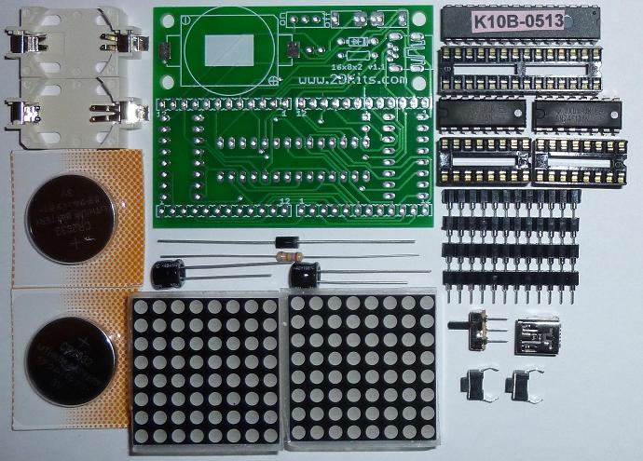

Got everything to start? If not, give us a shout. Next, a few words on soldering…

Soldering Hints

Soldering is not like gluing; the solder forms an alloy with the metals to be connected that creates a stable electrical path and a certain amount of mechanical attachment. For the small connections on this project, a 25 or 30 watt soldering iron works well. Rosin core solder is used – the acid core solder sold for plumbing would eat your components in a short time.

Here’s how to make a good joint:
- Prepare the joint. Bend the component lead slightly after it passes through the printed circuit board (this helps hold it in place while soldering).
- Prepare the tool. The soldering iron should be up to temperature. Clean the tip by quickly brushing it against a dry wire pad, or damp sponge, or damp cloth. Melt a little solder (a 2mm length) onto the tip so it’s shiny. This is called “tinning”. The solder coating helps conduct heat from the tip to the joint.
- Place the tip in contact with the component lead and the printed circuit board pad.
- Place the solder against the joint directly opposite the tool. It should melt within 2 seconds, and flow around the joint. If it takes longer than that, you’re not getting enough heat into the joint.
- Keep the soldering iron in place until the solder flows freely and completely covers the joint. If the heat is removed too soon, the solder will tend to “ball up” and not stick well to the conductors. The solder joint should look "wetted”, with concave shapes.
- Let the joint cool without movement at room temperature. This usually takes only a few seconds.
- If a joint is moved before it cools, it will take on a dull, satin look that is characteristic of a cold solder joint. A cold solder joint is fragile and conducts poorly – reheat the joint until the solder flows freely, and hold it still until it cools.
- Keep the tip of the soldering iron clean. Wipe off flux and excess solder regularly in the damp sponge or cloth, and re-tin if needed.
Assembly

Take care when soldering the headers and sockets to the circuit board and make sure you are soldering them from the correct side!

Ready to start? First, orient the board so the 16x8x2 silk screen printing shows.

- Place the battery holder in the upper left hand location. It will match the silk screen outline. On the battery holder white plastic, note the “-“, notch, and “+”. These will also match the silk screening.  - Solder the two flat metal leads to the board. It will take a little extra time to heat up the pad, so be patient. The solder will flow both on the surface of the pad, as well as underneath. | 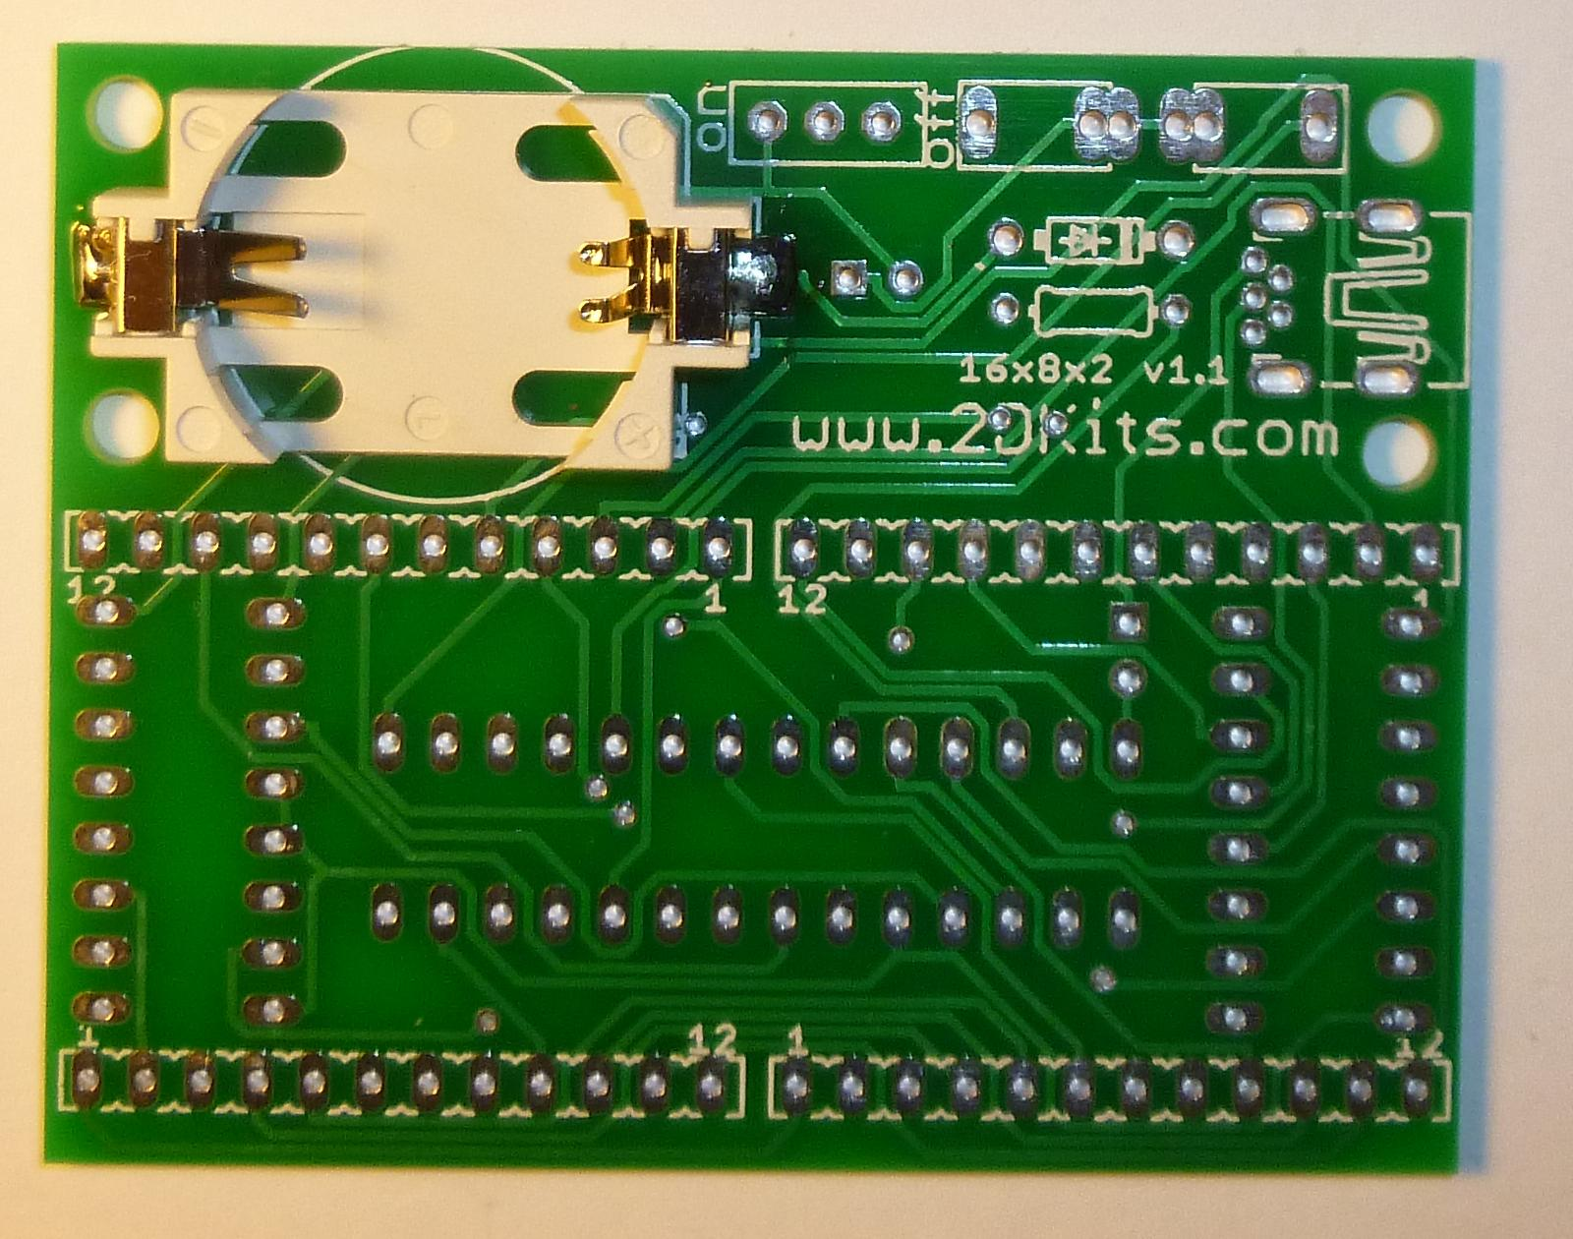

- Insert the four 12-pin headers. Be careful! These must be inserted from the correct side. If you can see the silk screening for the headers, they are being inserted correctly. Please re-check the placement again.  - Flip the board over and solder. The 12-pin headers will fall out unless you use a business card to hold them in place as you flip over the board.  - Solder pins 1 and 12 on each header. Inspect the header and make sure they are aligned and flush with the board. If they are not, gently press the center of each header while reheating (and re-melting the solder). You will feel the header settling nice and tight against the board.  - If all looks aligned and flush, solder the rest of the pins. Flip the board over. | 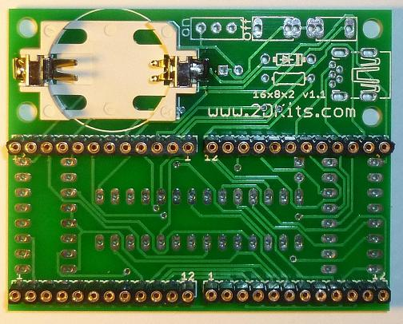

- Insert the diode. To make inserting easier, pre-bend the leads like this: 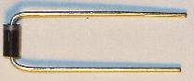 Orientation is important for diodes. There is a bar on the diode. It should inserted so the bar is on the right, and it should match the silk screening. Flip the board over and solder. Flip the board over.  - Insert the 27K ohm (red, violet, orange) resistor. To make inserting easier, pre-bend the leads like this: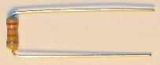  Flip the board over and solder. Trim all the leads and flip the board over. | 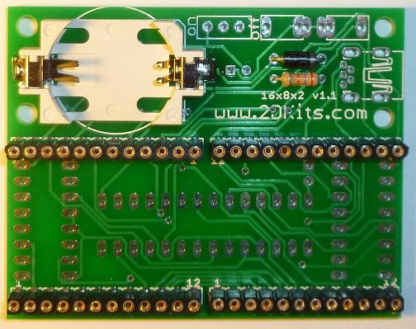

- Insert the USB socket. The USB socket will fall out unless you use one of the carded 2032 battery to hold it in place – it’s the right height to keep the USB socket snugged up against the board. Flip the board over and solder. Flip the board over.  - Insert the push buttons. Note there is a set of three holes; the push button leads will go in the outermost holes. They will snap into place.  - Insert the power switch. Flip the board over and solder. Trim the leads. | 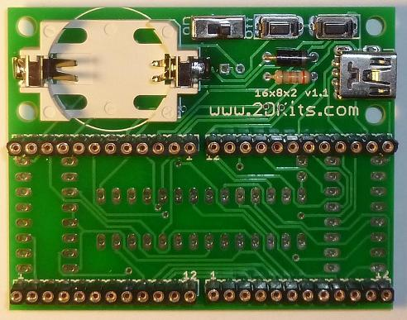

- Insert the 28 pin socket. The socket will be inserted from the side that has the silk screen outline and silk screen printing of PIC18F25K50. Make sure the notch on the socket matches the silk screen outline; the notch will be to the right.  - Insert the two 16 pin sockets. The sockets will be inserted from the side that has the silk screen outline and silk screen printing of 74AC138. Make sure the notch on the socket matches the silk screen outline; the notch will face the top of the board.  - Flip the board over and solder. Flip the board over. | 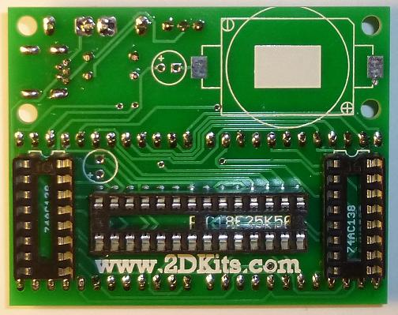

- Place the battery holder in the upper right hand location. It will match the silk screen outline. On the battery holder white plastic, note the “-“, notch, and “+”. These will also match the silk screening.  - Solder the two flat metal leads to the board. It will take a little extra time to heat up the pad, so be patient. The solder will flow both on the surface of the pad, as well as underneath.  - Insert the electrolytic capacitors at the round silk screen outline. Orientation is important for electrolytic capacitors. Remember: Short lead, square pad. Long lead, round pad. Also, the positive (long lead) will match up with the “+” silk screen marking. Flip the board over and solder. Trim all the leads and flip the board over. | 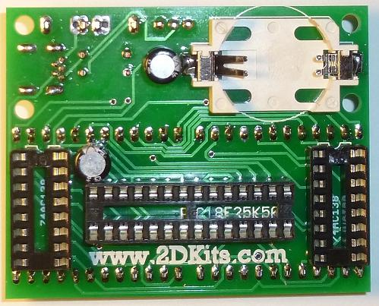

- Verify the power switch is in the off position. Insert the batteries. The plus “+” faces up. The battery needs to be angled in and then snapped in place. The battery will slide under the right side twin terminals, and snap into place on the left. Repeat with the other battery holder.  - Insert the 8x8 LED matrixes. If you flip over the matrixes, they will have writing on the back side. This will indicate the top of the matrixes. Insert the matrixes. The will require a bit of care to align and slowly wiggle the leads into the 12 pin headers. Take your time. | 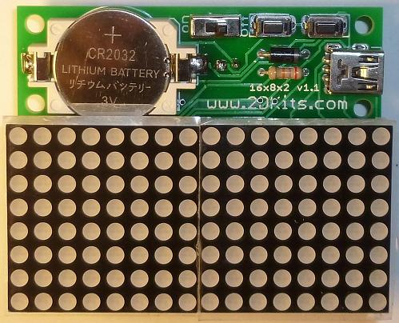

- The LED driver ICs (74AC138) are inserted so the dot or notch is facing up. These are the only components that are unforgiving if you insert them the wrong way. If they are incorrectly inserted, they will short out internally. You won’t see any smoke, but they will be dead.  - The PIC chip is inserted so the dot or notch is facing right.  - Flip the board over, and remove the protective coating from the 8x8 matrixes. Turn the power on and enjoy. Alternatively, this board can be connected to a USB power supply *or* to a USB cable connected to a USB port. | 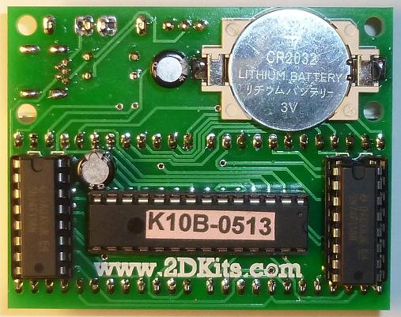

Troubleshooting

If the LED matrixes don’t flash, then you’ll need to do a little troubleshooting to finish your project. The following steps should isolate most problems.

- Recheck your solder connections. 80% of all problems are traced to this. Cold solder joints and broken joints will cause erratic performance or failure. Reheat any questionable solder connections until they flow and look shiny and secure.
- Check for bits of solder, wire ends, or other foreign matter which may be lodged in the wiring.
- LED matrixes installed upside down.
- Batteries incorrectly inserted. The “+” side of the battery should always be inserted facing up.
- Bad part – it does happen. In the hundreds of boards assembled, we’ve seen two or three parts fail. Send us email, and we will send a replacement part.
- A part got lost/melted/damaged/destroyed while building the kit. It happens – you’re not the first (or second, or fiftieth). Send us email, and we’ll see what we can do. We have no problem selling just the parts you need to get it working.

