4x4x4 RGB Cube Blinkie

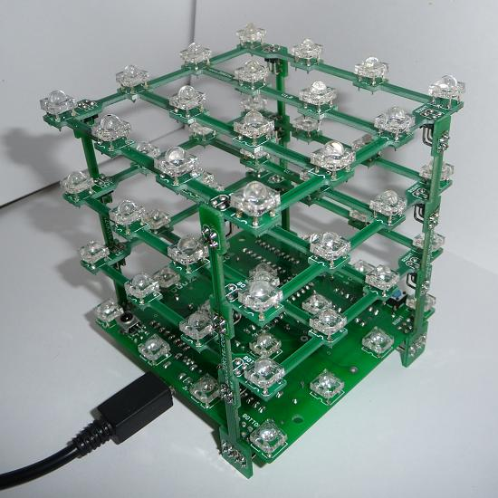 | 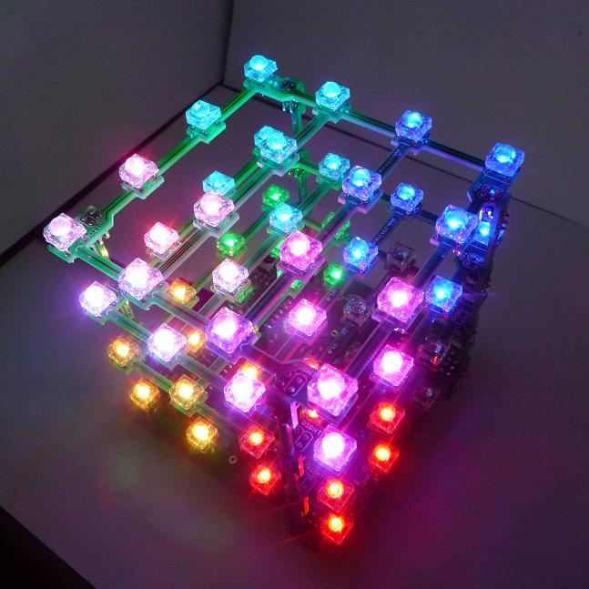

The heart of this blinkie is a 18F2550 PIC produced by a company called Microchip. A PIC is a tiny, yet surprisingly powerful little computer. By itself, it can’t do much – it needs someway to interact with the world – we are going to do this by giving it senses:
- Sight – an IR receiver
- Touch – push buttons

and ways to communicate:
- To us – 64 RGB light emitting diodes (LEDs)
- To other blinkies – an infrared (IR) LED
- To a computer – via USB

Each LED is individually addressable. Since each RGB is made up of three LEDs, there are 192 individual LEDs, each which can be displayed at 8 different brightness levels, allowing for 512 colors per RGB LED.

By building this blinkie, we hope you have a lot of fun! First, open up the kit and review the contents. There will be two packets.
In the first packet, looking from left to right, and top to bottom there should be the following parts:

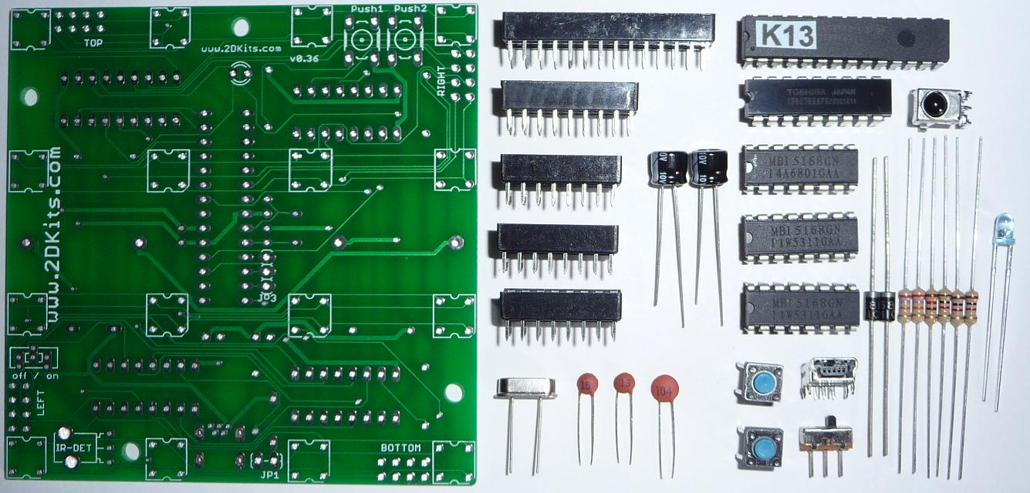

One bottom driver circuit board One 120 ohm resistors (brown, red, brown)
28 pin socket Three 1K ohm resistors (brown, black, red)
18F2550 PIC 3mm IR LED
18 pin socket 20 MHZ oscillator
18 pin TD62783APG RGB row driver chip Two 15 pF capacitors
IR detector 0.1 uF capacitor
Three 16 pin sockets Two push buttons
Three 16 pin MBI5168 RGB column driver chips Mini-USB socket
Two 220uF can capacitors Power switch
Two diodes 120V to 5V mini USB power supply (not shown)
Two 27K ohm resistors (red, violet, orange)

In the second packet, looking from left to right, and top to bottom there should be the following parts:

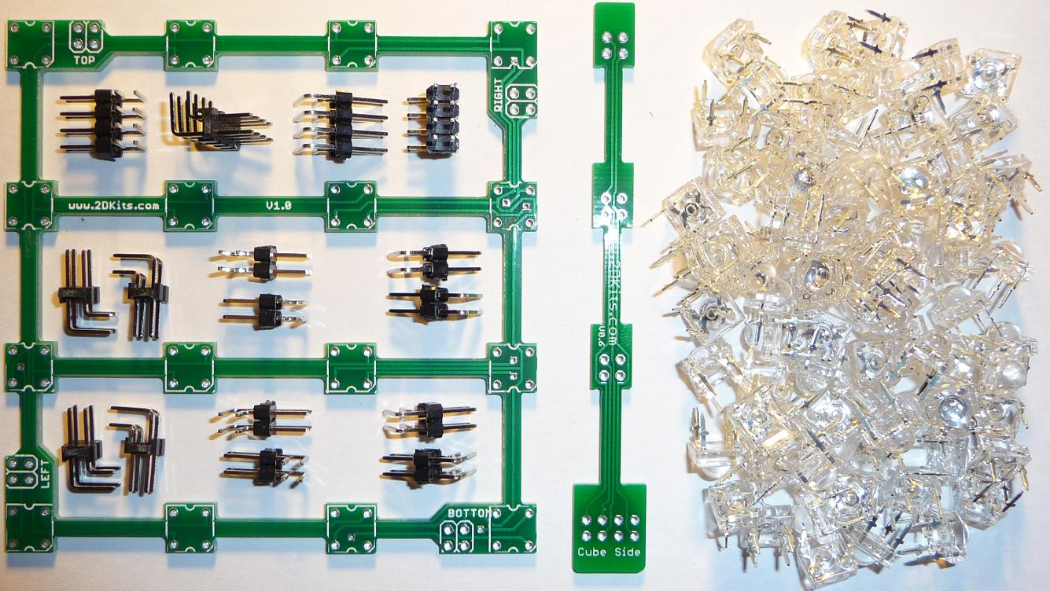
Three top circuit boards (aka waffle boards) Four 8-pin angle header connectors
Four leg circuit boards Twelve 4-pin angle header connectors
64 RGB LEDs

Got everything to start? If you're building at a convention, the kit won't initially include the chips. Get the solder at the work table, and the chips from the staff after you solder your board.

Soldering Hints

Soldering is not like gluing; the solder forms an alloy with the metals to be connected that creates a stable electrical path and a certain amount of mechanical attachment. For the small connections on this project, a 25 or 30 watt soldering iron works well. Rosin core solder is used – the acid core solder sold for plumbing would eat your components in a short time.

Here’s how to make a good joint:
- Prepare the joint. Bend the component lead slightly after it passes through the printed circuit board (this helps hold it in place while soldering).
- Prepare the tool. The soldering iron should be up to temperature. Clean the tip by quickly brushing it against a damp sponge or metal fiber pad. Melt a little solder (a 2mm length) onto the tip so it’s shiny. This is called “tinning”. The solder coating helps conduct heat from the tip to the joint.
- Place the tip in contact with the component lead and the printed circuit board pad.
- Place the solder against the joint directly opposite the tool. It should melt within 2 seconds, and flow around the joint. If it takes longer than that, you’re not getting enough heat into the joint.
- Keep the soldering iron in place until the solder flows freely and completely covers the joint. If the heat is removed too soon, the solder will tend to “ball up” and not stick well to the conductors. The solder joint should look "wetted”, with concave shapes.
- Let the joint cool without movement at room temperature. This usually takes only a few seconds.
- If a joint is moved before it cools, it will take on a dull, satin look that is characteristic of a cold solder joint. A cold solder joint is fragile and conducts poorly – reheat the joint until the solder flows freely, and hold it still until it cools.
- Keep the tip of the soldering iron clean. Wipe off flux and excess solder regularly in the damp sponge or metal fiber pad, and re-tin if needed.

Assembly

You will notice this board has a lot of holes. There is a special type of hole, called a via. Very simply, it is a way to connect a trace from one side of the board to the other without the need of a jumper wire. Due to the complexity of the board, there are quite a few. Be careful when placing a part so one end does not accidentally end up in a via. Also be careful not to make a solder bridge to a via. Take your time and you shouldn’t have any trouble.

Please take special care when placing parts. Is this the correct component? Am I putting it on the correct side of the board? Is the orientation correct? Is it properly aligned? Take your time – you are building a work of art! If you accidentally drip solder into a via, as long as it isn’t bridged to another pad, it’s ok. You can leave it filled. Now, onto the assembly!

First, orient the bottom driver board so the silk screening for the push button1 (Push1) is at the top. The board also has labels for TOP, LEFT, RIGHT, and BOTTOM.

- Insert the 16 RGB LEDs. Orientation is important for LEDs. There is a beveled corner. This should be in the lower right corner.  - Please recheck and make sure all 16 LEDs are oriented properly. Flip the board over and solder the LEDs. Solder one pad on each of the 16 LEDs. Flip it over and make sure they are flat with the board. If they are not, reheat and adjust the LEDs. | 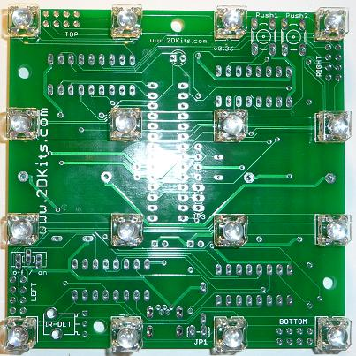

- If your LED looks like this, you will need to reheat the solder joint while gently pressing down on the LED to make it sit level on the board. To this for any LEDs that are not level. | 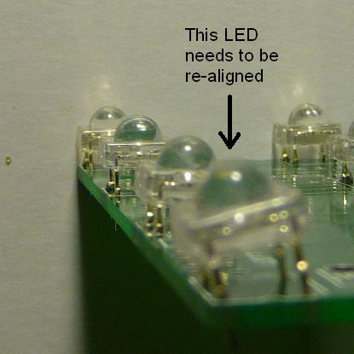

- Flip the board back over and insert the IR LED. Orientation is important. Remember, short lead, square pad. Flip the board over and solder the IR LED. Trim the leads with the cutters.  - Flip the board back over and insert the IR detector, power switch, and the two push buttons.  To keep the power switch from falling out, bend the leads over. For the IR LED, bend them apart at a 45 degree angle – this will keep it from falling though. | 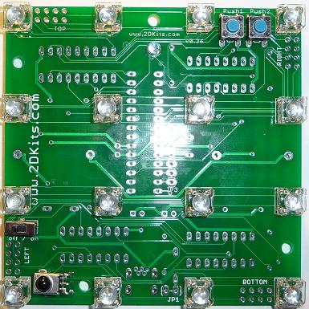

- Flip the board over and insert the five sockets. Make sure the pin one indicator on each socket matches the correct position on the silk screening. Flip the board over and solder in the five sockets.  Make sure it’s being soldered from the correct side of the board!  To keep the sockets from falling out when the board is flipped over for soldering, place a post card (or other stiff material) over the sockets as the board is flipped. | 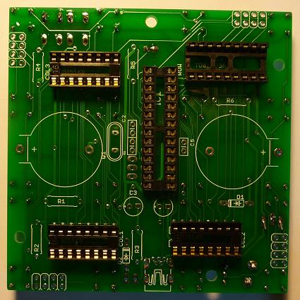

- Insert the can caps into C3 and C4. Orientation is important. Short lead, square pad, long lead, round pad. If these are soldered in backwards, they will dramatically self destruct when power is applied! Flip the board over and solder in the five sockets.  - Flip the board back over. Insert the 15 pF disk caps into C1 and C2. Insert the 0.1 uF disk cap into C5. Insert the 20Mhz can crystal into Q1. Orientation is not important for these components. Flip the board over and solder. Trim the leads. | 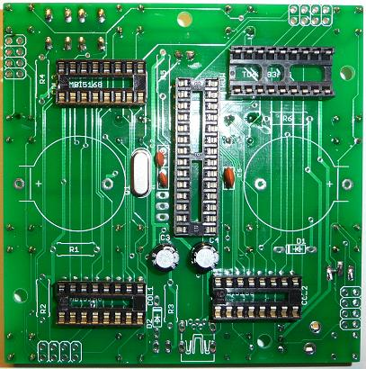

- In the next few steps, diodes and resistors will be inserted. It is easier to insert them in you pre-bend the leads as shown. | 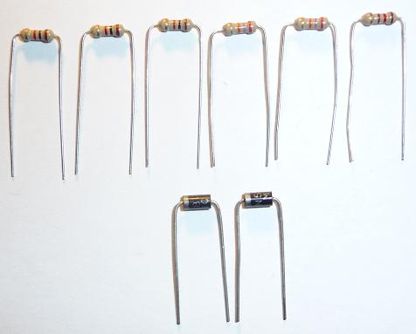

- Flip the board over. Insert the diodes in to D1 and D2. Orientation is important. There is a bar on the diode that matches the bar on the silk screening. Flip the board over and solder. Trim the leads.  - Flip the board over. Insert the resistors. It does not matter which way they are inserted, as long as the correct resistors is inserted into the correct board location:  - R1, R2, R3 – 1K ohm (brown black red)  - R4, R5 – 27K ohm (red purple orange)  - R6 – 120 ohm (brown red brown)  - Flip the board over and solder. Trim the leads. | 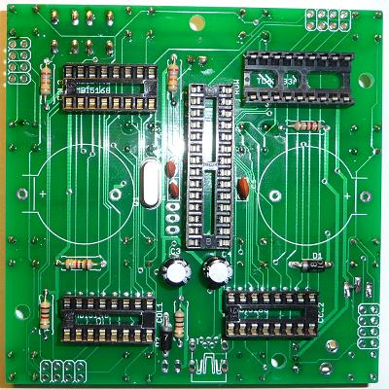

- Flip the board over. Insert the USB socket. Be careful with soldering the leads as they are close together. Flip the board over and solder.  - Flip the board over. Insert the 8-pin angle headers. Verify they are inserted the correct way and on the correct side of the board! Flip the board over.  - Solder one pad on each of the 8-pin angle headers. Flip it over and make sure they are flat with the board. If they are not, reheat and adjust. It is easy to overheat the angle headers, melting the plastic. Alternate soldering one pin at a time on each of the angle headers. Top, right, bottom, left. Repeat until soldering is complete. | 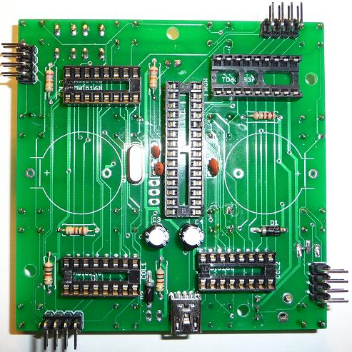

- The opposite side for Step 13, Step14, and Step 15 will look like this.  - Once all soldering is complete, trim all leads. Do not trim the angle portion of the headers – those will be soldered to the leg boards in a future step. | 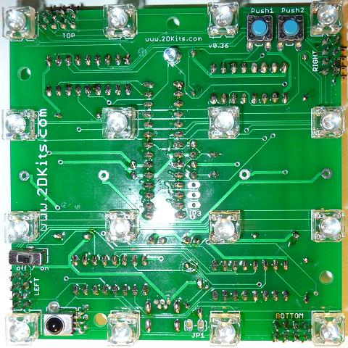

- Orient the waffle boar so the silk screening for TOP is at the top of the board. The board also has labels for LEFT, RIGHT, and BOTTOM.  - Flip the board over. Insert the 4-pin angle headers. Verify they are inserted the correct way and on the correct side of the board! Flip the board over.  - Solder one pad on each of the 4-pin angle headers. Flip it over and make sure they are flat with the board. If they are not, reheat and adjust. It is easy to overheat the angle headers, melting the plastic. Alternate soldering one pin at a time on each of the angle headers. Top, right, bottom, left. Repeat until soldering is complete. | 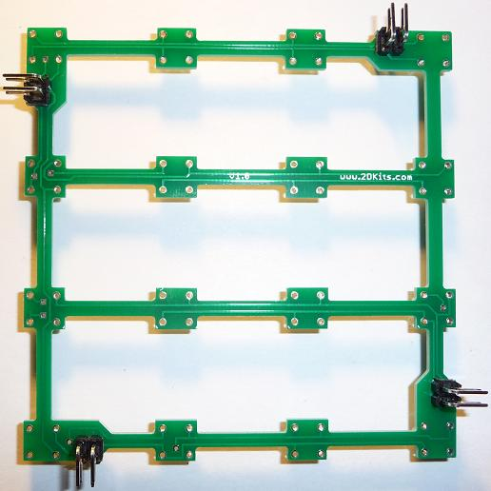

- Insert the 16 RGB LEDs. Orientation is important for LEDs. There is a beveled corner. This should be in the lower right corner.  - Please recheck and make sure all 16 LEDs are oriented properly. Flip the board over and solder the LEDs. Solder one pad on each of the 16 LEDs. Flip it over and make sure they are flat with the board. If they are not, reheat and adjust the LEDs.  - Repeat steps 21 and 22 for the remaining waffle boards.  - Once all soldering is complete, trim all leads. Do not trim the angle portion of the headers – those will be soldered to the leg boards in a future step. | 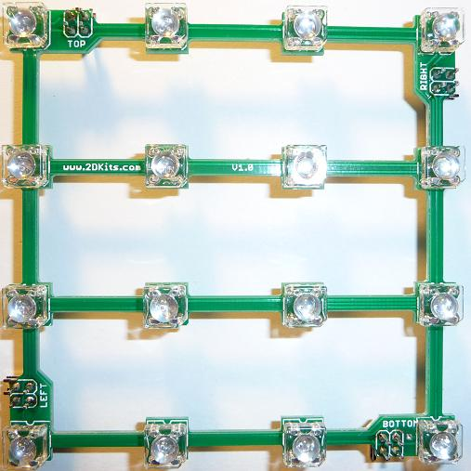

- Fit the leg boards to the base and waffle boards. Verify the boards are properly oriented – one leg board will connect all the TOP connectors together. All of the TOP, RIGHT, LEFT, and BOTTOM silk screening will align.  - On the legs, one side is labeled Cube Side. This faces in to the cube! All legs must have the label facing the bottom driver circuit board. | 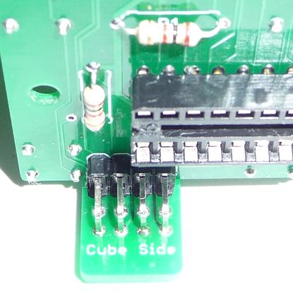

- Solder one pad on each of the headers. Alternate soldering one pin at a time on each of the angle headers to prevent the plastic from overheating. Repeat until soldering is complete.  - Once all soldering is complete, trim all leads. | 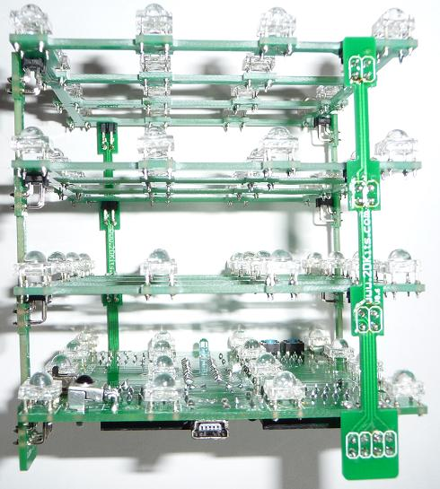

- The LED driver ICs are inserted so the dot or notch is facing left. These are the only components that are unforgiving if you insert them the wrong way. If they are incorrectly inserted, they will short out internally. You won’t see any smoke, but they will be dead.  - The PIC chip is inserted so the notch is facing up.  - Insert a mini-USB connector to provide power. Power con be provided either from a USB wall charger, or via a computer USB port..  - Turn on the board! Enjoy. | 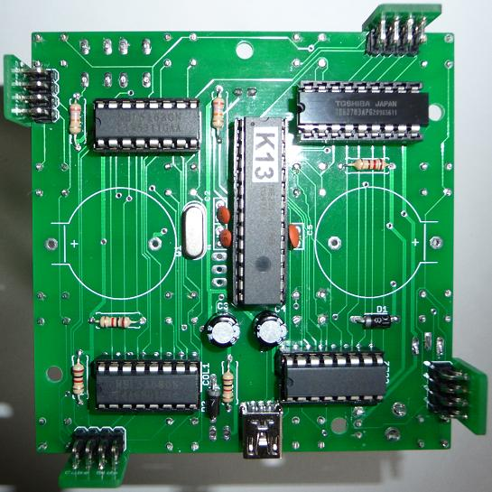

Troubleshooting

If all the LEDs don’t flash, then you’ll need to do a little troubleshooting to finish your project. The following steps should isolate most problems.

- Recheck your solder connections. 80% of all problems are traced to this. Cold solder joints and broken joints will cause erratic performance or failure. Reheat all solder connections until they flow and look shiny and secure.
- Check for bits of solder, wire ends, or other foreign matter which may be lodged in the wiring.
- The chips are reversed *or* one leg of a chip was folded when inserted.
- One of the metal socket leads is folded or missing.
- A resistor is in the incorrect location. This may cause the switches not to work, or LEDs to not light up properly.
- One of the diodes are reversed.
- Bad part – it does happen. In the hundreds of boards assembled, we’ve seen two or three parts fail. Let us know.
- A part was missing or wrong. Sorry about that, we sort and bag the parts by hand – no outsourcing here! Let us know.
- A part was lost/melted/damaged/destroyed while building the kit. It happens – you’re not the first (or second, or fiftieth). Let us know.
If it is still not working correctly, drop us a note and explain the problem.

Use

Once built, the use of this blinkie is fairly straightforward. Don’t get it wet. Don’t place it on a conductive surface where it might short out.

This blinkie has additional patterns stored in the PIC. To change patterns, press either push button and hold. The LEDs will display the current pattern number, and then the number displayed on the in binary will count up (or down). This is displayed on the left-most bottom row in blue. Each number represents a stored pattern. If the push button is released, the pattern associated with that particular number will then be displayed on your blinkie.

There are two modes. Regular and demonstration. Regular will stay at the selected pattern unless another blinkie is detected (via IR). It may switch patterns to match that blinkie. Demonstration will cycle through all patterns. If you are in demonstration mode, the top left LED on the second level will show red when either of the buttons are pressed. To toggle between the modes, press both switches at the same time.

This blinkie will also broadcast its current pattern via the IR LED. If another blinkie with an IR detector sees this, it will change its pattern to match. Of course, this can also happen to this blinkie – another blinkie may “infect” its pattern on this one before it can do the same.

This blinkie has a mini USB connector. It can be connected to a stand-alone power supply, or directly to a computer.

The USB port is more than a power port. It supports full USB communication. Using your computer to control the cube will be discussed in a separate document.

